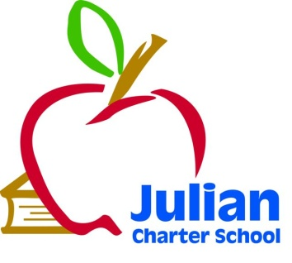 | JCS Special Governing Board Meeting  Friday November 4, 2016  San Diego Academies  6112 Lorca, San Diego, CA  1:00 p.m.  Via Teleconference  Kevin Ogden  Calling From:  177 Holston Drive, Lancaster  Roxanne Huebscher  Calling From:  JCS Palm Desert Student Services  72855 Fred Waring Drive, Palm Desert
Julian Charter School P. O. Box 2470 1704 Cape Horn Julian, CA 92036-2470
Board Members: | Roxanne Huebscher, Member Parent); Vacant (Parent); Suzanne Schumacher, President (Parent); Kevin Ogden, Secretary, (Community Member); Barbara Kingsbury, Treasurer (Community Member); Brian Duffy, (District Representative,) Member.
Agenda Topics
1. Call to Order

2. Approval of Agenda

3. Approval of September 9, 2016 Meeting Minutes

4. Comments from Members of the Public Concerning Items Not on the Agenda~

5. Board Member Announcements~

6. Board Training~None
7. Consent Agenda~None

8. Executive Director’s Report~None

9. CBO Report~None
10. Accountability Coordinator Report~None
11. Special Education Report~None
12. The Board of Directors will discuss or take action on the following items
- Approval of Resolution 11.4.16—Julian Charter School, Inc. Bylaws Revision
Approval of this item will allow Julian Charter School, Inc to oversee more than one charter as per the Articles of Incorporation adjusting Bylaw language to align.
- Approval of Waiver Language regarding Resource Center Locations
Approval of this item will allow the Executive Director to work with the Julian Union School District on submittal of a geographic waiver for Resource Centers located within SD County but out of the District boundary lines.
- Discussion of possible Resource Center Location solutions
The executive director will share with the board possible solutions for resource center compliance and seek appropriate direction.
- Approval of Math Placement Policy
Approval of this item will bring the Charter School in compliance with the Math Placement Policy criteria
- Approval of Classroom Visitation Policy
Approval of this policy will give guidelines to JCS staff and parents regarding classroom visitations.
- Review and Possible Appointment of Parent and Community Member Board Applications.
Potential new board members: Judy Bufford, parent; Dr. Coral Bergman, Community Member
- Approval of Agreement/Contract with SDCOE for Big Splash Fieldtrip (PLC)
This happens to be an Agreement that needs Board Approval since it’s out of the SDCOE. It’s for a PLC fifth grade field trip.
- First Reading of JCS Vacation Policy
In order to avoid the fiscal liability of large payouts of vacation time, the school would like to adjust the JCS Vacation Policy to limit fiscal liability while allowing employees ample time to rest and rejuvenate.

13. Closed Session--None
Public Employee Discipline/Dismissal/Release as per Govt. Code 54957

14. Items for Next Agenda Meeting
Members of the public who would like to review materials pertaining to the agenda prior to the meeting may do so by requesting a packet from the Executive Director.

In compliance with the Americans with Disabilities Act, if you need special assistance, disability-related modifications or accommodations, including auxiliary aids or services, in order to participate in the public meetings of the School’s governing board, please contact the Director at 760-765-3847. Notification 72 hours prior to the meeting will enable the School to make reasonable arrangements to ensure accommodations and accessibility to this meeting. Upon request, the School shall also make available this agenda and all other public records associated with this meeting in appropriate alternative formats for persons with a disability.
Next Meeting
Next Meeting: Friday December 9, 2016 Location: PLC Encinitas

