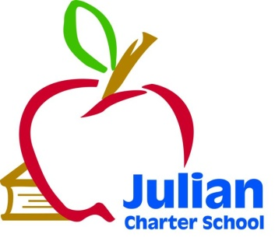 | JCS Governing Board Meeting  Friday, December 05, 2014  Phoenix Learning Center  777 Santa Fe Dr  Encinitas, CA 92024  Telephone: 760-632-4989  8:30 a.m. Open Session  10:30 a.m. Closed Session
Julian Charter School P. O. Box 2470 1704 Cape Horn Julian, CA 92036-2470
Board Members: | Roxanne Huebscher, Member (Riverside Parent); Julie Moore, Member (Orange County Parent); Suzanne Schumacher, President (San Diego Parent); Kevin Ogden, Secretary (District Liaison): Teresa Saueressig, Treasurer
Agenda Topics
1. Call to Order

2. Approval of Agenda

3. Approval of September 25, 2014 Meeting Minutes

4. Comments from Members of the Public Concerning Items Not on the Agenda

5. Comments from Members of the Board Concerning Items Not on the Agenda

6. Board Training
- Philosophy Discussion
7. Consent Agenda
Consent Agenda
- Approval of Warrants from August 20, 2014- October 31, 2014
- Ratification of New Hires, Terminations, and Resignations

8. Executive Director’s Report
- Facilities Update
- Academy Update
- Student Numbers Update
- School Goals 2014-2015
- Update on Bond
- New Laws
- Salary Compensation Study and progress

9. CBO Report
- First Interim Report
- 2014-2015 Budget
- 2013-2014 Audit

10. Special Education Report
- Current Numbers and Services Being Provided

11. The Board of Directors will discuss or take action on the following items
- First Interim Report
Approval of this item will show a positive fiscal certification to the district and County Office.
- Williams Uniform Complaints Quarterly Report
The board is asked to review and approve the quarterly report per the Uniform Complaint Procedure (Williams).
- 2014-2015 School Calendar (draft) 1st reading
Discussion of 2014-2015 school calendar.
- Audit Report
Approve Audit Report for 2012-2013 with no exceptions
- Approval of Benefits Compliance Stipend
Approval of this item will true up benefits for those employees who waved the school paying for their benefits for the 2014-2015 year.
- Conflict of Interest
Approval of this item will assure JCS governing board complies with the Conflict of Interest code.
- Consideration of new life insurance benefit offered to staff
The board will discuss and take action on the addition of a $50,000 school paid life insurance benefit with Open Enrollment in January 2015.
- Consideration for adjusting Assistant/Associate Director’s salaries
The board will discuss and may take action on potentially increasing Assistant/Associate Director’s salaries to bring them more in line with the 50% target market rate.
- Employee Handbook
Approval of the 2014-2015 Employee Handbook will bring it up to date.

12. Closed Session
- Executive Director’s Goals Review
- Possible Litigation
Public Employee Discipline/Dismissal/Release as per Govt. Code 54957

13. Items for Next Agenda Meeting
Members of the public who would like to review materials pertaining to the agenda prior to the meeting may do so by requesting a packet from the Executive Director.
In compliance with the Americans with Disabilities Act, if you need special assistance, disability-related modifications or accommodations, including auxiliary aids or services, in order to participate in the public meetings of the School’s governing board, please contact the Director at 760-765-3847. Notification 72 hours prior to the meeting will enable the School to make reasonable arrangements to ensure accommodations and accessibility to this meeting. Upon request, the School shall also make available this agenda and all other public records associated with this meeting in appropriate alternative formats for persons with a disability.
Next Meeting
Next Meeting: Friday, January 23, 8:30 a.m. Location: Encinitas

