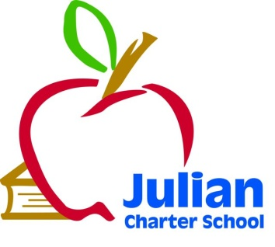 | JCS Special Governing Board Meeting  Thursday, September 25, 2014  Cardinal Industrial Conference Room  2131 Palomar Airport Road, Conference Room—2nd floor  Carlsbad, CA 92011  Telephone: 760-522-5038  10:00 a.m. Open Session  Via Telephone:  Kevin Ogden  511 N 2nd Street  El Cajon, CA
Julian Charter School P. O. Box 2470 1704 Cape Horn Julian, CA 92036-2470
Board Members: | Roxanne Huebscher, Member (Riverside Parent); Julie Moore, Member, (Orange County Parent); Suzanne Schumacher, President (San Diego Parent); Kevin Ogden, Secretary, (District Liaison); Member: Teresa Saueressig, Treasurer
Agenda Topics
1. Call to Order

2. Approval of Agenda

3. Approval of September 12, 2014 Meeting Minutes

4. Comments from Members of the Public Concerning Items Not on the Agenda

5. Comments from Members of the Board Concerning Items Not on the Agenda

6. Board Training--None
7. Consent Agenda--None

8. Executive Director’s Report--None

9. CBO Report--None
10. Accountability Coordinator Report--None
11. Special Education Report--None
12. The Board of Directors will discuss or take action on the following items
- Resolution #9.25.1
Approval of this item provide the official intent to reimburse expenditures from proceeds of a future borrowing
- Resolution #9.25.2
The Board of Directors of Julian Charter School, Inc. will authorize, approve, ratify, and confirm the purchase of the Encinitas Blvd/North Coast facility, the execution of a purchase agreement, the purchase price of the Encinitas Blvd/North Coast facility, and authorize and approve certain matters related thereto
- Resolution#9.25.3
The Board of Directors of Julian Charter School, Inc. will authorize, approve, ratify, and confirm the purchase of the Vallejo Ave/Temecula facility, the execution of a purchase agreement, the purchase price of the Vallejo Ave/Temecula facility, and authorize and approve certain matters related thereto
- Approval of Engagement Letter with Baird
Approval of this item will secure engagement with R.W. Baird & Company for work on the Bond Type financing

13. Closed Session--None
Public Employee Discipline/Dismissal/Release as per Govt. Code 54957

14. Items for Next Agenda Meeting
- Approval of Audit
Members of the public who would like to review materials pertaining to the agenda prior to the meeting may do so by requesting a packet from the Executive Director.

In compliance with the Americans with Disabilities Act, if you need special assistance, disability-related modifications or accommodations, including auxiliary aids or services, in order to participate in the public meetings of the School’s governing board, please contact the Director at 760-765-3847. Notification 72 hours prior to the meeting will enable the School to make reasonable arrangements to ensure accommodations and accessibility to this meeting. Upon request, the School shall also make available this agenda and all other public records associated with this meeting in appropriate alternative formats for persons with a disability.
Next Meeting
Next Meeting: Friday, December 5, 2014 10:00 a.m. Location: Orange County

