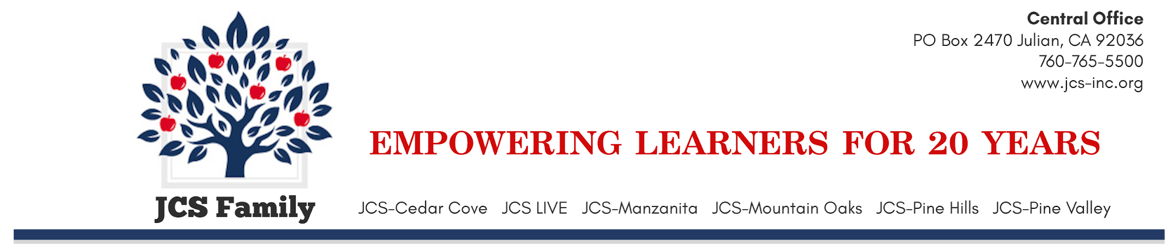

2022-2023 PARENTAL OPTIONS
(Applicable Only for the Current School Year)

PARENTS: PLEASE READ AND COMPLETE THE INFORMATION BELOW AND RETURN IT TO YOUR SCHOOL

Student Name: Date of Birth:
Address:
City: Zip Code:
Telephone No.: Grade:
School:
Physical Examination
JCS, Inc. may require physical examinations of students enrolled in JCS, Inc. programs or activities. Any physical examination required by JCS, Inc. shall be kept confidential. A parent or guardian having control or charge of any child enrolled in public schools may file annually with the principal of the school in which s/he is enrolled a statement in writing, signed by the parent or guardian, stating that s/he will not consent to a physical examination of the child.

- I do not want my child to undergo a physical exam for JCS, Inc. programs or activities.
- I grant consent for my child to undergo a physical exam for JCS, Inc. programs or activities.

