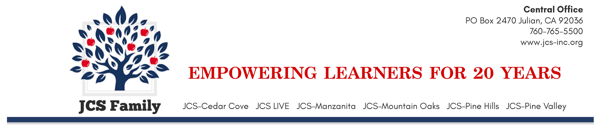2022-2023 ORAL HEALTH NOTIFICATION LETTER
(to accompany Oral Health Assessment/Waiver Request Form)
Dear Parent or Guardian:
To make sure your child is ready for school, California law, Education Code section 49452.8, now requires that your child have an oral health assessment (dental check-up) by May 31 in either kindergarten or 1st grade, whichever is your child’s first year in public school. Assessments that have happened within the 12 months before your child enters school also meet this requirement. The law specifies that the assessment must be done by a licensed dentist or other licensed or registered dental health professional.
Take the attached Oral Health Assessment/Waiver Request form to the dental office, as it will be needed for your child’s check-up. If you cannot take your child for this required assessment, please indicate the reason for this in Section 3 of the form. You can get more copies of the necessary form at your child’s school or online from the California Department of Education’s Web site at http://www.cde.ca.gov/ls/he/hn/. California law requires schools to maintain the privacy of students’ health information. Your child’s identity will not be associated with any report produced as a result of this requirement.
The following resources will help you find a dentist and complete this requirement for your child:
1. Medi-Cal/Denti-Cal’s toll-free number or website can help you to find a dentist who takes Denti-Cal: 1-800-322-6384; http://www.denti-cal.ca.gov. For help enrolling your child in Medi-Cal/Denti-Cal, contact your local social service agency.
2. Healthy Families’ toll-free number or website can help you to find a dentist who takes Healthy Families insurance or to find out if your child can enroll in the program: 1-800-880-5305 or
http://www.benefitscal.com/.
3. For additional resources that may be helpful, contact your local public health care department or Dental Health Initiative – San Diego at 619-692-8858.
Remember, your child is not healthy and ready for school if your child has poor dental health! Here is important advice to help your child stay healthy:
● Take your child to the dentist twice a year.
● Choose healthy foods for the entire family. Fresh foods are usually the healthiest foods.
● Brush teeth at least twice a day with toothpaste that contains fluoride.
● Limit candy and sweet drinks, such as punch or soda. Sweet drinks and candy contain a lot of sugar, which causes cavities and replaces important nutrients in your child’s diet. Sweet drinks and candy also contribute to weight problems, which may lead to other diseases, such as diabetes. The less candy and sweet drinks, the better!
Baby teeth are very important. They are not just teeth that will fall out. Children need their teeth to eat properly, talk, smile, and feel good about themselves. Children with cavities may have difficulty eating, stop smiling, and have problems paying attention and learning at school. Tooth decay is an infection that does not heal and can be painful if left without treatment. If cavities are not treated, children can become sick enough to require emergency room treatment, and their adult teeth may be permanently damaged.
Many things influence a child’s progress and success in school, including health. Children must be healthy to learn, and children with cavities are not healthy. Cavities are preventable, but they affect more children than any other chronic disease.
If you have questions about the new oral health assessment requirement, please contact your school's principal.
Sincerely,
Jennifer Cauzza
Executive Director
JCS-Inc.

2022-2023 ORAL HEALTH ASSESSMENT FORM
California law (Education Code section 49452.8) states your child must have a dental check-up by May 31 of his/her first year in public school. A California licensed dental professional operating within his scope of practice must perform the check-up and fill out Section 2 of this form. If your child had a dental check-up in the 12 months before he/she started school, ask your dentist to fill out Section 2. If you are unable to get a dental check-up for your child, fill out Section 3.
Section 1: Child’s Information (Filled out by parent or guardian)
Child’s First Name: | Last Name: Middle Initial: | Child’s birth date:
Address: |  | Apt.:
City: |  | ZIP code:
School Name: | Teacher: Grade: | Child’s Sex:  □ Male □ Female
Parent/Guardian Name: | Child’s race/ethnicity:  □ White □ Black/African American □ Hispanic/Latino □ Asian □ Native American □ Multi-racial □ Other___________  □ Native Hawaiian/Pacific Islander □ Unknown

Section 2: Oral Health Data Collection (Filled out by a California licensed dental professional)
IMPORTANT NOTE: Consider each box separately. Mark each box.
Assessment  Date: | Caries Experience  (Visible decay and/or fillings present)  □ Yes □ No | Visible Decay  Treatment Urgency:  Present:  □ No obvious problem found  □ Early dental care recommended (caries without pain or infection;  or child would benefit from sealants or further evaluation)  □ Yes □ No  □ Urgent care needed (pain, infection, swelling or soft tissue lesions)
Licensed Dental Professional Signature CA License Number Date

Section 3: Waiver of Oral Health Assessment Requirement
To be filled out by parent or guardian asking to be excused from this requirement
Please excuse my child from the dental check-up because: (Check the box that best describes the reason)
□ I am unable to find a dental office that will take my child’s dental insurance plan.
My child’s dental insurance plan is:
□ Medi-Cal/Denti-Cal □ Healthy Families □ Healthy Kids □ Other __________________□ None
□ I cannot afford a dental check-up for my child.
□ I do not want my child to receive a dental check-up.
Optional: other reasons my child could not get a dental check-up:
If asking to be excused from this requirement: ►____________________________________________________ Signature of parent or guardian Date

The law states schools must keep student health information private. Your child's name will not be part of any report as a results of this law. This information may only be used for purposes related to your child's health. If you have questions, please call your school.

Return this form to the school no later than May 31 of your child’s first school year.
Original to be kept in child’s school record.

