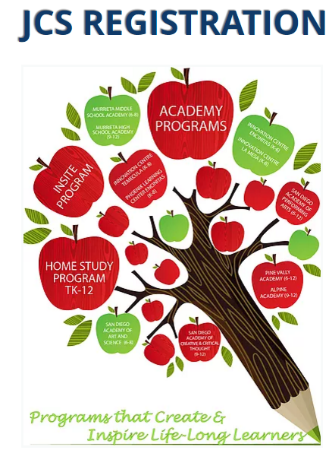

REGISTRATION INSTRUCTIONS

Table of Contents

Before You Start | 2
New Student Registration | 3
Continuing Student Registration | 10
Getting Started with JCS | 11

Before You Start

Returning or Continuing Students
If you are a returning or continuing family, you will receive an email letting you know it is time to review REG-Online.

New Students
If you have a student who is not yet in the system, call Admissions to initiate enrollment:
760-705-4JCS (4527) or email admissions@jcs-inc.org.

Registrars will enter your child(ren) into the system, and you will receive an email at the address you provided. Be sure to check your junk/SPAM folder for an email from your JCS school.
Documents Needed for New Student Enrollment
If you are enrolling a student with JCS-Inc., you will need the following documents in order to complete this process. You may scan the documents, or you can take a photo with your cell phone, and upload it. If you do not have a scanner or the ability to upload documents, please email registrars@jcs-inc.org
- Birth record - Documentation of your student's age (new students only), such as birth certificate, baptismal record, passport, etc. You will need to upload each document individually.
- Immunization Record - Upload a record of all immunizations received, including Tdap for 7th grade students. If your child is missing doses, contact registrars@jcs-inc.org.
- Proof of Residence - Upload a mortgage statement, rental agreement or a utility bill showing the Service Address - one per family - if you have students in separate schools, you will need to upload to each school.
- 1st Grade Health and Dental Form - First grade students only. Forms can be found in Reg-Online/students/student documents.
- Transcript - For high school students only.
- Custody/Guardian paperwork (if applicable)
- Suspension and expulsion reports (if applicable)

Please note: We recommend that you use a computer for this process - cell phones and tablets may have limited access. If you do not have access to a computer with internet access, please email registrars@jcs-inc.org

New Student Registration

Login to REG-Online by clicking on the link provided in the email and create an account using your Email, Household Last Name and Phone Number.
Your username will be your primary email address.

Also, use this page, if an account has already been created to log in and finish an application.
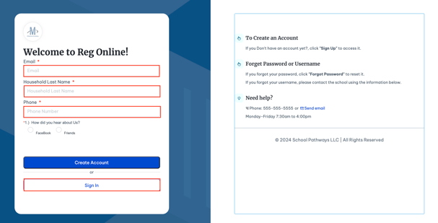
- Welcome to your new Reg Online portal. Start by Selecting the Begin tab and begin in the Household Information tab.
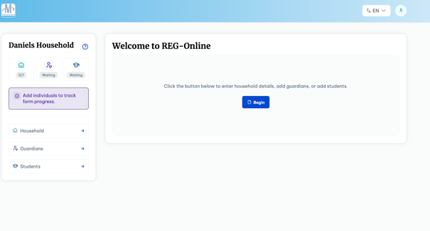

Household Information
- Select the Update Household Information tab to begin.
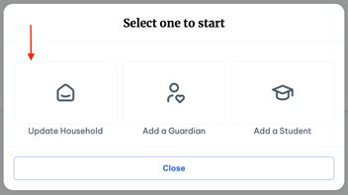
Inside the Household Information, there are three Hubs: Basic Information, Household Documents and Household Survey.
- Complete these hubs, along with the required information with a red asterisk applied to the question.
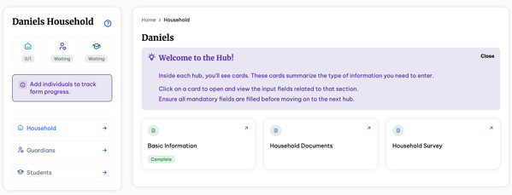

- To move onto the next selection, you may select the Home button on top to return (1) or the Household Hub on the left using (2 or 3).
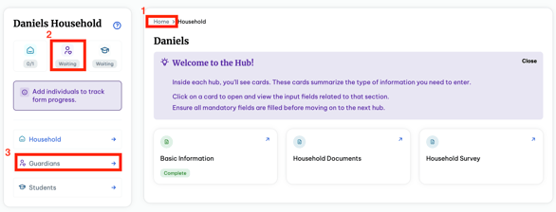
For Household Documents -

Click on 'Upload Documents' and upload a recent utility bill that shows the 'property or service address' ( ie. gas and electric bill, whole front page of statement, not coupon for mail)

If proof of residence isn't in a guardian's name, complete the Shared Residence Affidavit and upload it along with a bill in their name.

Click Save and continue to Guardians:

Guardians
- Using one of the following methods as described or by using the Save and Continue to Guardians button at the end of the Household survey, go into the Guardians Hub.
- Select Add a Guardian in the right hand corner. This Hub will compose of :
  - Basic Information
  - Address Information
  - Contact Information
  - Work Information
  - Education & Military Status
*Some of these fields and hubs may be optional and those with the red asterisk are required but it is best to fill out all information for optimal accuracy.
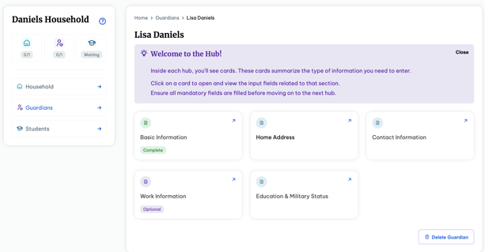

- Please ensure all information is accurate and correct. Sections such as contact information and address will be used for communication and more.
- You can add more than one Guardian on the Guardian Hub and select who is the Primary Guardian.
- To continue onto the Students section, you may use one of the three ways described or can you use the Save and Continue to Students button on the Education & Military Status page.

Students
- Navigate to the Students Hub. Select Add a Student in the right hand corner. If one has already been created, select the student under Active Registration.
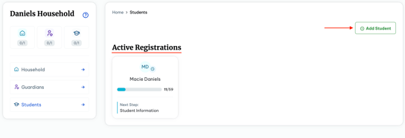

- The Students Hub consists of the following fields
  - Student Information
  - Supplemental Information
  - Enrollment History
  - Guardian Authorization
  - Emergency Information
  - Sibling Data
  - Immunization Information
  - Student Documents
- Choose the correct Registration window and Grade level when adding your student (s).
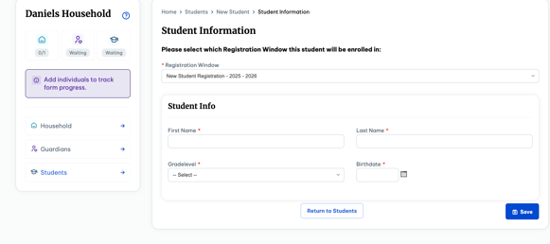

Enter all student information required (indicated with red asterisks) in the Student Record

Student Documents

Read, Sign and Save all of the documents

Upload all required documents (Birth Certificate, Immunization Record, etc)
- Complete all of the Hubs for the student. Then you may add another student on the Student Hub.
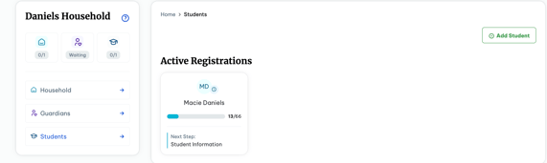

Please note some of these fields are optional but may be required for your specific school and it is imperative you fill and supply as much information as possible.

Home Page
- Your Homepage will consist of the modules and show what is complete and incomplete.
Example:
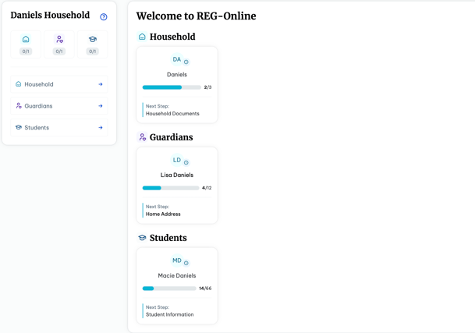
- There are several ways to navigate to your home-page while in the different sections and hubs. The simplest way would be using the Home field always located at the top of your Hub.


Finish
- Scroll back to the bottom of your screen and click Finish. If there is an alert box, as shown below, please check for what is missing/ indicated as Incomplete in the Hub.
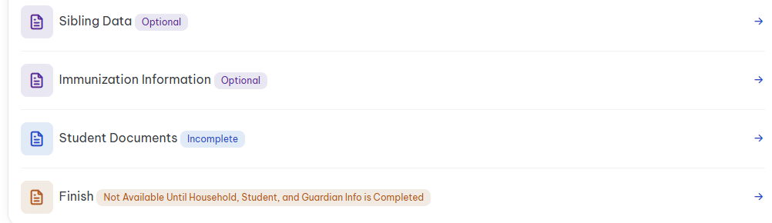

- Please email registrars@jcs-inc.org if you have a student registration that you would like to delete from the REG-Online system.

Continuing Student Registration

You must REVIEW & SAVE each section (Household Information, Guardians & Students) for registration to be complete for next school year!
If you have students in two different JCS-Inc. schools, you will be receiving two emails to complete the Reg Online in each school. You will need to use the links in each email to go to each school and complete the Reg Online.

Login for Continuing Students

- An email will be generated and sent to you with the link to complete the REG-Online. Click on the link.
- Your username is your primary email account.
- Click on the blue REG-Online link (top/right of page).
- Click on the Household Information Hub
- Review and SAVE Household information.
- Check for any sections indicated as “Incomplete” and go back to complete those sections.
- If you have a change of address, please upload a recent utility bill in ‘Upload Required Documents’ (add another file, then upload selected file) and update your address in the Household and Student Record(s). Otherwise, we will not need another proof of residence uploaded every year.
- Navigate to the Guardian Hub
- Click on each Guardian’s name and Review and SAVE each record.
- Check for any sections indicated as “Incomplete” and go back to complete those sections.
- Navigate to Students Hub
- Review and update any information as needed.
- Review, Sign and Save all of the documents. The documents need to be reviewed, signed and saved annually for all students. If you have more than one student, you will need to navigate to each of your students in the Hub and review, sign and save the documents for each of them.
- Review the documents that need to be uploaded. Scan the documents to your computer, and save them where you can easily retrieve them to upload. NOTE: First graders need the Health and Dental forms uploaded.
- Upload any updated Immunization records if applicable. NOTE: 7th graders need proof of TDAP.
For immunization requirements, review these links:
Immunization requirements
Medical Exemptions FAQs
Repeat these steps for each student you are re-enrolling.

Finish
- Scroll to the bottom of your screen and click Finish.
- If there is a red alert box, please go back and check to see what is missing/indicated as “Incomplete” and complete and save the missing information. Please email registrars@jcs-inc.org if you have a student registration that you would like to delete from the REG-Online system.
- If there is no alert message, Click on Finish to review the CONFIRMATION for each student.
- Read the confirmation and save for your files.

Getting Started with JCS

After you have completed registration, you will hear from an Educational Facilitator or Academy.

Note: If you complete registration during the months of June or July, you can expect to hear from your Academy or EF during the first week of August.

Once your EF or Academy contacts you, you will set up a meeting to review curriculum options, schedule appointments, sign the Written Learning Agreement, and discuss your program.

Home study
When planning the semester, and school year, the parent and EF need to discuss the student’s goals and instructional needs, including learning center sessions or online courses and possible Educational Enrichment Provider instruction. The EF will place requests for educational materials that are appropriate for the student’s personalized learning plan within a few days of the initial meeting. Because we are a public school, all items requested must be non-sectarian in nature. In the meantime, please familiarize yourself with the Parent Handbook: Parent Handbook (Home Study) - TK-12.

If you have questions, not related to registration prior to August, please email admissions@jcs-inc.org and one of our staff members will get back to you within 2 business days.

Thank you for choosing JCS-Inc.
We look forward to working with you and your child(ren).

