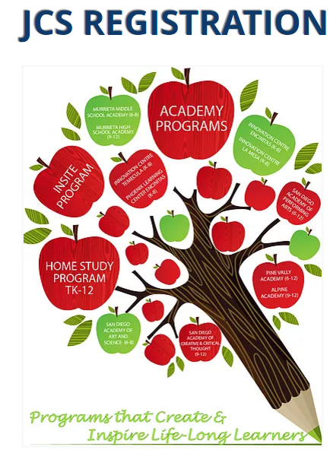

INSTRUCTIONS

Table of Contents

Before You Start | 2
New Student Registration | 3
Continuing Student Registration | 5
Getting Started with JCS | 7

Before You Start

Returning or Continuing Students
If you are a returning or continuing family, you will receive an email letting you know it is time to review REG-Online. You do not need to complete the REG-Online annually unless you have moved to a new address or need to update your contact information.

New Students
If you have a student who is not yet in the system, call Admissions to initiate enrollment:
760-705-4JCS (4527) or email admissions@jcs-inc.org.

Admissions will enter your child(ren) into the system, and you will receive an email at the address you provided. Be sure to check your junk/SPAM folder for an email from your JCS school.
Documents Need for New Student Enrollment
If you are enrolling a student to JCS-Inc. you will need the following documents in order to complete this process. You may scan the documents if you have a scanner or you can take a photo with your cell phone and upload it. If you do not have a scanner or the ability to upload documents, please email registrars@jcs-inc.org
- Birth record that documents your student's age (new students only), such as birth certificate, baptismal record, passport, etc. You will need to upload each document individually.
- Immunization Record (upload a copy of all immunizations received, including Tdap for 7th grade students. If your child is missing shots, contact registrars@jcs-inc.org)
- Proof of Residence (a utility bill showing the Service Address - one per family - if you have students in separate schools, you will need to upload to each school)
- 1st Grade Health and Dental Form (first grade students only. Forms can be found in REG-Online/application/student documents)
- Transcript for high school students
- Custody paperwork (if applicable)
- Suspension and expulsion (if applicable)

We recommend that you use a computer for this process - cell phones and tablets may have limited access. If you do not have access to a computer with internet access, please email registrars@jcs-inc.org

New Student Registration

Login to REG-Online by clicking on the link provided in the email and creating your password.
Your username will be your primary email address.

Household
- Click on the red Household link on the toolbar at the top of your screen.
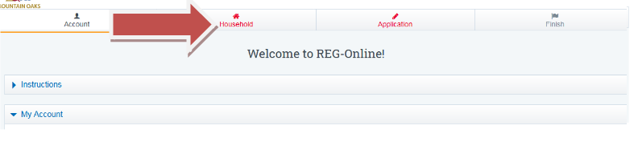
- Fill out all of your Primary Contact information then 'Save Household info.'
- Upload Required Documents (Proof of residence). Browse for file, then click 'Upload Selected File.'
- Add two Parents or Guardians and save each record.
- You should see all green checks on the right side of the screen when Household is complete.

More about Proof of Residence
Here is an example of a utility bill showing the service address:
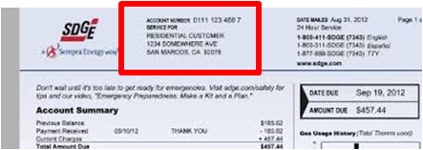
If the utility bill is not in the name of the parent/guardian listed, please have the person listed on the utility bill fill out and sign the Shared Residence Affidavit. Upload both the Shared Residence Affidavit and the Proof of Residence (Utility Bill).

Application
- Click on Application at the top of the page.
- Click ‘New Student Application’
- There are two parts to complete for each student: Student Information and Student Documents.
- First, click on Student Information and fill out all of the requested information.
- If there are any items missing, you will get an error message asking you to scroll back up and fill in any item highlighted in red.
- Click on the Student Documents and sign the forms that have a red X, and upload documents that show a red X. Please review the documents that need to be uploaded. Be sure to upload any document that pertains to your student. Scan the documents to your computer, and save them where you can easily retrieve them to upload.
- For immunization requirements, review these links:
Immunization requirements
Medical Exemptions FAQs
- You will have all green checks along the right side of the screen when you are done with this section.

Finish
- Scroll back to the top of your screen and click Finish. If there is a yellow alert box, please see what is missing in the Reg Online.
- Please email registrars@jcs-inc.org if you have a student registration that you would like to delete from the REG-Online system.
- If there is no alert message, click on the red circle with the X to print the CONFIRMATION for each student.
- Read the confirmation and save for your files.

Continuing Student Registration

You must RESAVE each section for registration to be complete for next school year!
If you have students in two different JCS-Inc. schools, you will be receiving two emails to complete the Reg Online in each school. You will need to use the links in each email to go to each school and complete the Reg Online.
Login for Continuing Students
- An email will be generated with the link to complete the REG-Online
- Your username is your primary email account
- Click on the blue REG-Online link (top/right of page).
Household
- Click on Household at the top of the page.
- Review and RESAVE Household information.
- If there are any items missing, you will get an error message asking you to scroll back up and fill in any item highlighted in red.
- If you have a change of address, please upload a recent utility bill in ‘Upload Required Documents’ (add another file, then upload selected file) and update your address in the Household and Student Record(s)/ Otherwise, we will not need another proof of residence uploaded every year.
- Click on each Guardian’s name and Review and RESAVE each record.
Application
- Click on Application at the top of the page.
- Click on your student’s name.
- Click on Student information. Review and update if needed. Click SAVE STUDENT RECORD
- Click on Student Documents, Sign and save documents that have a red X.
- Review the documents that need to be uploaded. Scan the documents to your computer, and save them where you can easily retrieve them to upload. NOTE: First graders need the Health and Dental forms uploaded.
- Upload any updated Immunization records if applicable. NOTE: 7th graders need proof of TDAP.
- For immunization requirements, review these links:
Immunization requirements
Medical Exemptions FAQs
- Repeat these steps for each student you are re-enrolling.

Finish
- Scroll back to the top of your screen and click Finish.
- If there is a yellow alert box, please see what is missing in the Reg Online. Please email registrars@jcs-inc.org if you have a student registration that you would like to delete from the REG-Online system.
- If there is no alert message, Click on the red circle with the X to print the CONFIRMATION for each student.
- Read the confirmation and save for your files.

Getting Started with JCS

After you have completed registration, you will hear from an Educational Facilitator or Academy.

Note: If you complete registration during the months of June or July, you can expect to hear from your Academy or EF during the first week of August.

Once your EF or Academy contacts you, you will set up a meeting to review curriculum options, schedule appointments, sign the master agreement, and discuss your program.

Home study
When planning the semester and school year, the parent and EF need to discuss the student’s goals and instructional needs, including learning center sessions or online classes and possible vendor course instruction. The EF wil place requests for educational materials that are appropriate for the student’s personalized learning plan within a few days of the initial meeting. Because we are a public school, all items requested must be non-sectarian in nature. In the meantime, please familiarize yourself with the Parent Handbook: Parent Handbook (Home Study) - TK-12.

If you have questions not related to registration prior to August, please email admissions@jcs-inc.org and one of our staff members will get back to you within 2 business days.

Thank you for choosing JCS-Inc.
We look forward to working with you and your child(ren).

