**JCS EF/Teacher Guide to EEP Ordering**

This guide contains information on ordering EMR (Educational Material Resources) and EEP (Educational Enrichment Partner) requests through JCS’s EEP system. Please refer to this guide when placing EEPs orders and when you have questions about orders.

The JCS Family of Schools has an extensive list of approved EEPs. (All EEPs must be fingerprinted and cleared through the proper agencies.) EEP services include group instruction in activities such as martial arts, dance, art, music, horseback riding, etc. as well as tutoring for academic subjects. If you choose to enroll a student in one of the classes, it is your responsibility to make sure there is room in the class and to make the initial contact with the EEPs **before** requesting services using the online ordering system.

Please stay informed about the quality of the instruction and your family’s satisfaction with the EEP. Communicate often with your families about their EEP offerings. If a family decides to cancel the class, for any reason, they need to notify you immediately, and you need to cancel the purchase order once you have confirmed with the EEP.  *If you do not cancel, JCS must pay them.*

Notes: EEPs may not get paid to have his/her own child in the class. An EEP should never begin instruction without a purchase order in hand.

For EMR (educational material resources), please be sure to check out the Resource Center catalog, Destiny, prior to placing any orders:  [julian.follettdestiny.com](http://julian.follettdestiny.com). The Resource Center carries nearly one million titles for check out, and each student can check out up to 50 resources, which includes EMR orders.

Notes: A**ll ordering ends mid February.** Please refer to the home study calendar for the exact date each year.

**Table of Contents**

Getting Started

Educational Units Available:

Pro-rated Educational Units:

Ordering

EEP Ordering (EEPs Course Instruction)

EEP Purchase Order Requests details:

Student attendance slip:

Online Individual Student Subscriptions/Classes:

EMR Ordering (Educational Material Resources)

No Purchase Chart:

AMAZON.COM:

EMR Shipping Fees and Siblings:

Ordering Live Specimen:

Direct Ship to Student:

No Pick up of EMR at EEPs’s Place of Business:

Order Status:

Events and Sign Me Up (Field Trips):

Refunds

EEP – Refunds:

EMR – Refunds:

Events and Sign Me Up (Field Trips) – Refunds:

Materials Reimbursement Form for Concurrent College Enrollment:

# 

# Getting Started

Navigate to this website: <https://vendors.jcs-inc.org/>

### Educational Units Available:

All funds, which include EEP (EEPs course instruction) and EMR (educational material resources) funds, are dropped into the student’s budget account each semester. Funds can be used for both EEP and/or EMR orders.

* TK-12 Home Study receive 750 EUs each semester
* INSITE Murrieta receive 350 EUs each semester

NOTE: If you need additional funds for EMR books or materials that are aligned with your student’s educational goals, let your EF know what items you need to support learning and we will review your requests for approval of additional needed funds.

### Pro-rated Educational Units:

Funds are pro-rated, based on month, if the student enrolls after the first month of the semester or transfers between JCS programs. Orders must be completed and approved by the due date. Check the calendar for semester due dates.

| **Home Study** | **TK - 12** |  | **INSITE Temecula** |  |
| --- | --- | --- | --- | --- |
| ***Enrollment Date*** | ***EU Funds*** |  | ***Enrollment Date*** | ***EU Funds*** |
| **Aug/Sep** | **750** |  | **Aug/Sep** | **350** |
| **Oct** | **600** |  | **Oct** | **280** |
| **Nov** | **450** |  | **Nov** | **210** |
| **Dec** | **zero** |  | **Dec** | **zero** |
| **Jan** | **750** |  | **Jan** | **350** |
| **Feb** | **750** |  | **Feb** | **350** |
| **March** | **zero** |  | **March** | **zero** |
| **April/May** | **zero** |  | **April/May** | **zero** |

**Academy Students do not receive EU's**

* **Unused EU's from 1st semester will roll over to 2nd semester**
* **Unused EUs from 2nd semester will be cleared off student's budget account once ordering has closed for the year**
* **No EU's are issued, nor can be allocated during the months of June & July, or when school is not in session.**

# Ordering

There are (2) ways you can place a request. (a) Click on New request or (b) look at EEPs by Category or Search for a EEPs.

Select the student for whom you want to make a request. If you have multiple students enrolled in JCS, they will all appear on this handy screen. Click on *EEP Request* to create a EEPs Course Instruction order or *EMR Request* for Educational Material Resources on the line next to your student’s name (be sure to place requests for the correct student each time). (Add Video here LGC)



**Click on EEP Request or EMR Request**

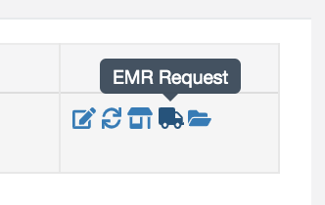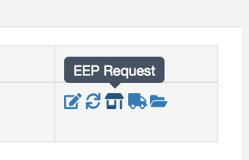

# EEP Ordering (EEP Course Instruction)

**Prior to creating an EEP (EEP Course Instruction) request, please contact the EEP and confirm with the EEP that they have space for the student in the instruction you are requesting (parents may complete this part of the process). It is highly recommended that the parent visit the EEP prior to placing a request, and that they confirm the location and place of services. Please do not place a request unless the parent or you have made an agreement with the EEP. Allow 7-10 business days for the processing of the request.**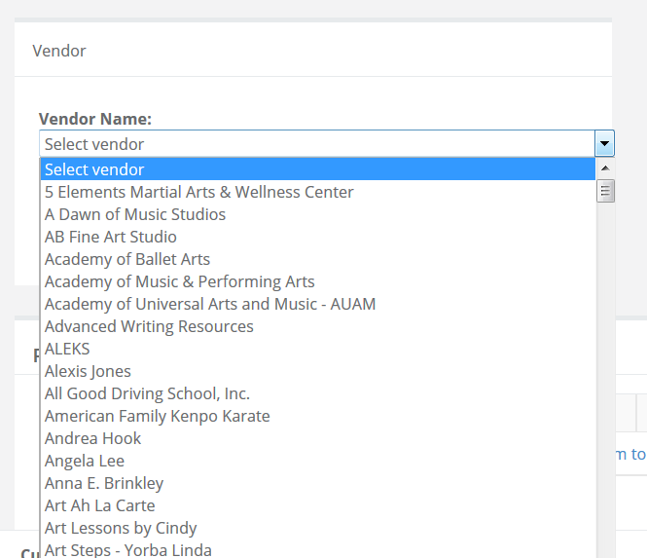

To create an EEP request, click on EEP Request next to the student for whom you would like to place a request.

You will arrive to the New Request Screen. Click on the EEPs Name box to get a listing of EEPs.

Select the EEP and the class for which the EEP has confirmed your student has a space.

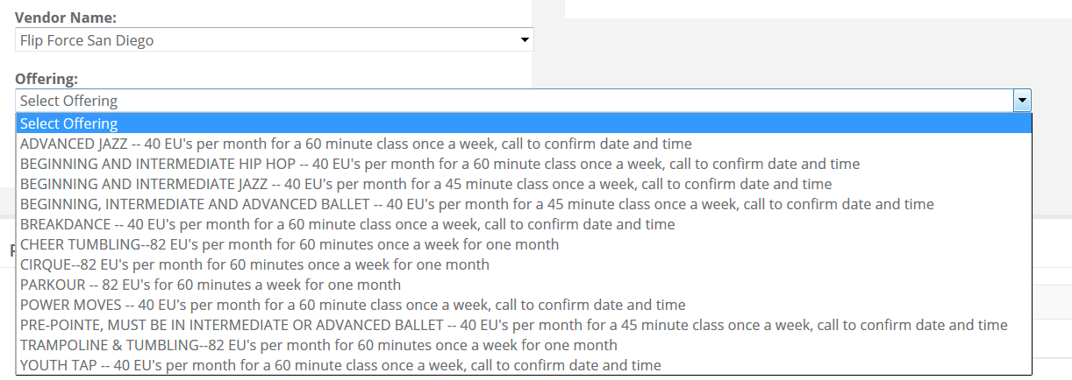

**Carefully review Special Ordering Instructions. Some EEPs have specific instructions to follow and additional yearly or membership fees that are not covered by JCS.**

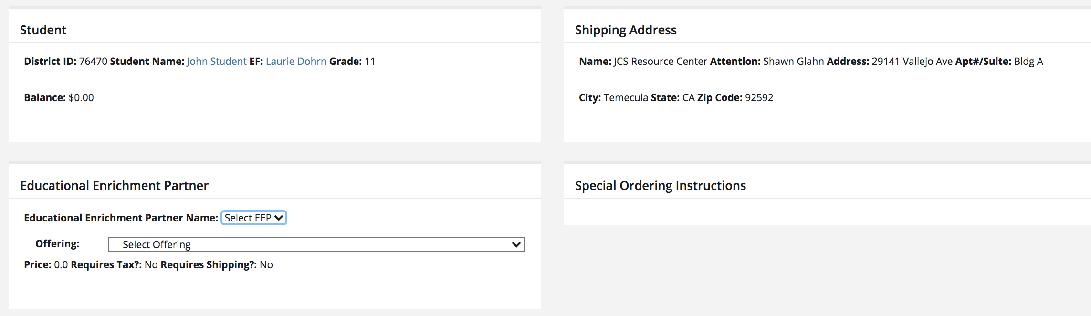

When placing multiple orders for the same EEPs - same class, use the **same request**. Use **different requests** for offerings from the same EEPs - different classes.

* An example **SAME request**: lessons for September, October & November @ $40/hr.
* An example **DIFFERENT request**: The same EEPs offers two different classes, horseback riding @ $40/hr and Equine Science @ $80/session. In this case place two different requests.

Click on “**Add New Item** to this request” to add multiple line items (separate line items for each month) for the same EEPs. **Your EF will not approve multiple separate PO requests for the same EEPs & class. Same EEPs, same class on one request.**

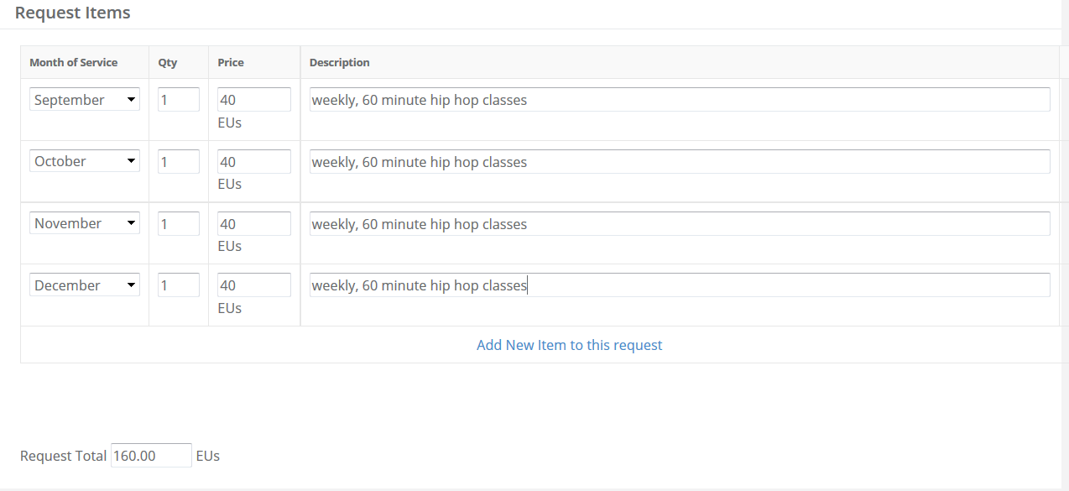

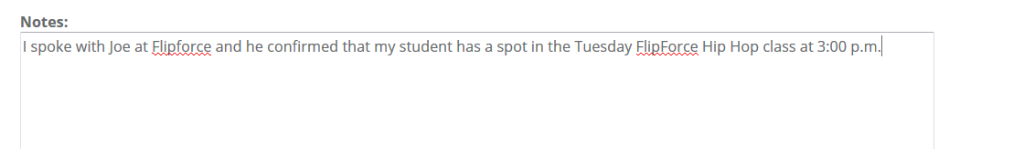

If the JCS EEP Purchasing Department does not approve the request, you will receive an email noting what is needed for approval.

Once approved, you will receive an email confirmation and **student attendance slips will be created in the student’s account for the EEPs.** (see Student Attendance Slips below)

**Do not “reply” to the automated system email.**

### EEP Purchase Order Requests details:

* Follow all directions for ordering. Read the small print on how and when to add shipping and tax. Each EEPs order is different.
* Fall and spring semester requests must be ordered separately. JCS does not cover any classes when school is not in session(ie; holidays, winter, spring, summer breaks). It is preferable that orders be placed one time at the beginning of the semester and not on a monthly basis. **Please place all orders for the entire semester by the order deadline.**
* The funds requested for a class *must match* the contracted price of the requested offering. Use the correct class offering when ordering a class.
* Partial payment of a class or session is allowed if pre-arranged with the EEPs by the parent prior to creating the request. *The reason for the different price must be entered in the Notes section of the request or the request will be declined.*

Request classes and sessions exactly how the EEP has specified on the class offering.

* If lessons are $20/hour and you want 4 lessons in March, that is 4 @ $20 (not 1 @ $80).
* If lessons are $80 per month for 4 one hour lessons, then that would be 1 @ $80.

An EEP may contract for a minimum of weeks. If it is stated $20 for one hour once a week for a minimum of 8 weeks, then you must have at least 8 weeks of lessons on the request**. *Any other arrangements made with the EEP must be entered in the Notes section of the request or the request will be Declined.***

EEPs cannot bill for lessons until the classes have been taught. ~~Verification of student attendance for a class is provided to the EEPs by way of the student’s attendance slip.~~

### Student Attendance Slips:

Students may not attend EEP Course Instruction without a student attendance slip for the EEP. A student attendance slip certifies that a purchase order has been approved for the student to use the EEP. The attendance slip also documents attendance with the EEP. EEPs can refuse class attendance without an attendance slip. An attendance slip must be presented to the EEP at the start of each class the student participates in with a specific EEP.

Student attendance slip will appear under each student’s account once a purchase order is approved. Each attendance slip will specify the student, EEPs, approved EEPs offering, PO #, month of service, QR code and/or attendance slip code for attendance. This will need to be provided to the EEPs in order to receive instruction. attendance slip can be printed to be given to the EEPs. attendance slip can also be provided to the EEPs by logging into student’s account in the EEPs’s program using a smartphone and clicking on the attendance slip folder icon in the left column menu. All available attendance slip will be listed and able to view using a smartphone. EEPs will need to be able to obtain either QR code or attendance slip code to record attendance for invoicing. Individual attendance slip can only be used once. Once a attendance slip is given and recorded with the EEPs it will no longer be available to print. Example of Smartphone screenshots: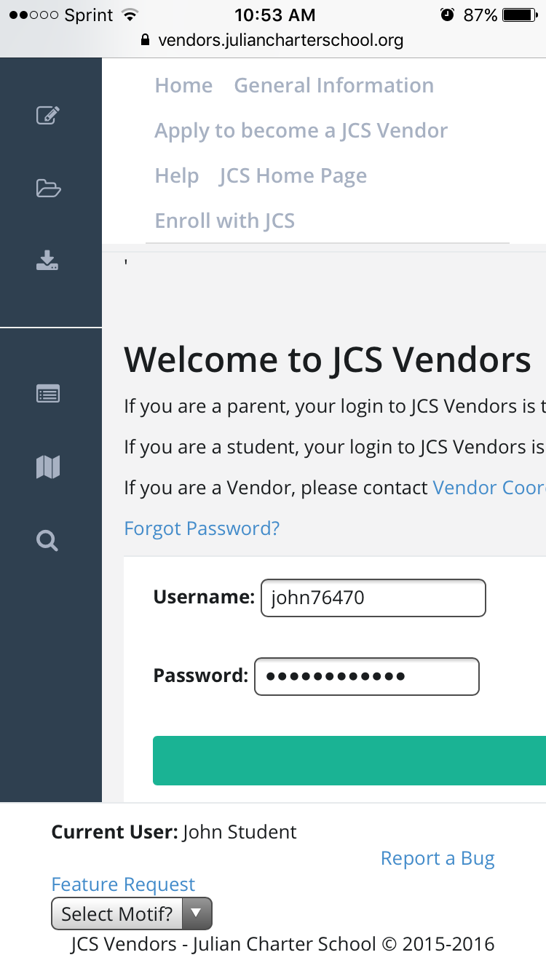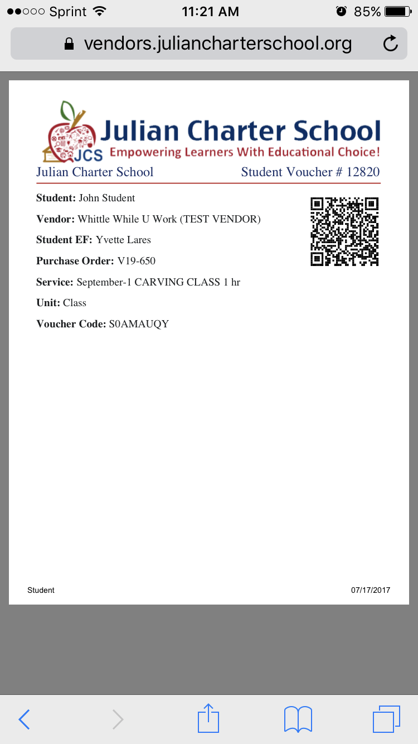

For technical difficulties in obtaining a attendance slip at time of instruction the EEPs may call EEPs Purchasing for assistance.

The PO sent to a EEPs is a contract. If you want to cancel the lessons, please contact the EEPs first and then your EF. JCS does not refund POs where the parent did not contact the EEPs in a timely fashion.

If a EEPs asks you for your purchase order or for their payment, please refer them directly to the JCS Main Office for help. For direct assistance for purchase orders contact the EEPs Purchasing Department at (760) 765-5500 ext. 101047 [EEPspurchasing@juliancharterschool.org](mailto:vendorpurchasing@juliancharterschool.org).

### Online Individual Student Subscriptions/Classes:

When placing a request that requires login information to be sent to the student or the teacher, enter the contact information where the company will send the login information. In the **Notes** section of the request, include the login information as well as any special ordering instructions that may be listed for the specific EEPs. Check your email ‘junk’ folders if you don’t receive the login information.

# EMR Ordering (Educational Material Resources)

All educational materials are processed through the Resource Center for inventory and check out. Each student has a 50-item limit which includes items checked out from the RC and any items received from special EMR orders (home study students only). All resources must be returned or renewed by your EF by the end of the current school year. Resources that are lost or damaged must be replaced; contact your EF for more information. Items purchased using EMR/EUs are property of JCS and must be returned, unless marked consumable.

Ordering can be challenging at times. Contact your EF for help as needed. There is a lot of necessary information, including item numbers or ISBN numbers for book orders, URLs, and descriptions that are needed to ensure your order is placed correctly. If you have any additional information that would help in placing the order, please include it in the **Notes** section. Not sure if an item is allowed? Check with your EF. EMR orders may not be placed for non-secular materials and items that are on the [No Purchase Chart](https://docs.google.com/document/d/1hYzzs4aIl5CANiCSUKlu9yUVA2iUZdWLMMpNjtyJZsU/edit?usp=sharing). Some items require prior approval by an AD, including items that are in excess of $100.00. Please also review the *Guidelines for Selecting Educational Materials/EMR Policy and Procedure*, provided by your EF.

Click on the Select EEPs drop down menu to review the EEPss, and then select the EEPs.

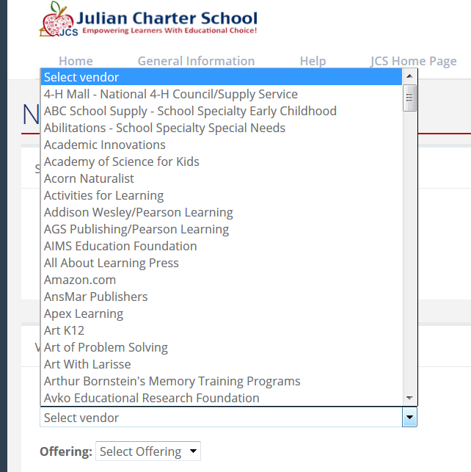

Once you have selected the correct EEPs Name, go to Offering and select EMR Request Offering for EMR orders.

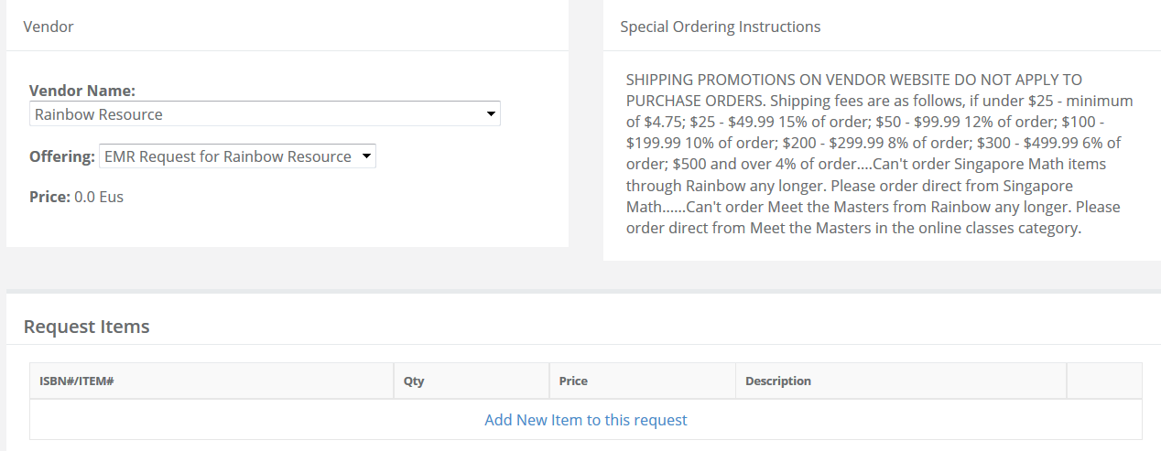

Click Add New Item to this request to begin adding the items you are requesting from this EMR EEPs. Be sure to include all requests for the same EEPs on the same request. If you have request for a different EEPs, then you will create a brand new request.

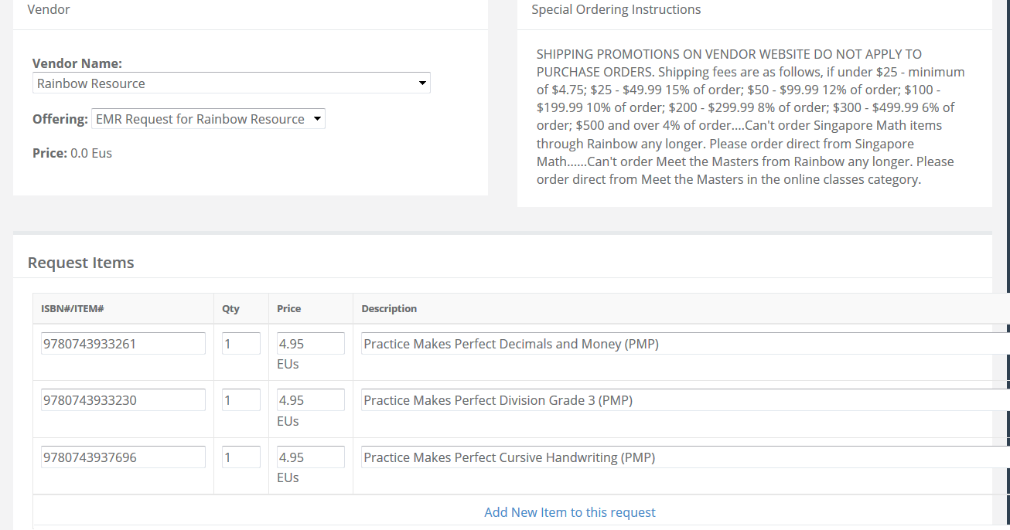

Enter any notes that will help your EF determine the need for the item. Enter any tax or shipping information, as found in the Special Ordering Instructions for the specific EMR EEPs. Click on recalculate, then click **SAVE**. Once you click save, the request will be sent to your EF for review. 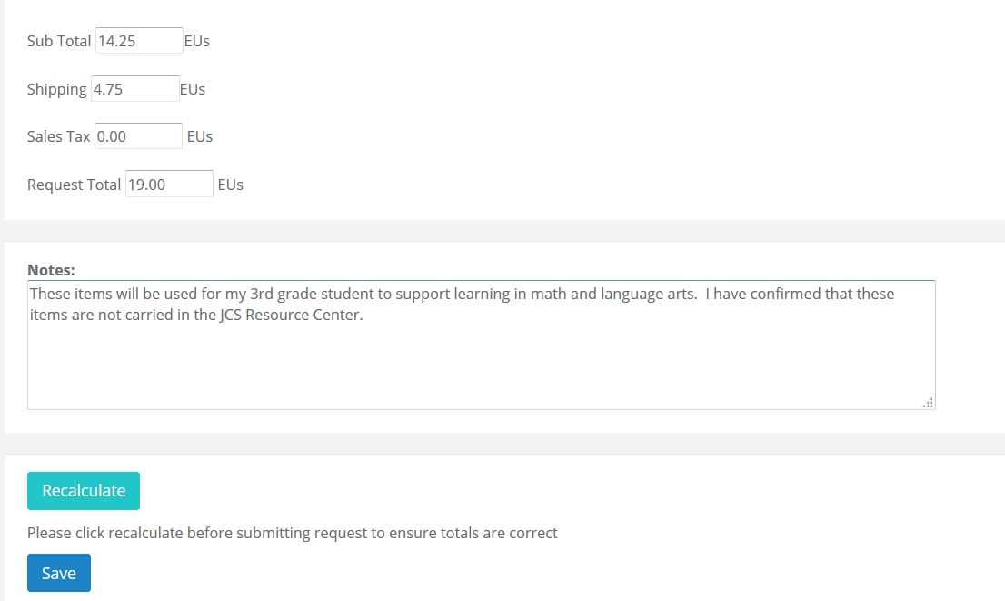

If you have made a mistake, you can edit the request. Remember to include ALL items from one EEPs on the same request. You do this by clicking ADD ITEM TO REQUEST, which creates an additional line for you to add more items for the SAME EEPs.



The second option for creating a REQUEST is to browse the EEPss first to decide what you would like to order. Click on *EEPss by Category* or *EEPss Near You* from the left side menu.

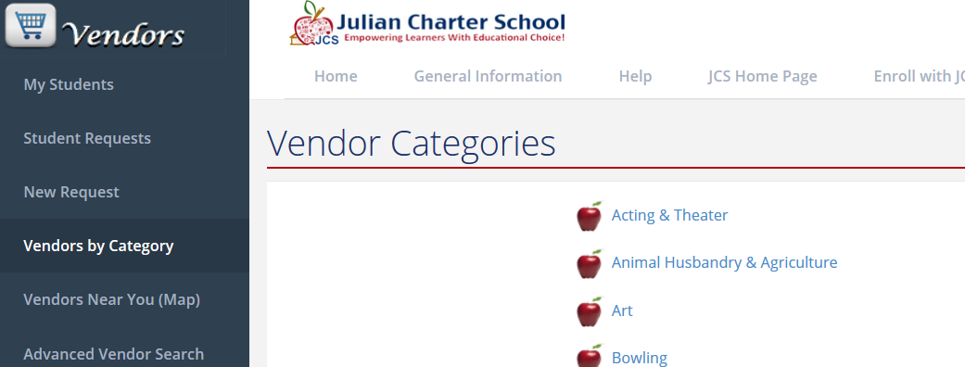

For EMR orders, scroll down until you see:



***(Refer to the EEP section and follow those directions when making a EEP order).***

Find the EMR EEPs from which you want to order a material:

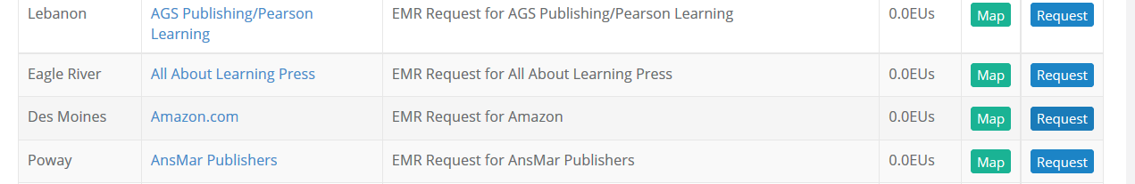

Click on the EMR icon from the EEPs ordering screen and ensure there are sufficient funds to order.

Select the EMR EEPs from the offering from the drop down menu. Review the *Special Ordering Instructions* very carefully. Type in the ITEM and, if applicable, SKU numbers, the quantity, the price and the description. Click on **Add New Item** to the request to add your next item. Add all of the requested items from that EEPs to the order and review for accuracy.

Add shipping costs as noted in the special ordering instructions for each EEPs. Different EEPss have different shipping costs. For more information on combining shipping for siblings, see EMR Shipping Fees and Siblings. If a EEPs charges JCS shipping, the rate is noted in the Special Ordering Instructions. If there is no shipping fee noted, you need not put anything in the shipping box.

**Sales tax is automatically calculated and added to the request as appropriate for that EEPs. Do not manually add tax.**

Once you have entered all the information requested, click the **Save** button.

### No Purchase Chart:

Contact your EF regarding items that are not available for order with EMR funds. Your EF has a comprehensive list of materials.

### AMAZON.COM:

When you copy a URL, be sure to copy the entire address (in the image below is the URL -- the highlighted blue portfolio -- this is what you want to copy and paste into the requisition).

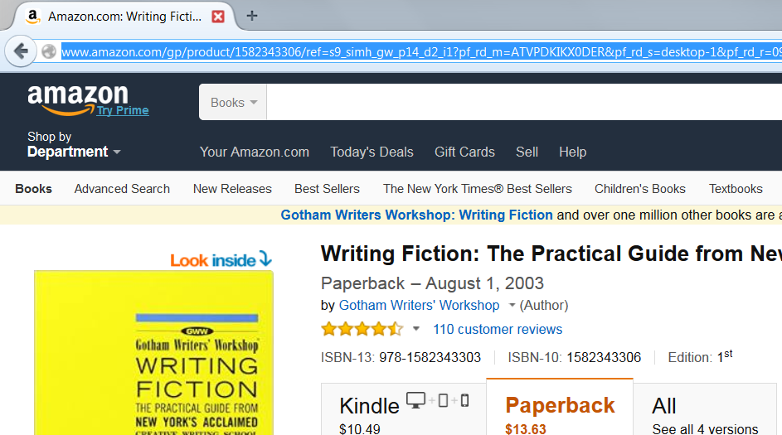

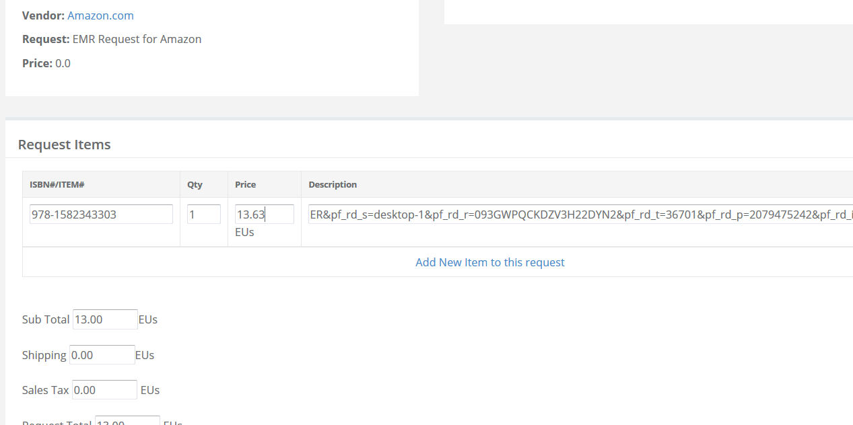

To find the ISBN #, scroll down the Amazon.com page to product details. Select the first ISBN listed.

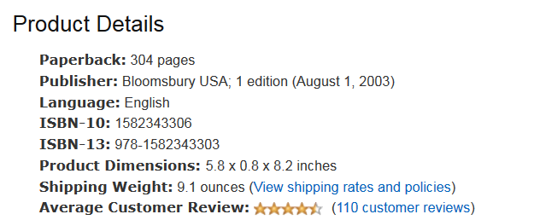

JCS does not order from third party EEPss from within Amazon.com. Below is an example of a third party. The book might be less expensive, but these sellers are not reliable and often times the product is no longer available at the reduced rate once the request has been received.

On the product screen, a third-party EEPs will look like this:

Look for who it is *sold by* not *fulfilled by*, and if it doesn’t say it’s *sold by* Amazon, then it is a third-party EEPs as well. Example shown is *sold by* NetRush and is a third-party EEPs.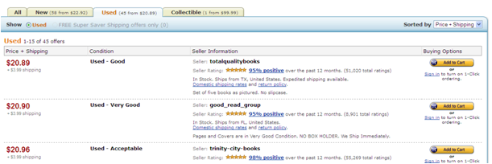

JCS has an Amazon Prime membership. https://lh5.googleusercontent.com/rNSLDa0dj2eFiqukHUXonRqjfb2H2aZgV0vthbP-Qqj5O4CtX2Oa0wWnqLNMRIqgJowRBtYrNd10g2Y0equ0gcVScglJtnVSK7UWWRBEyHvMoAGlSwKpVXDOAny items with Prime logo will qualify for free shipping even if your order is below $35. Items without the Prime logo must add up to $35+ to receive free shipping. As with any order, be sure to review the specific details for shipping and tax prior to approving the request.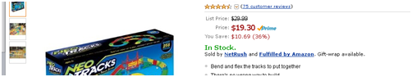

### EMR Shipping Fees and Siblings:

EEPss issue their own shipping prices. JCS does not have special shipping discounts, but you do have some options for combining shipping if you have more than one child. The EEPs will usually give special instructions or a code for discounted or free shipping. This information and the price must be in the **Notes** section of the request or normal shipping rates will be applied. If a different type or carrier is wanted, then that must be in the **Notes** section with the price.

Sibling orders can be combined on the Purchasing end to save on shipping. All individual EMR requests must be received at the same time and must say in the **Notes** section of **EACH** request that the requests are to be combined and the names of each sibling.  The shipping fees can be applied over each student or charged all to one – according to how you specify it in the **Notes** section of the request.

**Note:** JCS does not usually qualify for promotional FREE shipping or discounted shipping. If you’re looking at the EEPs’s website and they are advertising a special shipping rate, please check the fine print. **Usually orders by purchase order do not qualify for the reduced or free shipping**. If we do qualify for the promotional shipping rate, you must enter any codes, contacts or special instructions to receive the promotional shipping rate in the **Notes** section of the request.

### Ordering Live Specimen:

Live specimen are ordered on a separate request and are shipped directly to the student. You must put the address you want the items to go to in the **Notes** section of the request and note that the order is a direct ship to student (see “Direct Ship to Student”).

**The RC must be notified by parent or EF within 30 days of PO creation that the order has not arrived or JCS is not responsible to reorder or reissue EMR funds. If the RC is not notified, they will assume the family has received their item and mark the item(s) received.**

### Direct Ship to Student:

In addition to live specimen, Little Passports have consumable items shipped monthly to the student under a subscription and should bypass the RC. If you would like to know if your item can be shipped directly to the student and it is not a live specimen or Little Passports, please contact the RC to see if it is okay to ship direct to the student or not. If your item is to be shipped directly to the student, put the name and address you want the items to go to in the **Notes** section of the request and note that the order is a direct ship to student. Your order will be delayed if your address is not added in the note section.

**The RC must be notified by parent or EF within 30 days of PO creation that the order has not arrived or JCS is not responsible to reorder or reissue EMR funds.**

### No Pick up of EMR at EEPs’s Place of Business:

All orders must be sent via purchase order to the EEPs and shipped to the RC for inventory *before* being sent to the student. Some orders are actually direct ship. Do not put items on hold at a store and request a purchase order be sent.

### Order Status:

You can easily view the status of your student(s) orders when you are logged in to the EEPs system. If you have any questions, please contact your EF.

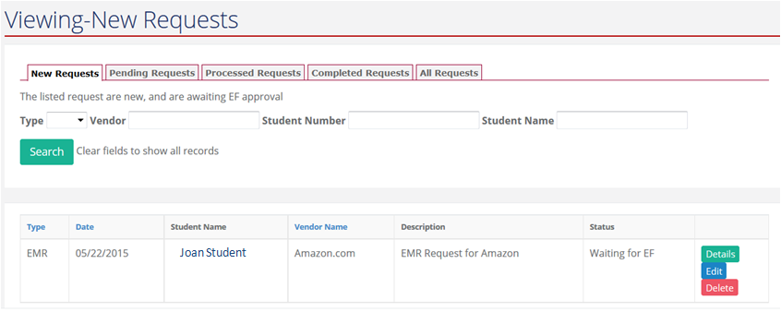

### Events and Sign Me Up (Field Trips):

Learning center classes, academy classes for non-academy students, and JCS distributed online licenses (such as Rosetta Stone) are ordered through the Events program, not the EEPss program. See “Events and Sign Me Up (Field Trips) - Refunds” for more information. www.**jcsfieldtrips.com**

Note:  Field Trips cannot be paid by student EU’s and must be paid by either PayPal or a check.

# Refunds

Once a PO # has been assigned to a request, you must contact your EF immediately if you decide to cancel this request.

### EEP – Refunds:

To receive a refund from a EEPs for lessons that the student is not going to use, contact the EEPs that you wish to cancel **as soon as possible and before the lesson is taught**. The EEPs is allowed to bill for lessons on the PO missed by the student without prior communication. Any paid lessons, attended or not, will not be refunded to the student’s budget account. **Changes cannot be made after ordering has closed for the year.**

Please contact EEPss before you request a PO for classes so you know the EEPs’s policies and schedule.

### EMR – Refunds:

If a EEPs cancels an item on a purchase order, the funds will be returned to the student’s budget account. If an item is received by the Resource Center that is deemed to be on the “No Purchase” chart or is non-secular in nature, it will be returned to the EEPs and the funds returned to the student’s account.

### Events and Sign Me Up (Field Trips) – Refunds:

Review the Events at www.**jcsfieldtrips.com** (such as Learning Center classes, and field trips) for costs and to place orders. In the event that the “event” is canceled or dropped, the cancelled registration in the Sign Me Up program will automatically result in a refund to the student’s budget account, if the registration originally resulted in an automatic debit to the student’s budget account.

**Note**: JCS Field Trips are paid in advance and do not pull funds from the student’s EUs. Pay by PayPal or a check. A refund request cannot be granted once the initial field trip registration deadline expires. If the cancellation is before the initial field trip registration deadline, the refund will be paid via PayPal or check. In the event a reservation must be cancelled, please contact the Field Trip Coordinator immediately so another student can participate.

### Materials Reimbursement Form for Concurrent College Enrollment:

Pertains only to students who have been approved by the Executive Director or High School Counselor to attend a concurrent college class. JCS reimburses for college books providing the required items are turned in *within 60 days* of the end of the semester. Return books to the Resource Center including a copy of passing grades, original receipts, and completed material reimbursement form. If there are no receipts, no refund will be issued. Please contact your EF for the Materials Reimbursement form.

Note:  EU’s cannot be used to purchase college class materials.