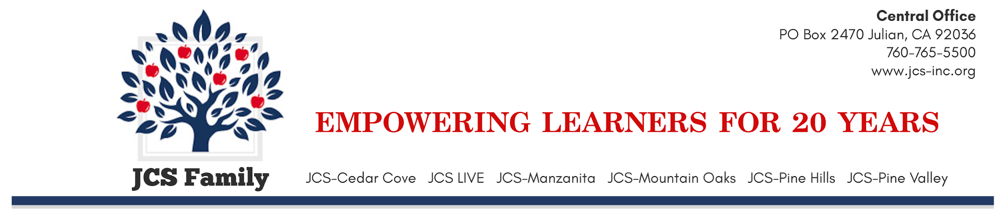
JCS-Inc.
2022-2023 RELEASE FORM FOR DIRECTORY INFORMATION
(Applicable Only for the Current School Year)
Parents: Please read and complete the information below and return it to your school principal or academy coordinator.
Student Name: __________________________________________ Date of Birth: ________________

Address: _______________________________________________

City: ____________________________________ ZIP Code: ___________________

Telephone: _______________________________ Grade: _____________________

School: __________________________________________________

The primary purpose of directory information is to allow the JCS-Inc. to include this type of information from your child’s education records in certain school publications. Directory information includes the pupil’s name, address, telephone number, date of birth, e-mail address, major field of study, participation in officially recognized activities and sports, dates of attendance, degrees and awards received, and the most recent previous public or private school attended by the pupil, or height and weight of athletes, information that is generally not considered harmful or an invasion of privacy released.
The Family Education Rights and Privacy Act (FERPA) and Education Code section 49073 permits JCS-Inc. to disclose appropriately designated “directory information” without written consent, unless you have advised JCS-Inc. that you do not want your student’s directory information disclosed without your prior written consent.

Student Directory Information
❑ I do not wish to have any directory information released to any individual or organization.
❑ I do not wish to release the name, address and telephone number of the student names above to the agencies I check below.
❑ PTA (if applicable)
❑ Health Department
❑ Elected Officials
❑ Third Party Providers of Online Educational Tools (Used within the classroom for educational purposes only.)
❑ United States Armed Forces*
❑ Universities or Other Institutions or Higher Education*

❑ I am a homeless and unaccompanied youth over the age of 14, or am a parent of a homeless and unaccompanied youth and authorize the release of my directory information in accordance with the law and JCS-Inc. policy.

Media Release
❑ The student may be interviewed, photographed, or filmed by members of the media.
❑ The student may NOT be interviewed, photographed, or filmed by members of the media.

____________________________________ __________________
Signature of Parent/Guardian (if student is under 18) Date

___________________________________ __________________
Signature of Student (if student is 18 or older) Date

____________________________________ __________________
Signature of Student (if over age of 14 and homeless Date
and unaccompanied youth)

