 | Knowledge Base

How to Register
a JCS-Inc. Educational Enrichment Partner

The following instructions are for new and returning JCS-Inc. Educational Enrichment Partners who need to complete the registration process annually. This includes supplying all the necessary paperwork, filled out completely.

- To begin, login to the JCS-Inc. Educational Enrichment Partner page using the username and temporary password in your email. If you do not remember your password select 'Forgot Password?' and a password reset will be sent to the email on file.
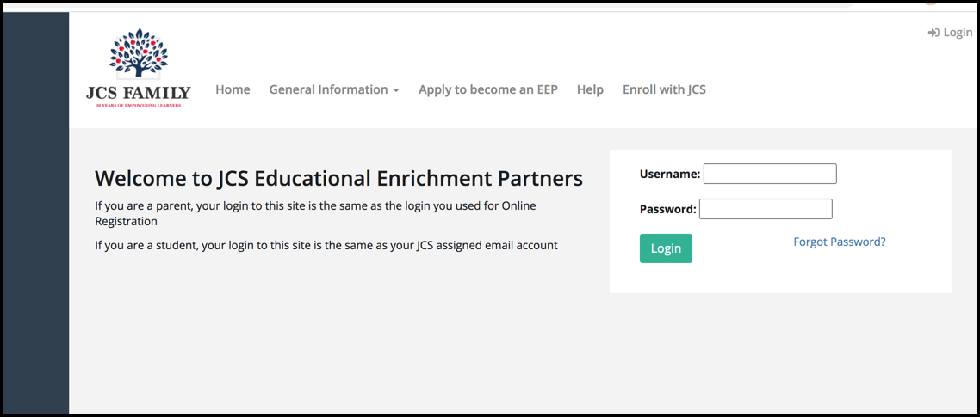
- Once you log in you'll see all the instructions needed to complete registration.
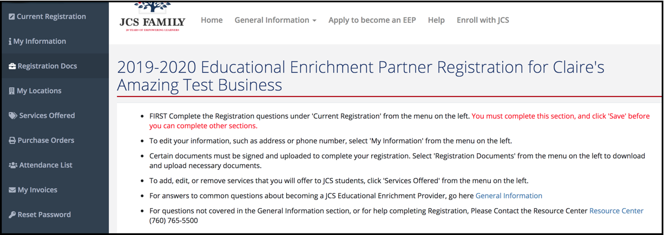
- Review your answers to the Acknowledgements. Make sure to select SAVE before moving on to another page. TIP: The Registration process isn’t interactive, you will need to select each tab in the Right column to progress through the registration.
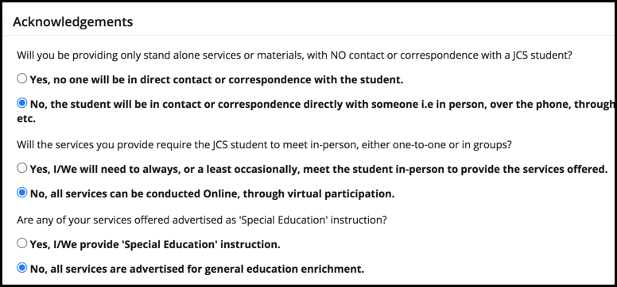
- Answer the Current Registration questions listed. These can be found by scrolling down under the main directions. You must complete each section. If it is not applicable please mark "N/A." If you do not answer each of these your registration will not be complete.
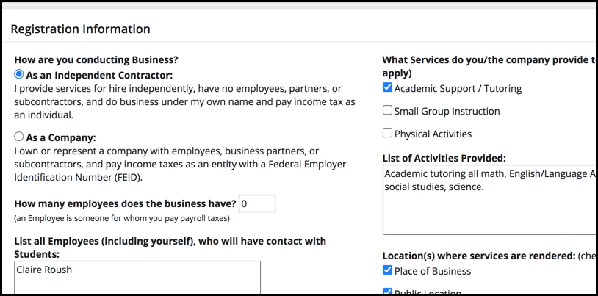
- Review your information under 'My Information' to verify accuracy.
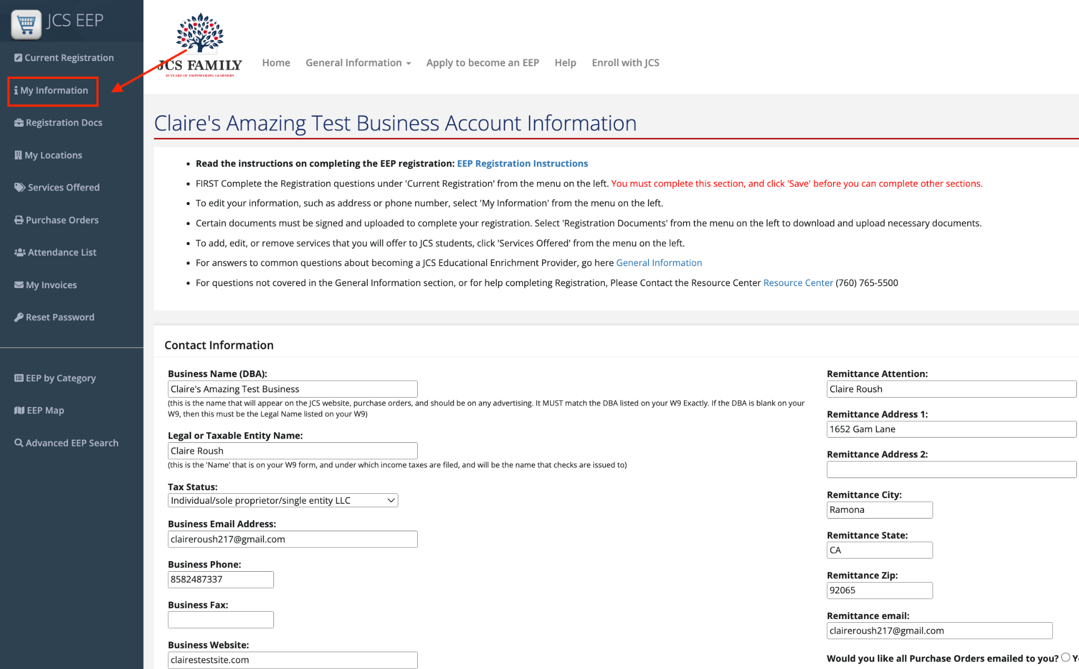
- Go to 'My Locations' to complete all locations your business will be providing services to students. If you have more than one location you can select the 'Add Another Location' button for each location. Make sure to select SAVE before moving on to another page.
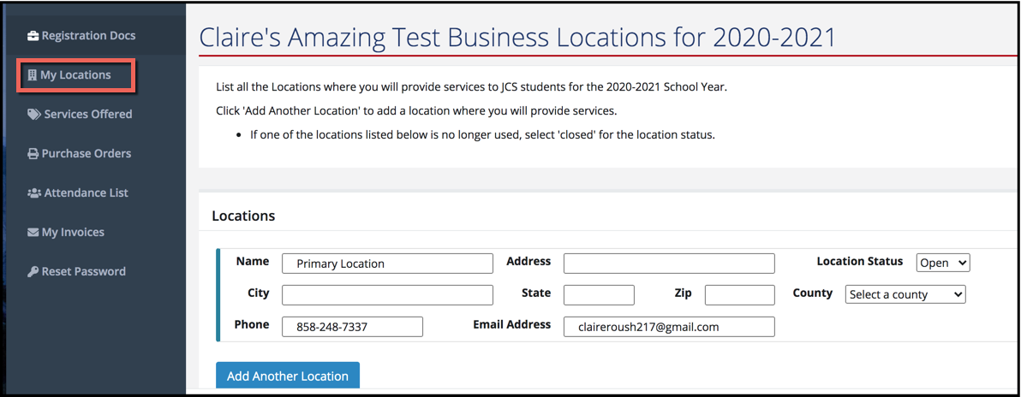
- Complete Services Offered section. Select 'Add a New Service' for each additional service you offer. If you are unsure how to list your service offerings please refer to the FAQs for Education Enrichment Partners: EEP FAQs.
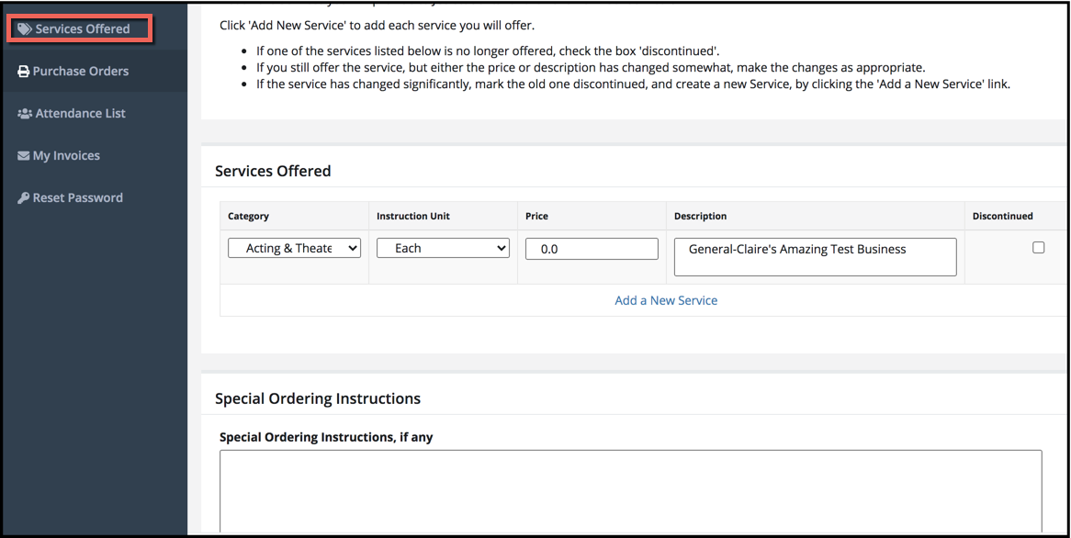

- Go to 'Registration Docs' and then download each of the documents needed to complete the registration process. *TIP: The EEP Agreement is not complete without the Fee Schedule page. Complete the Services Offered tab before signing and uploading the EEP Agreement.
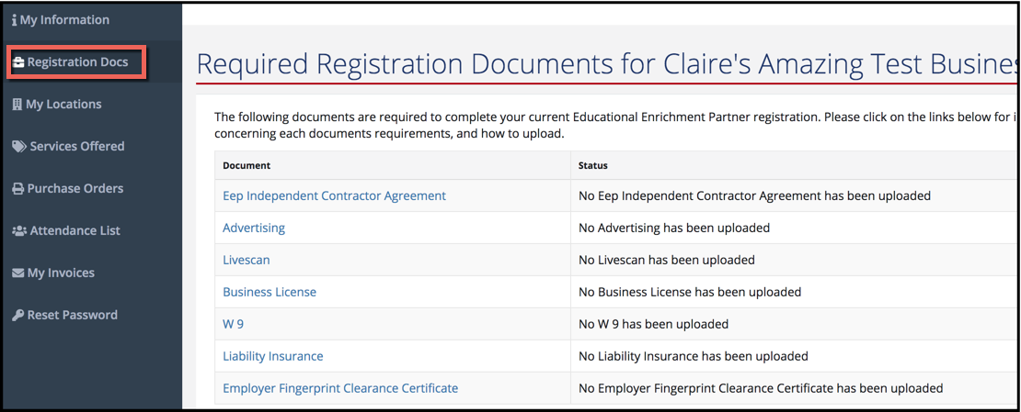
- When you click on one of the documents it will direct you to a page with: 1) instructions for how to complete the document; 2) a button to download it; and 3) a button to upload it once you have completed it. NOTE: To ensure your documents are readable please save them as PDFs. Saving them in the JPG format often causes errors in our system, which will delay completion of your registration. *TIP: Each file should include all pages in one file. Uploading each page individually will delay the approval process.
Make sure to select SAVE before moving on to another page.
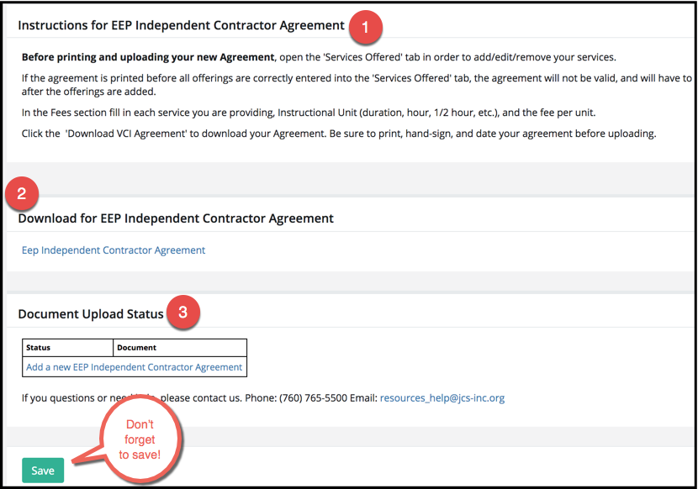
An example of how each document should be completed can be found in this table:
Individual/Sole Proprietor | Business
EEP Independent Contractor Agreement | EEP Company Contractor Agreement
Advertising | Advertising
LiveScan | LiveScan and Employer Fingerprint Clearance Certificate
Business License or Business License Waiver | Business License or Business License Waiver
W-9 | W-9
Liability Insurance or Liability Insurance Waiver | Liability Insurance or Liability Insurance Waiver
-- | Workers Compensation Insurance

- Complete this process for each of the registration documents. When you have finished each of them you'll see a message that you've uploaded the documents and they're pending approval.
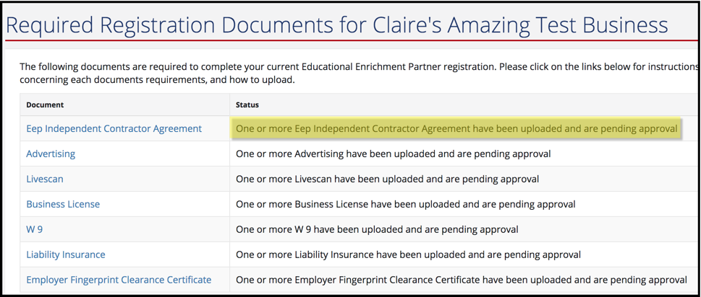
- Once you have completed all of the sections listed above a Resource Center staff member will review your registration and all the documents for accuracy. If any clarification is needed you will be contacted, and if you have any documents that have not been uploaded or have not been filled out completely you will receive an email.

