|  | **Knowledge Base** |
| --- | --- |

| **How to Apply to Become**  **a JCS-Inc. Educational Enrichment Partner** | |
| --- | --- |

*The following instructions are for businesses who wish to become JCS-Inc. Educational Enrichment Partners and would like to complete the application process.*

1. Go to the [JCS-Inc. Educational Enrichment Partner page](https://vendors.jcs-inc.org/) and select 'Apply to become an EEP' from the top.  
   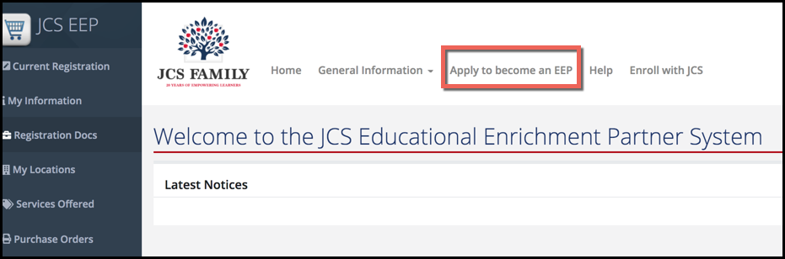
2. Complete the initial information and acknowledgements to begin your application. Once you have completed this step a JCS-Inc. employee will review your initial application and send you an email to begin the registration process. In some cases, someone may call you first to clarify information you entered on the application/acknowledgement page.  
   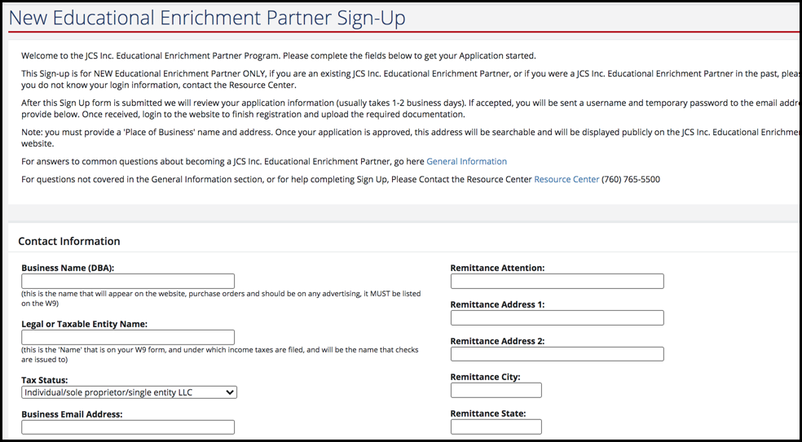
3. You'll receive the email to begin the registration process which will include your login information. You'll then log back in to the [JCS-Inc. Educational Enrichment Partner page](https://vendors.jcs-inc.org/)using the username and temporary password in your email.  
   