High School and Middle School – Registering for CMS (Specialist) Courses and adding PLS courses

Updated 2023-24

EF Guide to Adding CMS/LMS Courses School Pathways: 1

Adding Middle School LMS (core courses - see Curriculum Maps below) 3

Adding Middle School LMS/Canvas Mentor Classes 3

Work Experience Education (WEE) 3

Adding a PLS Course (elective course, portfolio course) 5

**Adding a PORTFOLIO Course 7**

**Adding a Community College Course (PLS Courses)/Dual Enrollment 7**

**Adding an Online Course (i.e., Odysseware or BYU) when THEY issue the grade 8**

What happens if you made an error adding the PLS or the CMS? 10

Fill out a Course Removal here: 10

Recordings:

[CMS - adding specialist classes](https://drive.google.com/file/d/1HEUgJN2HBBLybk3YPSl_TSsGDDgeuOcA/view?usp=sharing)

[PLS - adding classes](https://drive.google.com/file/d/15Sf-3LQU7VN-nwPE0nlPSWRKxDd-Pju8/view?usp=sharing)

For the 2023-24 school year, you will register for all CMS/LMS courses (taken with a specialist) in your school. EFs: You will **NOT** add any **CORE** PLS course [except Portfolio] to the MA. Remember to add BYU, dual college or community college, and online courses as well (see directions below).

_ _ _ _ _ _ _ _ _ _ _ _ _ _ _ _ _ _ _ _ _ _ _ _ _ _ _ _ _ _ _ _ _ _ _ _ _ _ _ _ _ _ _ _ _ _ _ _ _ _ _ _ _ _ _ _ _ _ _ _ _

## EF Guide to Adding CMS/LMS Courses School Pathways:

From your student roster in SP, click on the arrow next to the student:

Click on the Links tab.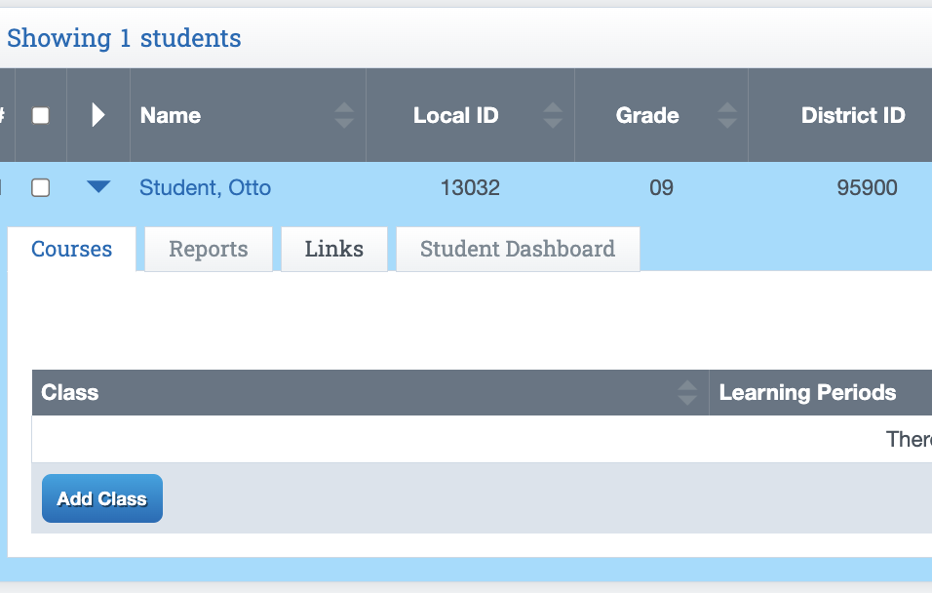



Click on Manual Reg



For EFs and INSITE teachers (not INSITE Portfolio). Click on the arrow for Program and choose **the HIGH SCHOOL PROGRAM (9-12) for your school** (make sure to do this step FIRST). Update Registration Window to **HIGH SCHOOL 2020**  (or Spring 2021 when you add Spring classes). Each school has a specific registration window - it is important that you select the correct one.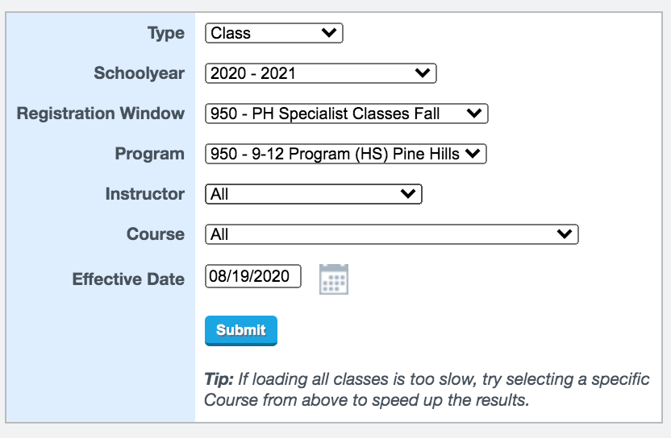

**(Note: the effective date – first date of the semester OR the first date the student will begin the course). Then, click Submit. If they student has started other than the first date of the semester, you must enter the actual start date under ENTER DATE so that it will be accurate. Leave the exit date blank.**

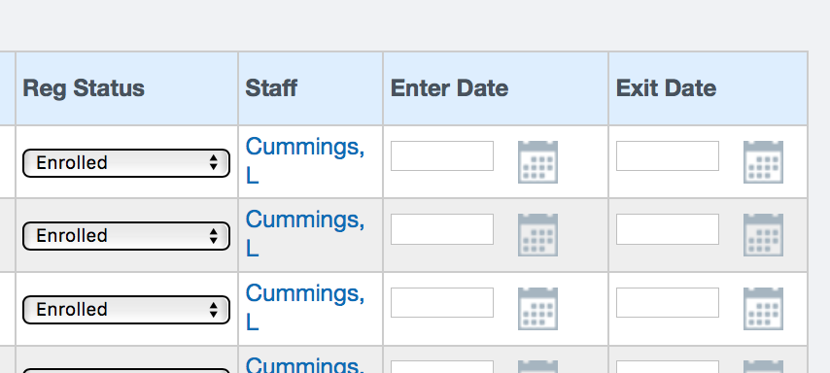

Scroll down and find the course(s) for which you want to register. You can check multiple courses at one time.

Do not choose classes with a J in front of them unless you are a middle school teacher. It is important that you spend extra time ensuring you have selected the correct section. Once you’ve selected the courses, click SAVE ENROLLMENTS.

### Adding Middle School LMS (core courses - see Curriculum Maps below)

For student in grades 6, 7, 8 (Middle School), we currently only offer Integrated Math I and II (A first semester and B second semester). These middle school classes begin with a **JH**. A middle school student taking the Integrated Math course should be enrolled in the course with the **J** in the front. Add both Fall and Spring classes (610-Specialists) for students taking Integrated Math I.



### 

### Adding Middle School LMS/Canvas Mentor Classes

**FIRST** select the **Program**, then the **Registration Window**: select drop down menu. Each school will have a home study option for K-8 and (3) mentor classes.

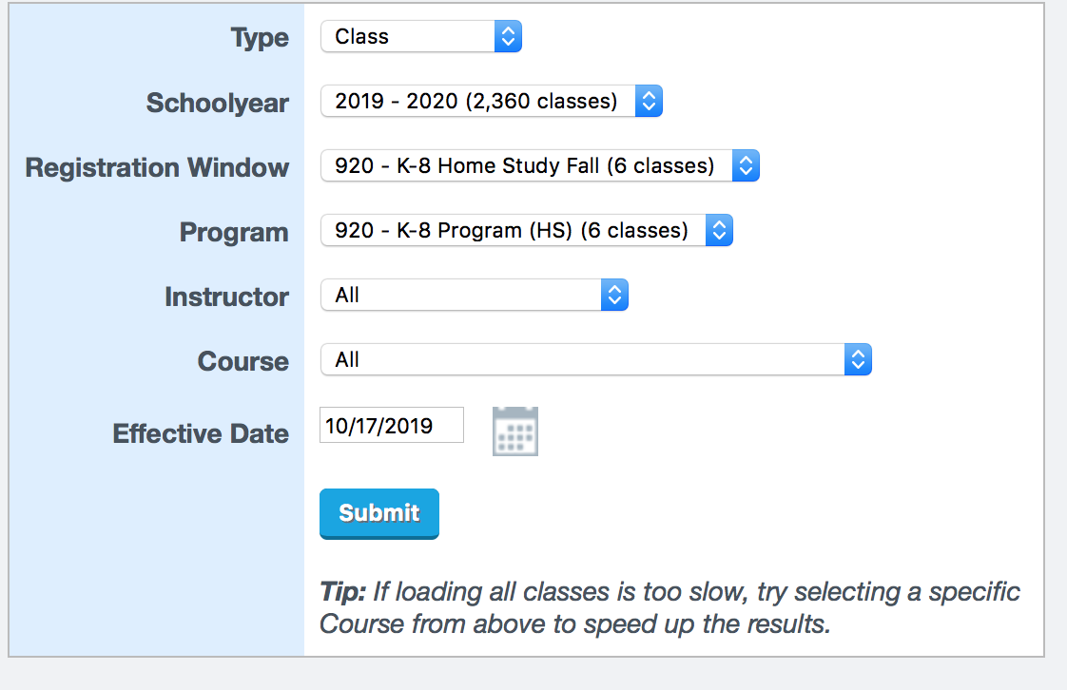

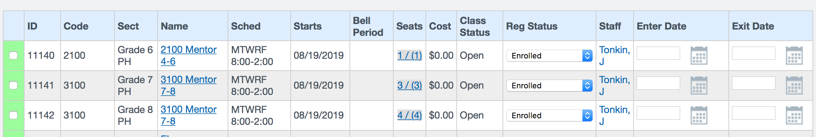

Place a checkmark next to the Mentor class and then click on SAVE ENROLLMENTS at the bottom of the page. This will enroll your student in all of the CMS classes.

### Work Experience Education (WEE)

Select drop down menu **SPECIALISTS (Registration Window) Program SPECIALISTS** (fall for fall and spring for spring). Click Update and scroll down. Select either 11th grade or 12th grade.

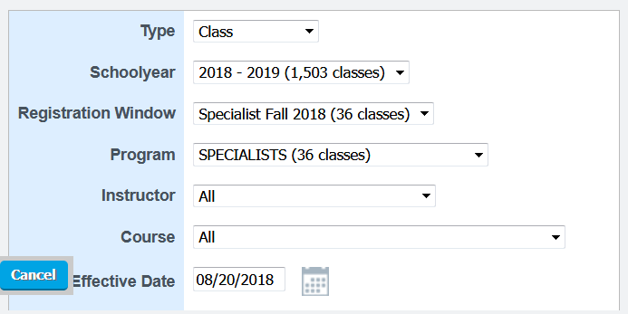

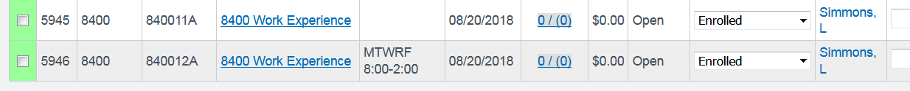

Once you find the course(s) your student is going to take, place a check mark in the box beside it. You can check multiple classes at one. Confirm, carefully, that this is the course you want. Review the check marks carefully before you Set Enrollment Info that you have registered correctly. If you select incorrectly (before you set enrollment information), uncheck the box by clicking on it and find the correct course.

Once you have ensured accuracy of the course(s) you’d like to register your student for, click the Save Enrollments Button. Be sure to only hit the button **ONCE**. Be patient. It might take a few seconds.

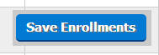

Once you have registered, you will get a message that reads: Registration Successful! in a green box. If you receive an error message, such as “conflicts with other courses” you can still continue. Enter CONFIRM in the box if prompted to do so. Students are now added to the classes and Canvas.

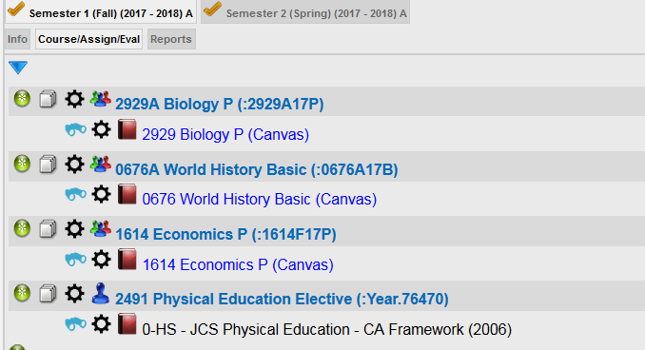

## Adding a PLS Course (elective course, portfolio course)

Note: for a portfolio student, please add the Portfolio designation, and add PLS courses. ALL electives will be added “as normal” in SP. You will make assignments, 4 modules (average) per Learning Period. If you want to send the entire course at one time, see below. Either way, you will always add the electives, PE, VAPA, to the MA, and add assignments each month to the gradebook.

Click on the green circle with the plus sign in it to add a class:

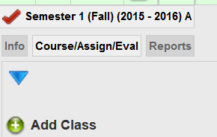

In the course box, enter the course you wish to add:

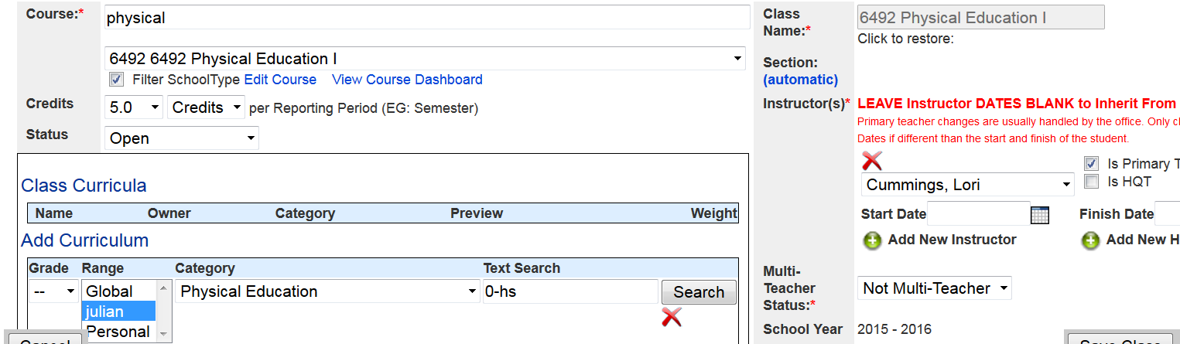

Now, click on the drop down menu to view the options for the course (in this case, Physical Education I):

Select the course you want. If you do not see the course you need, you will need to go back to the Course and enter a different title.

Because it is a high school course, it will automatically add the 5.0 units. If the student is not completing 5 units (for example, if he started the semester late), change the credits to the appropriate number.

Now, add the curriculum. Place a check mark in the box next to the curriculum to add it to the course. Once you have done this, the chosen curricula will appear with a check mark. 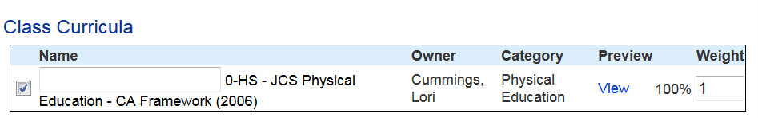

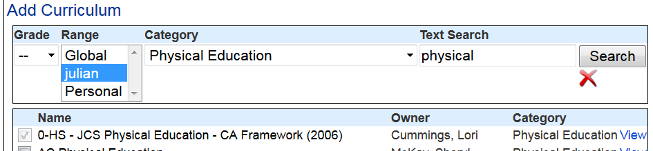

IF YOU WANT TO PRINT THE FULL SEMESTER, CLICK ON **VIEW** UNDER PREVIEW, AND A PDF OF THE WHOLE SEMESTER WILL BE MADE. Remember, you still have to make monthly assignments on the AWR for all elective, PE, and VAPA course.

If you get stuck, try changing the grade to – and look through different categories to find your curriculum. If you cannot find it after a few minutes of searching, contact your principal or designee. Please do not add curriculum that begins with AC or LC (those are academy or old learning center curriculum).

Once you add the curriculum, be sure to check that the course shows up correctly on the right side of the screen. Is the correct course appearing? Are the dates correct? Is the reported on transcript correct? If yes, click on SAVE. If you make a mistake, you can edit the course. If you add the wrong curriculum, uncheck the box and find the one you want.

# Adding a PORTFOLIO Course

Portfolio courses are those that are CORE courses approved by the specialist via a petition. To add a core portfolio course, you will add the PORTFOLIO DESIGNATION (see image) and then you will add each PLS course and include the HQT for your school (HQT =specialist). You will assign curriculum (not specialist curriculum) and collect samples each month for Portfolio students. These students will also present samples to their HQT/Specialist and take the final exam.

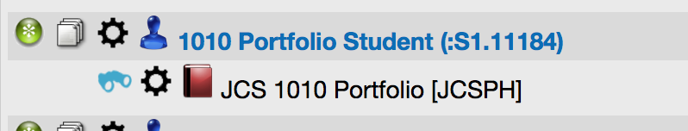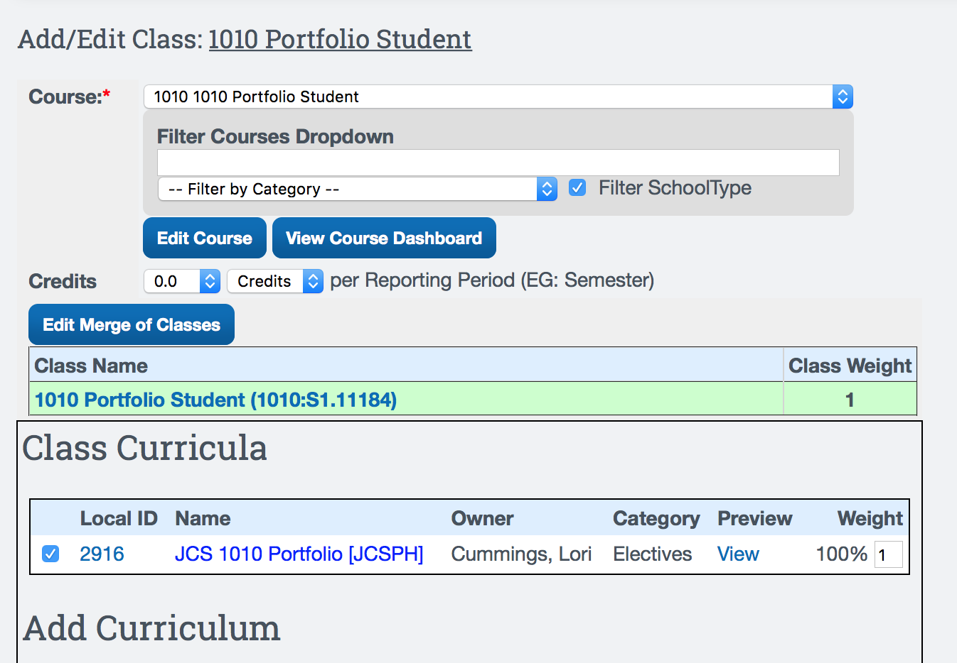

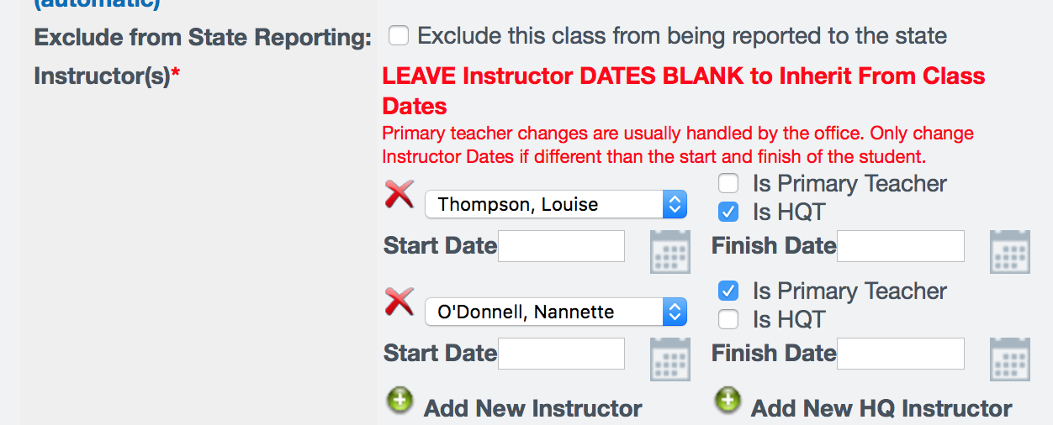

# Adding a Community College Course (PLS Courses)/Dual Enrollment

You will add Community College courses to the Master Agreement, and collect a syllabus from the student. You do not need to make assignments for the class since the CC is issuing the grade. To add a community college class:

Click on Add Class (just like adding any PLS class)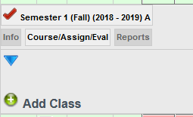

Search for the community college class. If you do not see the correct class, email your principal or designee so s/he can add the class to our catalog: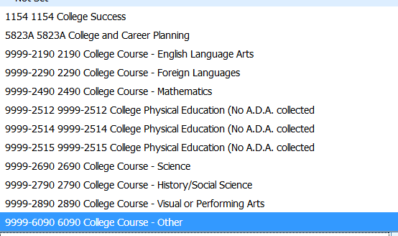

Each community college class will count as 10 units. **Do not hide from the MA or report card. You will add a report card grade for the CC or dual enrollment class.**

Add the curriculum to math the community college class (try college as the search - do not choose AC sections - those are for the Academy):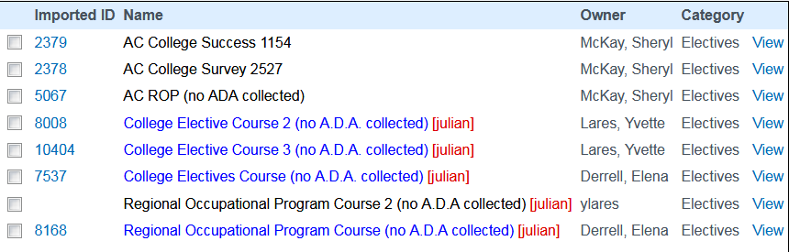

Follow the same directions for adding a PLS class and click on save.

# Adding an Online Course (i.e., Odysseware or BYU) when THEY issue the grade

Click on Add Class (just like adding any PLS class)



Search for Online Class

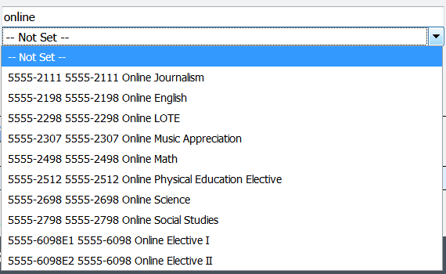

Add online curriculum:

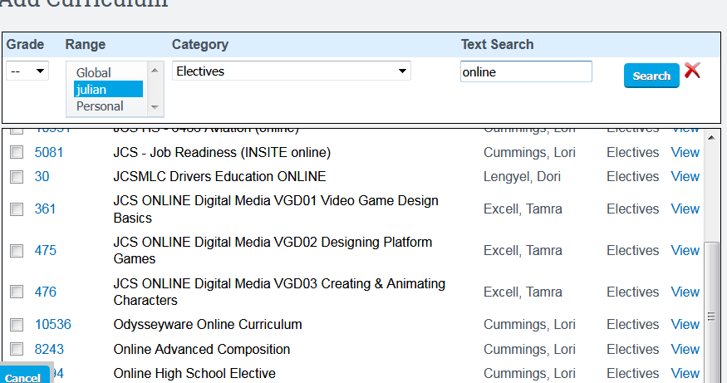

You can collect samples each month just to ensure the student is completing them (you are not required to put these in the paper packets). Odysseyware and BYU will issue the grade for their courses. Hide these from the report card.

Other online classes might have a different scenario (i.e., Drivers Education and Edgenuity) where you will add the grade to the report card because WE are issuing the grade and not the vendor. **For these online classes, you will make assignments AND put samples in the paperwork packet.**

## What happens if you made an error adding the PLS or the CMS?

## Fill out a Course Removal here:

https://portal.juliancharterschool.org/course_removals/new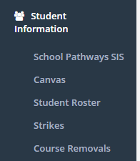

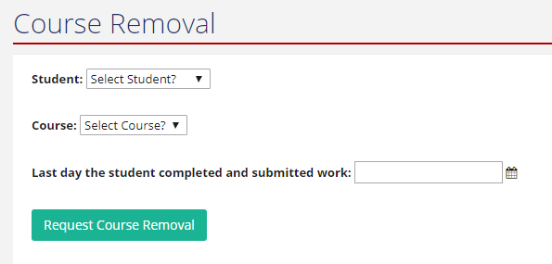

Reminder: a PLS course are the courses YOU add to the Master Agreement, such as electives or PE. The CMS/LMS course is the one you register for (aka Canvas courses).