JCS Comprehensive School Safety Plan
Process & Templates
SY 2018 - 2019
Date of Adoption: September 2017



Preface
The Comprehensive School Safety Plan Process & Templates is designed to be utilized as a school resource for preparedness, prevention, mitigation, response and recovery planning and training. The Plan also serves as a functioning template for meeting the requirements of the annual Safety Plan Process under SB 187 and the National incident Management System. It is designed to be an electronic or hardcopy Safety Plan.
The template is also designed as a living document to be updated as necessary to meet site, district and community needs, forms or requirements.
It is NOT intended to be a “grab and go” guide in an actual emergency.
Table of Contents
Chapter 1 School Safety Plan
Chapter 2 School Safety Planning Committee
Chapter 3 Annual Safety Goals
Chapter 4 Policies & Procedures
Chapter 5 Routine & Emergency Disaster Procedures
Chapter 6 Routine & Emergency Disaster Procedures Overview
Chapter 7 Emergency Response Procedures
Chapter 8 Appendices

Chapter 1
School Safety Plan
Introduction
Individual schools in districts with over 2,500 students must adopt a comprehensive school safety plan by March 1, 2000, and must review and update the plan by March 1 of every year thereafter. (Amended Ed. Codes 35294.1 & 35294.6)
Beginning July 1, 2000, each individual school must report on the status of its school safety plan, including a description of its key elements in the school accountability report card, and must continue to do so every July thereafter (Amended Ed. Code 35294.6)
The following guideline may be utilized to support the annual review and evaluation of the individual school safety plan. This guide will also provide a timeline and related administrative tasks to include a process that ensures compliance with the requirements of Senate Bill 187 - Comprehensive School Safety Plan.

The guideline/checklist has been organized into two parts:
- An assessment by the School Safety Planning Committee of the School Site Council, the School Site Council or equivalent of the school climate in relation to the current status of school crime committed on campus and at school related functions. Based on this assessment, safety goals will be set for the upcoming school year.
- The annual review and evaluation of the school's comprehensive safety plan which is certified by the members of the School Safety Planning Committee, the School Site Council President, and the school Academy Coordinator before being presented to the Board of Trustees for final review and adoption. This review includes the following mandated components of Senate Bill 187:
  - Child Abuse reporting procedures
  - Policies pursuant to Education Code 48915(c) and other school-designated serious acts which would lead to suspension, expulsion, or mandatory expulsion recommendations
  - Procedures to notify teachers and counselors of dangerous students
  - Sexual Harassment Policy
  - Safe ingress and egress to and from school
  - Rules and procedures on school discipline in order to create a safe and orderly environment conducive to learning
  - Dress Code
  - Routine and emergency disaster procedures including natural disasters, human created disasters or power outages.

Implementation of Plan
The written plan may be distributed to all necessary departments and should be made available to all staff, students, parents, and the community to review in the school main offices.

Chapter 2
School Safety Planning Committee
Note: In all references to “school site council,” the Julian Charter School Advisory Council is a suitable substitute.
The school site council is responsible for developing the school site safety plan or for delegating the responsibility to a school safety planning committee. Ed. Code 35294.1
The school site safety committee shall be composed of the following members:
- Principal or designee
- One teacher who is a representative of the recognized certificated employee organization
- One parent/guardian whose child attends the school
- One classified employee who is a representative of the recognized classified employee organization
- Other members if desired. Ed Code 35294.1
Local law enforcement has been consulted (Ed. Code 39294.1) Other local agencies, such as health care and emergency services, may be consulted if desired. (Ed Code 39294.2)
Other members of the school or community may provide valuable insights as members of the School Safety Planning Committee. Additional members may include:
- Representative from the local law enforcement agency
- School Resource Officers
- Guidance counselor
- Special Education Department Chairperson
- One or more key community service providers
- Student representative(s)
- Disciplinary team member
- Staff leaders
- Additional parent representatives
The following template may be utilized as the cover signature sheet:
JCS Pine Valley Safety Plan Signature Page
The undersigned members of the Julian Charter School Advisory Council certify that the requirements for the SB 187 Safety Plan have been met.

________________________________________________________________
Executive Director:
________________________________________________________________ Advisory Council President or Secretary:
________________________________________________________________ Advisory Council Faculty Representative:
________________________________________________________________ Advisory Council Classified Representative:
________________________________________________________________ Advisory Council Parent Representative:
________________________________________________________________
Law Enforcement Representative (Optional):
________________________________________________________________
Other Member (Optional):
________________________________________________________________
Other Member (Optional):

JCS Manzanita Safety Plan Signature Page
The undersigned members of the Julian Charter School Advisory Council certify that the requirements for the SB 187 Safety Plan have been met.

________________________________________________________________
Executive Director:
________________________________________________________________ Advisory Council President or Secretary:
________________________________________________________________ Advisory Council Faculty Representative:
________________________________________________________________ Advisory Council Classified Representative:
________________________________________________________________ Advisory Council Parent Representative:
________________________________________________________________
Law Enforcement Representative (Optional):
________________________________________________________________
Other Member (Optional):
________________________________________________________________
Other Member (Optional):

JCS Pine Hills Safety Plan Signature Page
The undersigned members of the Julian Charter School Advisory Council certify that the requirements for the SB 187 Safety Plan have been met.

________________________________________________________________
Executive Director:
________________________________________________________________ Advisory Council President or Secretary:
________________________________________________________________ Advisory Council Faculty Representative:
________________________________________________________________ Advisory Council Classified Representative:
________________________________________________________________ Advisory Council Parent Representative:
________________________________________________________________
Law Enforcement Representative (Optional):
________________________________________________________________
Other Member (Optional):
________________________________________________________________
Other Member (Optional):

JCS Cedar Cove Safety Plan Signature Page
The undersigned members of the Julian Charter School Advisory Council certify that the requirements for the SB 187 Safety Plan have been met.

________________________________________________________________
Executive Director:
________________________________________________________________ Advisory Council President or Secretary:
________________________________________________________________ Advisory Council Faculty Representative:
________________________________________________________________ Advisory Council Classified Representative:
________________________________________________________________ Advisory Council Parent Representative:
________________________________________________________________
Law Enforcement Representative (Optional):
________________________________________________________________
Other Member (Optional):
________________________________________________________________
Other Member (Optional):

JCS Mountain Oaks Safety Plan Signature Page
The undersigned members of the Julian Charter School Advisory Council certify that the requirements for the SB 187 Safety Plan have been met.

________________________________________________________________
Executive Director:
________________________________________________________________ Advisory Council President or Secretary:
________________________________________________________________ Advisory Council Faculty Representative:
________________________________________________________________ Advisory Council Classified Representative:
________________________________________________________________ Advisory Council Parent Representative:
________________________________________________________________
Law Enforcement Representative (Optional):
________________________________________________________________
Other Member (Optional):
________________________________________________________________
Other Member (Optional):

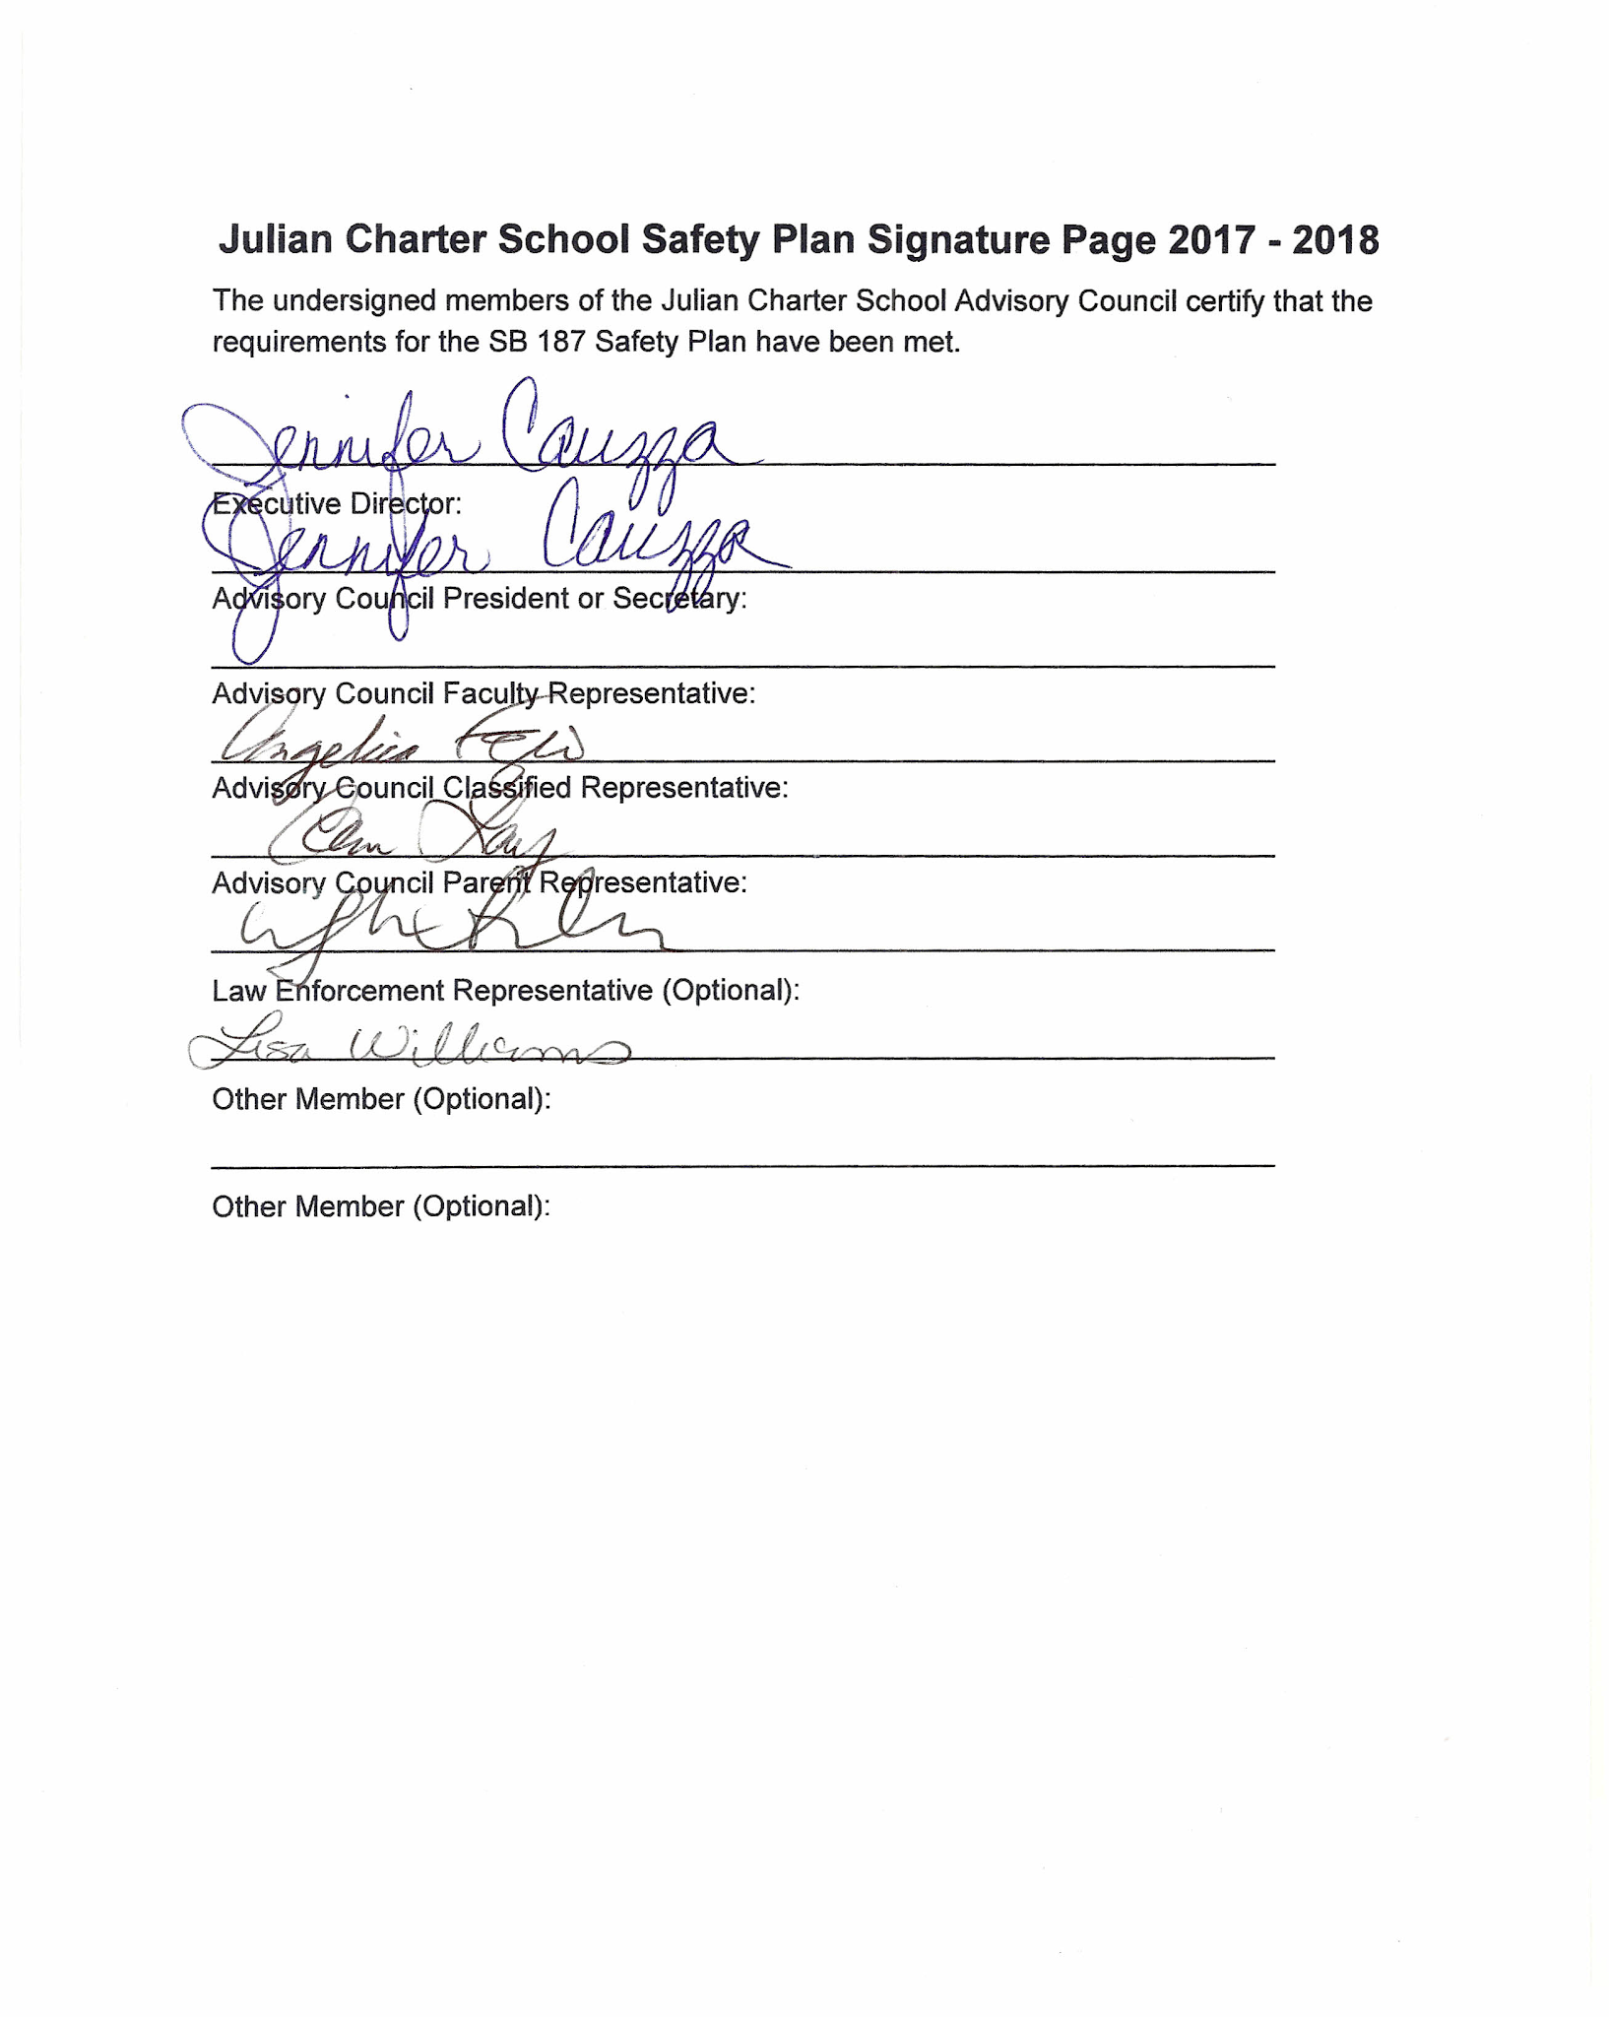

Chapter 3
Annual Safety Goals
The School Safety Planning Committee shall make an assessment of the current status of school crime committed on campus and at school-related functions and of appropriate strategies and programs that will provide or maintain a high level of school safety. (Ed. Code 35924.2)
While the School Safety Planning Committee reviews school and community crime data trends such as the California Safe School Assessment, other data can bring value to the discussions. Such data may include:
• Mental Health Data
• State, Julian Charter School or Site Surveys (i.e. Youth Risk Behavior Survey)
• Disciplinary Data
• Community Police Data
Data may be more valuable if disaggregated by gender, age, zip code, ethnicity, etc. Current trends should be reviewed as well.
Based on data analysis, the School Safety Planning Committee identifies one or two safety-related goals for the next school year as well as the strategies and/or programs that will be used to meet those goals. The objective is to provide meaningful goals in order to improve the campus climate.
The goals are reported, with the Safety Plan, to the Board of Trustees and are shared with the school staff and community.
In order to keep the goals as a safety focus for the school year, it is recommended that at least three brief meetings be held to review data and progress. The progress can be reported to the School Site Council, staff, parent groups and the Board of Trustees.
The year-end assessment should be completed in May and reported upon.
The following templates may be utilized:
Julian Charter School Safety Plan Goals
GOAL 1: Focus on Student and Staff Well-Being and Safety
- Action 1: Provide online training to staff on awareness on key wellness topics such as Bullying (Recognition and Response), Youth Suicide, Online Safety (predators), Boundary Invasion, Mandated Reporter: Child Abuse and Neglect; and Human Trafficking Awareness
  - Strategy 1.1.1: Research and find online tools for staff development and training
  - Strategy 1.1.2: Schedule one training per month to make staff more aware of wellness topics such as Bullying, Suicide Prevention and other student well-being issues in addition to other mandated trainings.
  - Baseline Data 1.1.1: Minimal training completed in the past (i.e. Mandated Reporter training, HR Sexual Harassment, and CPR)
  - Assessment 1.1.1: Document staff completion of trainings
  - Assessment 1.1.2: Data collected by Human Resources

- Action 2: Provide social-emotional training on bullying, harassment, and suicide prevention for students. (LCAP Goal)
  - Baseline Data 1.2: Three serious harassment cases during the SY 2016-2017
  - Strategy 1.2.1: Using a variety of resources (i.e. in-person, books/videos, etc.), provide training for students in grades K-5 on social emotional health.
  - Assessment 1.2.1: Assess data from the number of trainings completed
  - Assessment 1.2.2: Assess data on the number of incidents collected
  - Assessment Data 1.2.1: Comparisons between the training and incidents

- Action 3: Initiate increased safety procedures and prevention.
  - Baseline Data 1.3: Increased number of school shootings nationwide necessitates more vigilant prevention and safety procedures.
  - Strategy 1.3.1: Locks on inside doors for lock down safety
  - Strategy 1.3.2: Install lock blocks on all exterior opening doors
  - Strategy 1.3.3: Create individual lockdown procedures for each location.
  - Assessment 1.3.1: Locks on inside hallway doors installed
  - Assessment 1.3.2: All lock blocks are being used
  - Assessment: 1.3.3: Lockdown procedures written by and for each location
  - Assessment Data 1.3: Action items and strategies reviewed

GOAL 2: Development of a School Safety Planning Committee
- Action 1: Assemble a Safety Team
  - Baseline Data 2.1: Julian Charter School has had a School Site Safety Team for years. During the 2016-2017 school year it was not used because we lost our former Director of Operations mid-year. It will be reinstated during the 2017-2018 year so the school gets back on track.
  - Strategy 2.1: Develop a Safety Planning Team which will include classified or certificated staff from each program location to give insight and input into the Safety Plan.
  - Assessment 2.1: School Safety Meetings reinstated in 2017 to current
  - Assessment 2.2: Safety Meetings include classified/certificated staff feedback and input into the Safety Plan ongoing
  - Assessment 2.3: Action Items from team meetings
- Action 2: Conduct quarterly safety meetings
  - Baseline Data 2.2: Julian Charter School did not have consistent Safety Meetings for a period prior to 2017.
  - Strategy 2.2.1: Schedule three safety meetings per year
  - Assessment 2.2.1: Establish meetings dates/times
  - Assessment 2.2.2: Action items from team meetings

Julian Charter School
Safety Goals Assessment Report/Template

- Safety Plan Goals: status of strategy implementation; data on progress
  - Focus on Student and Staff Well Being and Safety
    - Ongoing assessments and action items
    - Implement the California Healthy Kids Survey (as well as gathering data through the parent and staff surveys as well.)
      - Parent survey - Last November 2017
      - Staff survey - Last November 2017
      - Student survey - Last November 2017
  - Development of School Safety Planning Committee
    - Starting SY 2017-2018, the School Safety Planning Committee will meet three times a year to discuss site safety issues.
    - Meetings scheduled for SY 2017-2019
      - Quarterly Safety Planning Committee Meetings via Zoom
        - Meeting - September 11, 2017 (Complete)
        - Meeting - February 7, 2018 (Complete)
        - Meeting - April 10, 2018 (Complete)
        - Meeting - October 2, 2018 (Complete)
        - Meeting - October 22, 2018
        - Meeting - January 2019 TBD
        - Meeting - March 2019 TBD
        - Meeting - May 2019 TBD
        - Meeting - August 2019 TBD
        - Meeting - October 2019 TBD
        - Meeting - January 2020 TBD
        - Meeting - March 2020 TBD
        - Meeting - May 2020 TBD
  - Review of Additional Data, Climate Reports
    - Data Shared
    - Trends Noted
    - Action items
    - Other Topics of Discussion

Chapter 4

Policies and Procedures
The School Safety Planning Committee has reviewed the site safety plan and made necessary updates and revision. The safety plan must include the following components: (Ed Code 35294.2)
- Child abuse reporting consistent with Penal Code 11164.
- Policies pursuant to Education Code 48915 and other school-designated serious acts which would lead to suspension, expulsion or mandatory expulsion recommendations.
- Procedures to notify teachers and counselors (amended Welfare and Institutions Code 827) of dangerous students pursuant to Education Code 49079.
- A sexual harassment policy pursuant to Education Code 212.6
- Procedures for safe entrance and exit of students, parents/guardians and employees to and from the school
- The rules and procedures on school discipline adopted pursuant to Education Code 35291 and 35291.5 (5411-discipline) in order to create a safe and orderly environment conducive to learning at school.
- If the school has adopted a dress code prohibiting students from wearing “gang related apparel,” the provisions of that dress code.
- Routine and Emergency Disaster Procedures that include:
  - • Emergency and Disaster Preparedness Plan
  - • Fire Drills
  - • Bomb Threats
  - • Earthquake Emergency Procedure System
  - • Transportation Safety and Emergencies

As the team reviews the following mandated components, critical questions to review include:
- What is the policy or procedure?
- How are staff, students and/or parents notified that this policy exists?
- How are staff, students and/or parents notified relative to a specific incident?
- What staff/student training(s) have been completed?
- What additional trainings are needed?
Child Abuse Reporting
A. Definition of Child Abuse
Child abuse means a physical injury that is inflicted by other than accidental on a child by another person. Child Abuse also means the sexual abuse of a child or any act or omission pertaining to child abuse reporting laws (willful cruelty, unjustifiable punishment of a child, unlawful corporal punishment or injury). Child abuse also means the physical or emotional neglect of a child or abuse in out-of-home care.
- Child Abuse
  - Injury inflicted by another person.
  - Sexual Abuse.
  - Neglect of child's physical, health, and emotional needs.
  - Unusual and willful cruelty; unjustifiable punishment.
  - Unlawful corporal punishment.
- Not Considered Child Abuse
  - Mutual affray between minors
  - Injury caused by reasonable and necessary force used by a peace
  - officer:
    - To quell a disturbance threatening physical injury to a person or damage property
    - To prevent physical injury to another person or damage to property
    - For the purposes of self-defense
    - To obtain possession of weapons or other dangerous objects within the control of a child
    - To apprehend an escapee
B. Mandated Child Abuse Reporting
- Mandated child abuse reporting is governed by the Child Abuse and Neglect Reporting Act, P.C. 11164.
- Any child care custodian, healthcare practitioner, or employee of a child protective agency who has knowledge of or observes a child in his or her professional capacity or within the scope of his or her employment whom he or she knows or reasonably suspects has been the victim of child abuse shall report the known or suspected instance of child abuse to a child protective agency by telephone and written report:
  - The telephone call must be made immediately or as soon as practicably possible by telephone.
  - A written report must be sent within 36 hours of the telephone call to the child protective agency.
- Any child care custodian, health practitioner, or employee of a child protective agency who has knowledge of or who reasonably suspects mental suffering has been inflicted on a child or his or her emotional well-being is endangered in any other way, may report such known or suspected instance of child abuse to a child protective agency.
- When two or more persons who are required to report are present and jointly knowledge of a known or suspected instance of child abuse, and when there is agreement among them, the telephone report may be made by a member of the team selected by mutual agreement and a single report may be made and signed by the selected member of the reporting team. Any member who has knowledge that the member designated to make the report failed to do so, shall thereafter make such a report.
- The intent and purpose of the law is to protect children from abuse. The definition of a child is any person under 18 years of age.
- This entire section on Child Abuse has been taken from California Laws Relating To Minors manual.
C. Sexual Activity
Child abuse laws change from time to time. Should you suspect that a student is engaged in unlawful sexual activity, please consult with the school social worker and campus officer to determine if particular provisions under this section are current and in effect.
- Involuntary sexual activity is always reportable.
- Incest, even if voluntary is always reportable. Incest is a marriage or act of intercourse between parents and children; ancestors and descendants of every degree; brothers and sisters of half and whole blood and uncles and nieces or aunts and nephews. (Family Code § 2200).
- Voluntary Sexual Activity may or may not be reportable. Even if the behavior voluntary, there are circumstances where the behavior is abusive, either by Penal Code definition or because of an exploitative relationship, then this behavior must be reported. If there is reasonable suspicion of sexual abuse prior to the consensual activity, the abuse must be reported.
Reportable Sexual Activity if a Child is 14 Years of Age and:
- Partner is younger than 14 years old, but there is a disparity in chronological or maturational age or indications of intimidation, coercion or bribery or other indications of an exploitative relationship.
- Partner is 14 years or older lewd & lascivious acts committed by a partner of any age partner is alleged spouse and over 14 years of age.
Reportable Sexual Activity if the Child is 14 or 15 years and:
- There is unlawful sexual intercourse with a partner older than 14 but less than 21 years of age and there is no indication of abuse or evidence of an exploitative relationship there is unlawful sexual intercourse with a partner older than 21 years
- There is lewd and lascivious acts committed by a partner more than 10 years older than the child
- The partner is the alleged spouse and over 21 years of age
Reportable Sexual Activity if the Child is 16 or 17 years and:
- The partner is less than 14 years of age
- There is unlawful sexual intercourse with a partner older than 14 and there is evidence of an exploitative relationship
- The partner is the alleged spouse and there is evidence of an exploitative relationship
Reportable Sexual Activity if the Child is under 18 years:
- Sodomy, oral copulation, penetration of a genital or anal opening by a foreign object, even if consensual, with a partner of any age.
Not Reportable Sexual Activity:
- Child is 14 years or younger and partner is younger than 14 years and of similar age or maturational age. Sexual behavior is voluntary and consensual. There are no indications of intimidation, coercion, bribery, or other indications of an exploitative relationship.
- Unlawful sexual intercourse of a child 14 to 15-years old with a partner older than 14 and less than 21 years of age and there is no indication of abuse or evidence of an exploitative relationship.
- Unlawful sexual intercourse with a child 16 or 17 years with a partner older than 14 and there is no indication of an exploitative relationship.
Mandated reports of sexual activity must be reported to either the Department of Family & Children's Services (DFCS) or to the appropriate police jurisdiction. This information will then be cross-reported to the other legal agency.

D. Failure to Report Known or Suspected Child Abuse
Failure to report known or reasonable suspicion of child abuse, including sexual abuse, is a misdemeanor. Mandated reporters are provided with immunity from civil or criminal liability as a result of making a mandated report of child abuse.

This information has been taken directly from the Santa Clara County Child Abuse Council Informational Handout.
E. Child Abuse Reporting Number: (858) 560-2191
F. Staff Training
JCS will inservice all veteran and newly hired staff annually through online coursework. After the school year has started, new hires will complete online trainings on their first day of employment.
SITE COMPREHENSIVE SAFETY PLAN 19
Suspension and Expulsion Policies:
Policy:
All students shall be subject to all disciplinary rules of the school. The disciplinary rules will be published annually on the JCS website, and access to a summary of the rules will be provided to the parent or legal guardian upon enrollment. A printed hard-copy is available to parents upon request.
A signature of acknowledgement is required for school registration and participation in Julian Charter School. A parent or legal guardian who signs the acknowledgement form is stating that they are responsible to read and review the school discipline rules with their child.
Any changes to the disciplinary rules will be subject to the approval of the Board of Directors, and all parents shall be notified promptly of the changes.
Policies and procedures concerning student conduct apply to actions of students while attending site-based instruction during school hours, while meeting with facilitators, before and after school, while on school property, at all school-sponsored meetings, events/activities, field trips, evening school-related activities, and when the actions affect the missions or operations of the school.

Acts of General Misconduct are those infractions that require teacher or staff intervention and correction, and may or may not require administrative referral or reporting. Julian Charter recognizes that parents/guardians are an important partner in the discipline process of their children and will team with parents to eradicate negative behaviors and promote positive intervention.

Level One acts of misconduct include those student acts, which interfere with the orderly educational process in the classroom and/or the school. All level one acts will result in temporary suspension from Learning Center classes, field trips and school-sponsored events. Further disciplinary actions will depend on the offense, previous actions, and the seriousness of the misbehavior.

Level Two acts include student misbehaviors, which seriously disrupt the orderly educational program in the classroom, and/or school related activities. All Level Two infractions will result in expulsion from Learning Center and vendor classes for the duration of the school year for students in grades 4 through 12, provided that in imposing such discipline the entire circumstances of the incident(s) shall be taken into account. Further participation in vendor activities or independent study program is subject to administrator’s discretion. Students in Grades K – 3 will be temporarily suspended, until appropriate counsel is given. Administrator will determine when and if student may return to class.

Level Three acts are serious infractions requiring recommendation for expulsion.
Infractions will be individually judged by a hearing before school administrator and governing board.

Expulsion is the removal of a student from school for the remainder of a semester but not longer than one or two semesters. An expulsion occurring during the final six weeks of a semester may be extended to include the next semester. The governing board may determine that re-admittance to Julian Charter School’s independent study program may not an appropriate placement for the student.

Procedure for Disciplinary Action:
In addition to taking disciplinary action at the school level, the Executive Director will report all illegal acts to the appropriate authorities.
All professional staff is expected to enforce discipline and direct students so that they will demonstrate appropriate behavior.
Discipline shall be administered when necessary to protect students, school employees, or property, and to maintain essential order and discipline.
Students shall be treated fairly and equitably. Discipline shall be based on a careful assessment of the circumstances of each case:
- Seriousness of the offense
- Student's attitude.
- Frequency of misconduct.
- Potential effect of the misconduct on the school environment.
Personnel will use their professional judgment in determining which disciplinary action will be most effective in dealing with specific acts of student misconduct. Disciplinary actions apply equally to all students.
There should be immediate and consistent interventions by the classroom teacher of any behavior that disrupts orderly classroom procedures or operation of the classroom.
The school shall establish a three-member committee to determine placement of a student when suspension has occurred from Learning Center classes and/or make recommendations to the School regarding readmission of expelled students.
- Executive Director or designated administrator
- One professional staff member of the campus chosen by Executive Director.
- The coordinator and/or classroom teacher from site-based program. Students served by special education services may not be removed from the class without an Admission, Review, and Dismissal (ARD) committee conference.

An Administrative report shall be issued for Level One, Level Two, and Level Three violations.

Discipline shall be based on the seriousness of the infraction and specific intervention as prescribed below:

Acts of General Misconduct Including Such Behaviors as Student Failure To:
- Demonstrate courtesy and respect even when others do not.
- Behave in a responsible manner, always exercising self-discipline.
- Attend site-based classes regularly and on time.
- Be well groomed and dress appropriately.
- Obey all campus and classroom rules.
- Respect the rights and privileges of other students, of teachers and other staff.
- Respect the property of others, including School property and facilities.
- Cooperate with or assist the school staff in maintaining safety, order and discipline.
- Avoid violations of the Student Handbook and/or Learning Center Site Policies for Students Success.

A student who violates these or other classroom rules may be disciplined by one or more discipline management techniques, listed below. For these violations, the teacher will document and choose appropriate classroom disciplinary actions. A parent may or may not be notified.

Depending on the seriousness of the violation, or if the behavior is repeated, the teacher may refer the student to the on-site coordinator (administrative designee) or program director for further disciplinary action.
Any referral for behavior and correction will be formally documented and parents will be notified. Three documented referrals for acts of General Misconduct will result in recommendation for suspension and/or expulsion from site-based programs. Program Director will determine appropriate placement.

Disciplinary Options for General Misconduct
- Oral correction.
- Cooling-off time or "time-out".
- Seating changes in the classroom.
- Counseling by teachers, counselors, or administrative personnel.
- Parent-teacher conferences.
- Assignment to campus beautification project or help in the classroom.
- Behavioral contracts with parents consent.
- Withdrawal of privileges, such as participation in field trips.
- School-assessed and school-administered probation with parent notification.
- Other strategies and consequences as specified by the Discipline Policy.
A teacher may remove from class a student who has been documented by the teacher to repeatedly interfere with the teacher's ability to communicate effectively with the students, or has disruptive or abusive behavior.
Parental questions or complaints regarding disciplinary measures taken should be addressed to the teacher, Executive Director and/or administrative designee.

LEVEL ONE: ADMINISTRATIVE INTERVENTION
Level One Acts of Misconduct include those student acts, which interfere with the orderly educational process in the classroom and/or the school. The disciplinary actions will depend on the offense, previous actions, and the seriousness of the misbehavior. All acts will result in suspension from Learning Center class participation, field trips and school sponsored events for first offense acts. . Suspension will last three to seven on-site class days per offense, determined by Executive Director and/or administrative designee.
PROCEDURES
- Referral to administrator (with a completed Disciplinary Behavior Report).
- Administrator confers with student and/or teacher to establish appropriate action.
- Written notification is sent to the teacher indicating action taken.
- Written notification is sent to the educational facilitator indicating action taken.
- Written notification is sent to the parent indicating action taken and a phone call will be made to the parent depending on the severity of the situation.
- Disciplinary Behavior Report is retained by the administrator. Re-instatement to site-based classes will be determined by three member committee appointed by Program Director.
- Level One behavior violations and Disciplinary Options/Responses are not limited to those listed. Serious and/or repeated violations shall result in a more severe response and/or referral to Level Two.

LEVEL ONE ACTS OF MISCONDUCT INCLUDES SUCH BEHAVIOR AS:
- Cheating or copying the work of another.
- Leaving school grounds or school-sponsored events without permission.
- Profanity, vulgar language, or obscene gestures.
- Causing or attempting to cause damage or vandalize private property.
- Stealing from students, staff, or the school.
- Commission of obscene act or engaging in habitual profanity or vulgarity
- Possessing an imitation firearm or pocket knife.
- Causing, attempting to cause, or threatening to cause physical injury to another person
- Causing physical injury to another person through fighting (grades K - 3).
- Failing to comply with directives given by school personnel.
- Participation in name-calling, ethnic or racial slurs, or derogatory statements.
- Utilizing a walkman-type radios with headphones or cellular phone devices that teachers or students can hear and interferes with the learning environment.
- Violating safety rules.
- Repeatedly violating dress and grooming standards.
- Repeatedly violating General Misconduct Rules, Site Rules for Student Success or classroom standards of behavior.
- Truancy
- Gambling
- Possessing or using matches or a lighter.
- Possessing, smoking, or using tobacco products or nicotine or any device used for smoking of tobacco or controlled substances on school premises.
- Possession or use of any prescription or non-prescription drug, medicine, vitamins, or other chemicals in violation of the Guidelines for Dispensing Medications at School.
- Falsely activating a fire alarm.
- Any other behavioral acts, which interfere with the orderly educational process in the classroom and/or the school.

DISCIPLINARY OPTIONS/RESPONSES:
- Suspension for three to seven on-site days per offense.
- Behavioral contracts (with parental conference).
- Required administrator/student/parent conference.
- Referral to outside agency or authority.
- Expulsion from extracurricular activities including, but not limited to, field trips/commencement exercises/award ceremonies.
- Disciplinary reassignment such as reassignment of classes; transfer to different campus; or home-based instruction.
- Police citation.
- Positive Steps.
- Any other appropriate disciplinary actions determined by the administration.

LEVEL TWO:
Level Two acts include student misbehaviors, which seriously disrupt the orderly educational program in the classroom, and/or school related activities and pose a threat to students and a calm and safe learning environment. All acts will result in expulsion from Site Based Programs and Activities such as Learning Center classes, field trips and school sponsored events.

PROCEDURES:
LEVEL TWO ACTS OF MISBEHAVIOR INCLUDE SUCH BEHAVIORS AS:
- Causing physical injury to another person through fighting.
- Demonstrating hate behavior/violence
This may include:
  - Name-calling, ethnic or racial slurs, or derogatory statements or harassment that school officials have reason to believe will substantially disrupt the school program or incite violence.
  - Engaging in any misbehavior that gives school officials reasonable cause to believe that such conduct will disrupt school program or incite violence.
- Demonstrating sexual harassment
This may include:
  - Engaging in conduct that constitutes sexual harassment or sexual abuse whether the conduct is by word, gesture, or any other sexual conduct, including requests for sexual favors.
  - Engaging in inappropriate physical or sexual conduct
- Involved in gang activity, including participating as a member or pledge, or soliciting another person to become a pledge or member of a gang.
- Possession or distribution of pornographic material.

DISCIPLINARY OPTIONS/RESPONSES:
- Administrator/parent/ student conference.
- Restitution or restoration, as applicable, for vandalizing property.
- Positive steps.
- Police citation.
Expulsion from JCS Learning Center Classes, Field Trips and School sponsored events for students in Grades 4 – 12, for first offense acts.
Suspension and/or expulsion from JCS Learning Center Classes, Field Trips and School sponsored events for students in Grades K - 3, for first offense acts.
Any other appropriate disciplinary actions determined by the administration. Repeated
violations shall result in a more severe response and/or referral to Level Three
Julian Charter School recognizes that student discipline is a critical factor in maintaining a safe environment for students and staff. It is important that students be held accountable for their conduct, and for students and families to understand the consequences of inappropriate behavior.
- Discipline Intervention Notification or Strike Report
- Suspension
- Site Privileges Revocation
- Expulsion from the school

Definitions:
Discipline Intervention Notification or Strike Report
Forms used by staff to document minor infractions.
Report on Suspension
Official document used for student suspension from a site for up to five (5) in-class days.
Site Privileges Revocation Letter
Letter to notify family of a student whose site privileges are revoked.
Probation Behavior Contract
Used for reinstatement of site privileges.
Discipline Levels and Process
Many discipline issues are resolved through classroom management techniques, or one-to-one counseling with a teacher, Coordinator or Assistant Director (AD). Other issues may require additional intervention.

Level I: Discipline Intervention Notification (DIN) or Strike Report
Documentation of minor infractions that interfere with the orderly educational process in the classroom and/or school. For home study students, a Strike Report may be issued in lieu of a DIN.

Procedure:
- Student is referred by a staff member to the appropriate Coordinator or AD.
- Coordinator or AD determines appropriate action (DIN only or suspension).
- If suspension is not required, Coordinator or AD completes the DIN form and enters information in TeacherEase Behavior Log or School Pathways SIS.
- Coordinator or AD notifies the parent/guardian of the infraction and provides a copy of the DIN.
- Parent/guardian returns signed DIN.
- For home study students attending a Learning Center or Academy class, EF also receives a copy of DIN
- Coordinator or AD keeps DIN on file.

Level II: Suspension from Site — Prohibition of students from attending any site or school related activities for two to five (2-5) class days for serious offenses as determined by California Ed Code,. See JCS Summary of Offenses for a description of offenses. Student will continue to complete schoolwork at home. Depending upon severity of the offense, suspension may result in recommendation of Site Privilege Revocation.

Procedure:
- Coordinator or AD investigates the situation by gathering student/staff statements, conducting interviews or informal conferences with students) and staff involved.
- Coordinator or AD identifies the offense warranting a suspension and determines if Site Privilege Revocation should be recommended.
- Coordinator or AD contacts supervisor to discuss situation and receive approval on the course of action.
- Coordinator or AD contacts law enforcement if necessary (see offenses requiring law enforcement notification).
- Coordinator or AD contacts parent/guardian and schedules a meeting by the end of the day.
- Coordinator or AD completes the Report on Suspension.
- If the student has an IEP or 504, Coordinator/AD notifies the SPED department by email or phone.
- Coordinator or AD meets with the parent/guardian to review the offense and the Report on Suspension and explain the details of the suspension.
- Coordinator or AD completes an Incident Report noting the details of the incident.
- Coordinator or AD faxes or scans the Report on Suspension, student/staff statements and the Incident Report to appropriate Assistant Director or Director.
- Assistant Director or Director enters information into SP SIS and sends Report on Suspension to the main office to be placed in student’s permanent record.

Level III: Site Privileges Revocation — Removal of a student from participation or attendance in a Julian Charter School site or sponsored event for an extended period of time (one to two semesters or longer). Students whose Site Privileges have been revoked may not participate in any school program or activity outside of the home or independent study program. See JCS Summary of Offenses for a description of offenses that warrant student removal from a site.

Procedure:
- Specific offenses require a recommendation for revocation of site privileges. Students are issued a five-day suspension for the offense while revocation of site privileges for student is examined.
- During the suspension period, the Coordinator, Assistant Director, and Director will determine whether student’s site privileges should be revoked.
- If site privileges revocation is determined to be the necessary course of action, the Assistant Director or Director contacts the student’s family and sends a letter notifying the parents of the decision.
- If the student is an academy student, INSITE student, or a Learning Center student, the Assistant Director makes arrangements for the student to participate in the home study option and notifies SPED if applicable.
- At the end of the student’s site revocation term, the Coordinator, Assistant Director, Director, Student, and Parent meet to review the possibility of reinstating privileges.
- A behavior contract is created for students whose site privileges are reinstated.

.
LEVEL IV: Expulsion from Julian Charter School, including participation in the home study program — Removal of a student from all Julian Charter School programs for the remainder of a semester but not longer than two semesters. An expulsion occurring during the final six weeks of a semester may be extended to include the next year.

At the School's discretion a student may be expelled for:
- Criminal mischief, if punishable as a felony whether committed on or off school property, or at a school-related event.
- Serious or persistent misbehavior by a student who is already assigned to a disciplinary Alternative Education Program and continues to violate the school's Discipline Policy. The School defines "persistent" as two or more violations of the Discipline Policy in general, or repeated occurrences of the same violation.
- Serious offenses that include but are not limited to, the following:
  - Sells, gives, or delivers to another person, or possesses drug paraphernalia.
  - Possessing, using or is under the influence of marijuana or a controlled substance or a dangerous drug. This includes abusable glue or aerosol paint or volatile chemicals.
  - Transferring, selling, distributing, offering, arranging, or negotiating to sell or give to other students substances which are, or are purported to be alcohol, narcotics, dangerous drugs, other controlled substances or intoxicants of any kind.
  - Causing or attempting to cause assault or battery on any school employee or individual.
  - Engaging in inappropriate physical or sexual conduct or attempting to commit sexual assault or sexual battery.
  - Retaliation against a school employee.
  - Murder, capital murder, or criminal attempt to commit murder.
  - Indecency with a child.
  - Kidnapping.
  - Arson.
  - Possession of a firearm, live ammunition, or fireworks.
  - Possession of a prohibited knife (two-inch or longer blade).
  - Possession of a club or other dangerous objects such as but not limited to brass knuckles, slingshots, or razor blades.
  - Vandalism.
  - Robbery, theft, extortion, coercion, or blackmail.
  - Aggressive, disruptive action or group demonstration that substantially disrupts or materially interferes with school activities.
  - Hazing or public lewdness.
  - Fighting, committing physical abuse, or threatening physical abuse.
  - Making or assisting in making threats, including threats against individuals and bomb threats.
  - Sexual harassment of a student or campus employee.
  - Possession of or conspiring to possess any explosive or explosive device.
  - Falsification of records, or tampering with school-related documents.
  - Possession or distribution of pornographic material.
  - Threatening or intimidating a witness or a complaining witness in a school disciplinary proceeding.
  - Refusal to accept discipline management techniques proposed by the teacher or Executive Director.

A student must be expelled and reported to local authorities for any of the follow offenses if committed on school property or while attending a school-sponsored or school-related activity on or off school property:

- A firearm violation, as defined by federal law includes:
  - Any weapon; (including a starter gun), which will or is designed to or which may readily be converted to expel a projectile by the action of an explosive.
  - The frame or receiver of any such weapon.
  - Any firearm muffler or firearm weapon.
  - Any destructive device, such as any explosive, incendiary, or poison gas bomb, or grenade.
- Use, exhibition, or possession of the following, under the California Penal Code:
  - A firearm.
  - An illegal knife, such as a knife with a blade over 5 1/2 inches; hand instrument, designed to cut or stab another by being thrown; dagger, including but not limited to a dirk stiletto, and poniard; bowie knife; sword; or spear.
  - A club.
  - A prohibited weapon, such as an explosive weapon; a machine gun; a short-barrel firearm; a firearm silencer; a switchblade knife; knuckles; armor-piercing ammunition; a chemical dispensing device; or a zip gun.
- Behavior containing the elements of the following under the California Penal Code:
  - Aggravated assault, sexual assault, or aggravated sexual assault.
  - Arson.
  - Murder, capital murder, or criminal attempt to commit murder.
  - Indecency with a child.
  - Aggravated kidnapping.
  - Behavior related to an alcohol or drug offense that could be punishable as a felony.
  - Retaliation against a school employee combined with one of the above listed offenses on or off school property or at a school related activity.
- In an emergency, the Executive Director or designee may order the immediate removal of a student when people or property is in imminent harm.

Julian Charter School enforces zero tolerance for possession of firearms, illegal knives, or any other illegal weapon, and any conduct punishable as a felony.

A student shall be considered to be in possession which means actual care, custody, control, or management of any substance or object prohibited or regulated by this Discipline Policy if the substance or object is:

- On the student's person or in the student's personal property, including but not limited to the student's clothing, purse, book bag, or briefcase.
- In any private vehicle used by the student for transportation to or from school or school-related activities, including but not limited to, an automobile, truck, motorcycle, or bicycle.
- In any school property used by the student including, but not limited to, a locker or a desk.

Procedures:
- The administrator investigates the school infractions and/or illegal act and confers with the student.
- The investigating building administrator notifies parents or guardians in writing of the reasons for the proposed expulsion.
- A school administrator will act as a hearing officer and conduct a full hearing before a final decision to expel a student is made, unless the parent or guardian waives the hearing.
- A parent may appeal the expulsion decision to the School office.

Disciplinary Options/Responses
- Police citation.
- Required administrator/parent/student conference(s).
- Expulsion.
- Other viable options.

Discipline of Students with Disabilities
- Students with disabilities are expected to exhibit appropriate conduct and are subject to the requirements of this Discipline Policy.
- A student with disabilities is one who has been determined to have an eligible disability (auditory disabled, autistic, deaf/blind, emotionally disturbed, learning disabled, mental retardation, orthopedic disability, other health impaired, developmentally delayed, speech disability, visually disabled, multiple disabilities, or traumatic brain injury), and is in need of special education and/or related services.
- Misconduct by a student with disabilities results in the same disciplinary actions that would be imposed upon regular education students.
- Students with disabilities may be suspended in the same manner as regular education students.
- Procedures regarding suspension and the appeal of a suspension shall be the same as those for regular students. All reasonable efforts must be made to notify the parent of the behavior, suspension, and the decision.
- If the disciplinary actions are implemented in accordance with the specifications in the Individual Educational Plan (IEP), the requirements for hearing procedures, including the hearing at the campus level, do not apply.

Students Disabled Under Section 504
A student previously disabled under Section 504 shall not be expelled unless the School first determines that the misbehavior is not a manifestation of the student's disability. That determination may be made by the team appointed by the Special Education Department to review such cases. The appointed team must have available to it evaluation information that is current to afford an understanding of the student's current behavior. At a minimum, the CARE team shall include persons knowledge­able about the student and the meaning of the evaluation data.

Emergency Removal
In an emergency, the Executive Director or the administrative designee may order the immediate removal of a student when a student is so unruly, disruptive, or abusive that the student's presence seriously interferes with a teacher's ability to communicate effectively with the students in a class, with the ability of the student's classmates to learn, or with the operation of school or a school-sponsored activity.

Julian Charter School
Discipline Intervention Notification (DIN)

Program: Site: Referring Staff:

Student Name: (Last, First, Middle Initial)

Grade Date Time Incident Location

Incident Type (check one)
1. Dress Code Violation 3. Inappropriate Language 5. Other
2. Disruption to class/activity 4. Defiance/Disrespect

Possible Motivation (check one)

1. Avoid Adult 3. Obtain adult attention 5. Avoid Peers
2. Avoid task/Act 4. Obtain Peer Attention 6. Obtain items/activities
7. Unknown 8. Other

Intervention (check all that apply)

1. Student Conference 4. Time Out 7. E-mail to home
2. Behavior Contract 5. Peer Mediation 8. Phone call to home
3. Seating change 6. Curricular Mod. 9. Parent Conference
10. Safety Net/SST 11. Other
Additional Explanation (if necessary)

This is a repeat offense.
Students with habitual or consistent inappropriate behavior are at risk for suspension or loss of privileges.

Please sign and return to school

Parent/guardian signature_________________________________________ Date ________________

Parent/guardian comments:

Copy given to student’s Educational Facilitator, (enter name) on (date)

Julian Charter School
Summary of Offenses Leading to Suspension or Revocation of Site Privileges
The following summary applies to all students enrolled in Julian Charter School or students attending a JCS program, in accordance with the Statutes of the State of California. The Governing Board authorizes the school administrator to administer interventions and corrections towards student acts which interfere with the orderly educational process in the classroom and/or the school.

Revocation of Site Privileges is the “removal of a student from participation at or attendance in a Julian Charter School site or sponsored event for an extended period of time. Students whose site privileges have been revoked may not participate in any school program or activity outside of any Home or Independent Study program.
A student may be suspended from school or recommended for site privilege revocation if the Site Coordinator and the Assistant Director of the student’s site or program determines that the student has violated one or more of the following causes for suspension:

- Assault/Battery: Includes caused, attempted to cause, or threatened to cause physical injury; willful use of force or violence upon the person of another, except in self-defense; assault or battery on school employees; committed or attempted to commit sexual assault or committed a sexual battery.
- Disruption, Defiance: Disrupted school activities or willfully defied the authority of school personnel.
- Obscenity/Profanity/Vulgarity: Committed an obscene act, engaged in habitual profanity/vulgarity.
- Damage to School or Private Property: Attempted or caused damage.
- Theft of Property: Attempted to steal, stole, or received stolen property.
- Tobacco: Possessed, offered, arranged or negotiated to sell.
- Drugs, Alcohol or an Intoxicant of Any Kind: Includes unlawful use, possession, furnished, sold, and/or under the influence of these items.
- Prescription Drugs/OTC Medications: Furnished, sold, or attempted to sell prescription or OTC drugs.
- Substance in Lieu of Alcohol/Controlled Substance: Delivered, furnished and/or sold items by representing them as drugs or alcohol.
- Drug Paraphernalia: Possessed, offered, arranged or negotiated to sell.
- Weapons: Includes the possession, selling or furnishing of any firearm, knife, explosive, or other dangerous object.
- Imitation Firearm: Possessed an imitation firearm.
- Robbery or Extortion: Including attempted robbery or extortion
- Threats and Intimidation: Harassed, intimidated, or threatened a pupil who is a witness in a disciplinary proceeding to prevent the pupil from being a witness or to retaliate against the pupil for being witness.
- Terroristic Threats Against School Officials or Property: Any written or oral statement willfully threatening to commit a crime which will result in death, great bodily injury or property damage.
- Harassment (Grades 4-12): Harassed, intimidated, or threatened a pupil or group of pupils or school district personnel with actual or expected effect of (1) disrupting class work, or (2) creating substantial disorder, or (3) creating an intimidating or hostile educational environment. Only students in grades 4-12 may have site privileges revoked for this cause.
- Sexual Harassment (Grades 4-12): Only students in grades 4-12 may have site privileges revoked for this cause.
- Hate Violence (Grades 4-12): Caused, threatened to cause, attempted to cause, or participated in such act. Only students in grades 4-12 may have site privileges revoked for this cause.

-More-
A student may be suspended or have site privileges revoked for those acts listed above at any time, including, but not limited to, (a) while on school grounds; (b) while going to or from school; (c) during lunch period, on or off campus; (d) during, or while going to or from, a school sponsored activity. If a student is arrested off campus, he/she may be suspended at that time or upon return to campus.

Zero Tolerance Offenses require a recommendation for site privilege revocation. These offenses are:

All Students (K-12)
- Weapons, violent acts and fighting. Students who are involved in an incident of fighting that inflicts injury will be suspended and recommended for site privilege revocation. Students who possess a firearm, knife, explosive, or any other dangerous object in school will be suspended and recommended for site privilege revocation. For purposes of Zero Tolerance, an object used in a threatening manner shall be considered a weapon even if its normal use is not as a weapon. In cases where students violate Penal Codes pertaining to weapons, Police must be notified.
- Possessing, selling or otherwise furnishing a firearm or explosive (defined under 18 United States Codes Section 921)
- Possess, Sold or Furnished Imitation/Toy Firearms
- Unlawfully selling a controlled substance (listed in Health and Safety Code Sections 11053 et seq.)
- Alcohol, tobacco, and other drugs. The school’s substance abuse policy specifies a recommendation for revocation of site privileges with the first incident of furnishing, selling, or possession of any dangerous or prohibited substance. The student will be suspended five (5) days with a recommendation for site privilege revocation.
- Robbery/Extortion or Threats and Intimidation
- Assault and Battery or Causing Serious Injury

Secondary Students (7-12)
- Harassment
- Sexual Assault or Battery
- Hate Violence

Acknowledgement

I have reviewed the summary of offenses leading to suspension or revocation of site privileges for Julian Charter School. For further information on Julian Charter School’s Discipline Policy, I can consult the school policy manual located in the main office. I understand it is my responsibility to read the above rules and review them with my child.

X ___________________________________________________________________ X ______________________
STUDENT’S NAME (print) GRADE LEVEL

X ___________________________________________________________________ X ______________________
PARENT’S SIGNATURE DATE

Julian Charter School REPORT ON SUSPENSION

Site/Program: Phone:
NOTE TO PARENTS: Please read the important parental rights information attached to this form.

INCIDENT DATE: School hours or activity?: yes no
On campus Off-campus, school-sponsored activity On bus or other transportation Directly to/from school Other

Student Name: Student ID#: Age: Gender:
Grade: Ethnic Code: Special Education? Y N 504? Y N
Address: Phone:
PERIOD OF SUSPENSION: Start Date: Number of Days: End Date: May return to site/activity on:
IF THIS BOX IS CHECKED, THE SITE COORDINATOR IS RECOMMENDING THE STUDENT HAVE ALL SITE PRIVILEGES REVOKED. STUDENT’S SUSPENSION IS EXTENDED PURSUANT TO EDUCATION CODE SECTION 48911(g). PARENT WILL BE CONTACTED REGARDING THE RECOMMENDATION BY THE ASSISTANT DIRECTOR.

01 Assaults/Battery/Mutual Combat  a. Attempted or threatened to cause physical injury, including verbal/written threats, or mutual combat with minor or no injury « ·  b. Willfully caused minor injury upon the person of another, except in self- defense. (NOT mutual combat ) « ·  c. Willfully caused serious injury upon the person of another, except in self- defense (can include mutual combat) « ·  d. Assault or battery on school employee « ·  e. Sexual assault or sexual battery « ·  f. Aids or abets the infliction or attempted infliction of physical injury  02 Disruption/Defiance  a. Minor disruption / defiance  b. Major disruption / defiance  03 Obscenity  a. Obscene act  b. Habitual profanity / vulgarity  04 Property-Damage  a. Attempted to cause damage  b. Caused minor damage  c. Caused major damage « ·  05 Property Theft  a. Attempted to steal  b. Stole ·  c. Receipt of stolen property · | 06 Tobacco/Nicotine Product  a. Possessed/Used ▲ « ·  b. Delivered, furnished/sold « ·  07 Controlled/Prohibited Substances or Substances in Lieu of a Controlled Substance  a. Possessed / Used  1st offense ▲« · sexual harassment  b. Furnished or sold « ·  c. Possession of amount for more than personal use « ·  d. OTC medications – offered, arranged to sell, or sold « ·  08 Drug Paraphernalia  a. Unlawful possession ▲« ·  b. Unlawfully offered, arranged or negotiated to sell « ·  09 Weapons, Explosives, Dangerous Objects, Imitation Firearms  a. Possessed, sold, or furnished a firearm, knife, explosive, or dangerous object « ·  b. Brandished a knife « ·  c. Possessed, sold or furnished devices such as snappers and poppers, firecrackers and fire­works other than M80s or cherry bombs « ·  d. Possessed an imitation firearm « ·  10 Robbery/Extortion (Includes attempts)  a. Robbery or Extortion « · | 11 Threats and Intimidation  a. Witness intimidation using harassment and/or threats « ·  b. Threat (death or grave bodily injury) to staff, or against school property (damage > $1000) « ·  12 Harassment (grades 4-12 only)  a. Harassed, intimidated, or threatened pupil(s) or district personnel with intended effect of disrupting classwork, creating substantial disorder, or creating an intimidating or hostile educational environment. «  b. Hazing « ·  13 Sexual Harassment (Grades 4-12 only)  a. Verbal/Visual  b. Minor physical contact (non-intimate)  c. Continued verbal, visual, or physical « ·  14 Hate Incidents (Grades 4-12 only)  a. Mutual combat « ·  b. Offensive comment, intent to harm « ·  c. Use of physical force, minor injury « ·  d. Use of physical force, serious injury  e. Threat of violence « ·  f. Vandalism or graffiti « ·
  Revocation of Site Privileges can be waived by the Assistant Director or Director for the following listed offenses: 1a, 1b, 6a, 7a, 8a, 9c, 9d, 12a.
  · MUST call Local Law Enforcement
  « Site coordinator must recommend revocation of site privileges.
  ▲ Suspension Waiver (in lieu of): Assistant Director may waive a portion or all of a suspension for specific substance violations.

Comments/Circumstances:

PARENT CONFERENCE DATE: at: AM PM
Conference attendees (in person or by phone):
COORDINATOR SIGNATURE: ____________________________________________ Date:
ASSISTANT DIRECTOR SIGNATURE: _________________________________________________ Date:
SITE PRIVILEGES REVOKED yes no n/a Dates From/To: Circumstances:
INPUT INTO DISCIPLINE HISTORY WITHIN 24 HOURS 3/31/09

To the Parent/Guardian:
This suspension has been issued in accordance with California Education Code and the Julian Charter School Discipline Policy.

(1) During the period of this suspension, your child is to remain at home during school hours or under your direct supervision and is prohibited from entering any Julian Charter School premises (except in connection with an authorized or official meeting or other proceeding related to this suspension).

(2) As parent/guardian of the child, you have the right to request and attend a meeting with school officials at which time the causes, the duration, the school policy involved, and other matters pertinent to the suspension shall be discussed. As parent/guardian you may call the school at the number listed on the front of this form and make an appointment to discuss this suspension.

(3) If revocation of site privileges has been recommended for your child, a suspension for 5 class days will be issued due to the seriousness of the offense.

(4) Students who have been suspended or had site privileges revoked will be on probation for the remainder of that current semester.

(5) You as the parent/guardian have the right to review your child’s school records.

The signature of the administrator on the front of this form is to verify that the student has been informed of the reasons for this suspension, presented with the facts upon which the suspension is based, and given the opportunity to present his/her explanation of what occurred.

Julian Charter School Site-Based Programs
Address
City, State, Zip
Telephone: # • Fax: #
www.juliancharterschool.org

JCS—the right choice for personalized learning

(Date)
(Name of Student)
(Name of Parent or Guardian)
(Address)

Dear (Name of Parent):

This letter is to notify you that the site coordinator of (name of site) has recommended to administration that site privileges be revoked for your child.

The misconduct and the violated school rules are noted below. Details are outlined in the suspension form:

Assault/Battery or Mutual Combat
Alcohol, Tobacco, and Other Drugs
Property Damage, Robbery or Extortion
Weapons or Imitation/Toy Firearms
Threats, Intimidation, or Violent Acts
Sexual Harassment or Hate Incident
Ongoing Disruption and/or Defiance
Further Explanation:

As a school, it is our responsibility to provide a safe and peaceful environment for our students to learn. Your child’s behavior has put him/herself and others in our school at risk. As a result, his/her site privileges have been revoked. This means that he/she can no longer be present on any site of Julian Charter School. In addition, he/she may not attend any school sponsored activity or event. Special arrangements will be made for state mandated testing and Educational Facilitator meetings.

Your child may continue in our home study program. If this is your desire, you will be referred to an Educational Facilitator to receive assignments and to transition you and your student to the home study program.

Revocation of site privileges will remain in place for your child until (date). At that time, a review committee will meet with you to discuss and determine if and how site privileges will be reinstated.

Sincerely,

(Administrator's Name & Title)
cc: Director of Education

Julian Charter School Academy/Site Program
Post Site Privilege Revocation Probation Agreement – Behavior Contract

I, _______________________________________________, recognize that my site privileges were revoked due to a serious violation of the Julian Charter Discipline Policy. I understand that upon returning to a site for classes or activities, I am on probation for at least one semester.
During this period of probation, I will demonstrate that I can, and will, follow the rules of the school and will not take part in the any of the prohibited acts listed in the Discipline Policy. (See attached)
I understand that any violation of school rules during my probation, whether minor or major, may impact my site privileges for the remainder of my time at Julian Charter School.
Terms of the Behavior Contract:
______ I shall not discuss with any student the prohibited act(s) in which I participated.
______ I shall not willfully participate in any of the prohibited acts listed in the Discipline Policy.

Student Signature __________________________________ Date __________

Parent/Guardian___________________________ Date___________

Coordinator/AD____________________________ Date __________This remaining part gets left in- goes above and beyond new portion.

LEVEL THREE: EXPULSION FROM JULIAN CHARTER SCHOOL, INCLUDING PARTICIPATION IN THE HOME STUDY PROGRAM.
Expulsion means removal of a student from any Julian Charter School program for the remainder of a semester but not longer than two semesters. An expulsion occurring during the final six weeks of a semester may be extended to include the next year.
At the School's discretion a student may be expelled for:
- Criminal mischief, if punishable as a felony whether committed on, off school property, or at a school-related event.
- Serious or persistent misbehavior by a student who is already assigned to a disciplinary Alternative Education Program and continues to violate the school's Discipline Policy. The School defines "persistent" as two or more violations of the Discipline Policy in general, or repeated occurrences of the same violation.
- Serious offenses that include but are not limited to, the following:
  - Sells, gives, or delivers to another person, or possesses drug paraphernalia.
  - Possessing, using or is under the influence of marijuana or a controlled substance or a dangerous drug. This includes abusable glue or aerosol paint or volatile chemicals.
  - Transferring, selling, distributing, offering, arranging, or negotiating to sell or give to other students substances which are, or are purported to be alcohol, narcotics, dangerous drugs, other controlled substances or intoxicants of any kind.
  - Causing or attempting to cause assault or battery on any school employee or individual.
  - Engaging in inappropriate physical or sexual conduct or attempting to commit sexual assault or sexual battery.
  - Retaliation against a school employee.
  - Murder, capital murder, or criminal attempt to commit murder.
  - Indecency with a child.
  - Kidnapping.
  - Arson.
  - Possession of a firearm, live ammunition, or fireworks.
  - Possession of a prohibited knife (2 inch or longer blade).
  - Possession of a club or other dangerous objects such as but not limited to brass knuckles, slingshots, or razor blades.
  - Vandalism.
  - Robbery, theft, extortion, coercion, or blackmail.
  - Aggressive, disruptive action or group demonstration that substantially disrupts or materially interferes with school activities.
  - Hazing or public lewdness.
  - Fighting, committing physical abuse, or threatening physical abuse.
  - Making or assisting in making threats, including threats against individuals and bomb threats.
  - Sexual harassment of a student or campus employee.
  - Possession of or conspiring to possess any explosive or explosive device.
  - Falsification of records, or tampering with school-related documents.
  - Possession or distribution of pornographic material.
  - Threatening or intimidating a witness or a complaining witness in a school disciplinary proceeding.
  - Refusal to accept discipline management techniques proposed by the teacher or Program Director.

A student must be expelled and reported to local authorities for any of the follow offenses if committed on school property or while attending a school-sponsored or school-related activity on or off school property:

- A firearm violation, as defined by federal law includes:
  - Any weapon; (including a starter gun), which will or is designed to or which may readily be converted to expel a projectile by the action of an explosive.
  - The frame or receiver of any such weapon.
  - Any firearm muffler or firearm weapon.
  - Any destructive device, such as any explosive, incendiary, or poison gas bomb, or grenade.
- Use, exhibition, or possession of the following, under the California Penal Code:
  - A firearm.
  - An illegal knife, such as a knife with a blade over 5 1/2 inches; hand instrument, designed to cut or stab another by being thrown; dagger, including but not limited to a dirk stiletto, and poniard; bowie knife; sword; or spear.
  - A club.
  - A prohibited weapon, such as an explosive weapon; a machine gun; a short-barrel firearm; a firearm silencer; a switchblade knife; knuckles; armor-piercing ammunition; a chemical dispensing device; or a zip gun.
- Behavior containing the elements of the following under the California Penal Code:
  - Aggravated assault, sexual assault, or aggravated sexual assault.
  - Arson.
  - Murder, capital murder, or criminal attempt to commit murder.
  - Indecency with a child.
  - Aggravated kidnapping.
  - Behavior related to an alcohol or drug offense that could be punishable as a felony.
  - Retaliation against a school employee combined with one of the above listed offenses on or off school property or at a school related activity.
- In an emergency, the Executive Director or designee may order the immediate removal of a student when people or property is in imminent harm.

Julian Charter School enforces zero tolerance for possession of firearms, illegal knives, or any other illegal weapon, and any conduct punishable as a felony.

A student shall be considered to be in possession which means actual care, custody, control, or management of any substance or object prohibited or regulated by this Discipline Policy if the substance or object is:

- On the student's person or in the student's personal property, including but not limited to the student's clothing, purse, book bag, or briefcase.
- In any private vehicle used by the student for transportation to or from school or school-related activities, including but not limited to, an automobile, truck, motorcycle, or bicycle.
- In any school property used by the student including, but not limited to, a locker or a desk.

PROCEDURES:
- The administrator investigates the school infractions and/or illegal act and confers with the student.
- The investigating building administrator notifies parents or guardians in writing of the reasons for the proposed expulsion.
- A school administrator will act as a hearing officer and conduct a full hearing before a final decision to expel a student is made, unless the parent or guardian waives the hearing.
- A parent may appeal the expulsion decision to the School office.

DISCIPLINARY OPTIONS/RESPONSES
- Police citation.
- Required administrator/parent/ student conferences.
- Expulsion.
- Other viable options.

DISCIPLINE OF STUDENTS WITH DISABILITIES
Students with disabilities are expected to exhibit appropriate conduct and are subject to the requirements of this Discipline Policy.

A student with disabilities is one who has been determined to have an eligible disability (auditory disabled, autistic, deaf/blind, emotionally disturbed, learning disabled, mental retardation, orthopedic disability, other health impaired, developmentally delayed, speech disability, visually disabled, multiple disabilities, or traumatic brain injury), and is in need of special education and/or related services.

Misconduct by a student with disabilities results in the same disciplinary actions that would be imposed upon regular education students.

Students with disabilities may be suspended in the same manner as regular education students.

Procedures regarding suspension and the appeal of a suspension shall be the same as those for regular students. All reasonable efforts must be made to notify the parent of the behavior, suspension, and the decision.

If the disciplinary actions are implemented in accordance with the specifications in the Individual Educational Plan (IEP), the requirements for hearing procedures, including the hearing at the campus level, do not apply.

EMERGENCY REMOVAL
In an emergency, the Executive Director or the administrative designee may order the immediate removal of a student when a student is so unruly, disruptive, or abusive that the student's presence seriously interferes with a teacher's ability to communicate effectively with the students in a class, with the ability of the student's classmates to learn, or with the operation of school or a school-sponsored activity.

STUDENTS DISABLED UNDER SECTION 504
A student previously disabled under Section 504 shall not be expelled unless the School first determines that the misbehavior is not a manifestation of the student's disability. That determination may be made by the CARE team on each campus. The CARE team must have available to it evaluation information that is current to afford an understanding of the student's current behavior. At a minimum, the CARE team shall include persons knowledgeable about the student and the meaning of the evaluation data.

Original Policy 06/09/03
Revised 9/10/09

Staff Notification of Dangerous Students
A. Staff Notification Regarding Placement of Dangerous Students Procedure
- District/School Administrators are notified of student with history of dangerous behavior.
- Assistant Director and school staff with a legitimate educational interest will be notified regarding the placement of students with dangerous behavior.
- School Administrator (or designee) will be responsible for maintaining staff notifications and current data in the school's designated Student Information System.

B. Staff Training
CA Codes (edc:48900-48926) EDUCATION CODE SECTION 48900-48926
48900. A pupil may not be suspended from school or recommended for expulsion unless the superintendent or the principal of the school in which the pupil is enrolled determines that the pupil has committed an act as defined pursuant to one or more of subdivisions (a) to (o), inclusive:
(a) (1) Caused, attempted to cause, or threatened to cause physical injury to
another person; or (2) Willfully used force or violence upon the person of another, except in self-defense. (b) Possessed, sold, or otherwise furnished any firearm, knife, explosive, or other Dangerous object, unless, in the case of possession of any object of this type, the pupil had obtained written permission to possess the item from a certificated school employee, which is concurred in by the principal or the designee of the principal. (c) Unlawfully possessed, used, sold, or otherwise furnished, or been under
the influence of, any controlled substance listed in Chapter 2 (commencing with Section 11053) of Division 10 of the Health and Safety Code, an alcoholic beverage, or an intoxicant of any kind. (d) Unlawfully offered, arranged, or negotiated to sell any controlled substance listed in Chapter 2 (commencing with Section 11053) of Division 10 of the Health and Safety Code, an alcoholic beverage, or an intoxicant of any kind, and then either sold, delivered, or otherwise furnished to any person another liquid, substance, or material and represented the liquid, substance, or material as a controlled substance, alcoholic beverage, or intoxicant. (e) Committed or attempted to commit robbery or extortion.
(f) Caused or attempted to cause damage to school property or private property. (g) Stolen or attempted to steal school property or private property. (i) Committed an obscene act or engaged in habitual profanity or vulgarity. (j) Unlawfully possessed or unlawfully offered, arranged, or negotiated to sell any drug paraphernalia, as defined in Section 11014.5 of the Health and Safety Code. (k) Disrupted school activities or otherwise willfully defied the valid authority of supervisors, teachers, administrators, school officials, or other school personnel engaged in the performance of their duties. (l) Knowingly received stolen school property or private property.
(m) Possessed an imitation firearm. As used in this section, "imitation firearm" means a replica of a firearm that is so substantially similar in physical properties to an existing firearm as to lead a reasonable person to conclude that the replica is a Firearm. (n) Committed or attempted to commit a sexual assault as defined in Section 261, 266c, 286, 288, 288a, or 289 of the Penal Code or committed a sexual battery as defined in Section 243.4 of the Penal Code. (o) Harassed, threatened, or intimidated a pupil who is a complaining witness or witness in a school disciplinary proceeding for the purpose of either preventing that pupil from being a witness or retaliating against that pupil for being a witness, or both. (p) A pupil may not be suspended or expelled for any of the acts enumerated unless that act is related to school activity or school attendance occurring within a school under the jurisdiction of the superintendent or principal or occurring within any other school district. A pupil may be suspended or expelled for acts that are enumerated in this section and related to school activity or attendance that occur at any time, including, but not limited to, any of the following:
(1) While on school grounds. (2) While going to or coming from school. (3) During the lunch period whether on or off the campus. (4) During, or while going to or coming from, a school sponsored activity. (q) It is the intent of the Legislature that alternatives to suspensions or expulsion be imposed against any pupil who is truant, tardy, or otherwise absent from school activities.
48900.2. In addition to the reasons specified in Section 48900, a pupil may be suspended from school or recommended for expulsion if the superintendent or the principal of the school in which the pupil is enrolled determines that the pupil has committed sexual harassment as defined in Section 212.5.
For the purposes of this chapter, the conduct described in Section 212.5 must be considered by a reasonable person of the same gender as the victim to be sufficiently severe or pervasive to have a negative impact upon the individual's academic performance or to create an intimidating, hostile, or offensive educational environment. This section shall not apply to pupils enrolled in kindergarten and grades 1 to 3, inclusive.
48900.3. In addition to the reasons set forth in Sections 48900 and 48900.2, a pupil in any of grades 4 to 12, inclusive, may be suspended from school or recommended for expulsion if the superintendent or the principal of the school in which the pupil is Enrolled determines that the pupil has caused, attempted to cause, threatened to cause, or participated in an act of, hate violence, as defined in subdivision (e) of Section 233.
48900.4. In addition to the grounds specified in Sections 48900 and 48900.2, a pupil enrolled in any of grades 4 to 12, inclusive, may be suspended from school or recommended for expulsion if the superintendent or the principal of the school in which the pupil is enrolled determines that the pupil has intentionally engaged in harassment, threats, or intimidation, directed against a pupil or group of pupils, that is sufficiently severe or pervasive to have the actual and reasonably expected effect of materially disrupting classwork, creating substantial disorder, and invading the rights of that pupil or group of pupils by creating an intimidating or hostile educational environment.
48900.7.
(a) In addition to the reasons specified in Sections 48900, 48900.2, 48900.3, and 48900.4, a pupil may be suspended from school or recommended for expulsion if the superintendent or the principal of the school in which the pupil is enrolled determines that the pupil has made terrorist threats against school officials or school property, or both.
(b) For the purposes of this section, "terroristic threat" shall include any statement, whether written or oral, by a person who willfully threatens to commit a crime which will result in death, great bodily injury to another person, or property damage in excess of one thousand dollars ($1,000), with the specific intent that the statement is to be taken as a threat, even if there is no intent of actually carrying it out, which, on its face and under the Circumstances in which it is made, is so unequivocal, unconditional, immediate, and specific as to convey to the person threatened, a gravity of purpose and an immediate prospect of execution of the threat, and thereby causes that person reasonably to be in sustained fear for his or her own safety or for his or her immediate family's safety, or for the protection of school district property, or the personal property of the person threatened or his or her immediate family.
Sexual Harassment Policy
A. Definition
"Sexual Harassment includes 'unwelcome sexual advances, requests for sexual favors, sexually motivated physical contact, or other verbal or physical conduct or communication of a sexual nature,' when any of four conditions are met:
- Submission to the conduct or communication is made a term or condition, either explicitly or implicitly, of obtaining education;
- Submission or rejection of the conduct or communication is used as a factor in decisions affecting that person's education;
- The conduct or communication has either the purpose or effect of 'substantially interfering' with a person's education;
- The conduct or communication creates an 'intimidating, hostile, or offensive' educational environment."
B. Policy Pertaining to Sexual Harassment
- Student vs. Student
- Student vs. Staff Member
- Staff Member or. Student
- Staff Member vs. Staff member
- Knowledge of Student-to-Student or Staff-to-Student Sexual Harassment

Sexual Harassment
Policy:
The Governing Board is committed to maintaining a school environment that is free from harassment. The Board prohibits sexual harassment of any student by another student, an employee or other person, at school or at a school-sponsored or school-related activity. The Board also prohibits retaliatory behavior or action against any person who complains, testifies, assists or otherwise participates in the complaint process established in accordance with this policy.

Any student who engages in sexual harassment of anyone at school or at a school-sponsored or school-related activity is in violation of this policy and shall be subject to disciplinary action. For students in grades 4 through 12, disciplinary action may include suspension and/or expulsion, provided that in imposing such discipline the entire circumstances of the incident(s) shall be taken into account. Such circumstances shall include but are not limited to:

- Age and maturity of the victim and the perpetrator
- Pervasiveness of the alleged harassing conduct (i.e., how many times the act(s) occurred, how many individuals were involved, etc.)
- Prior complaints against the perpetrator

The Executive Director, or designee, shall ensure that all school students receive age-appropriate instruction and information on sexual harassment. Such instruction and information shall include:

- What acts and behavior constitute sexual harassment, including the fact that sexual harassment could occur between people of the same gender
- A clear message that students do not have to endure sexual harassment. Students should be encouraged to report observed instances of sexual harassment, even where the victim of the harassment has not complained
- Information about the person(s) to whom a report of sexual harassment should be made.

Any student who feels that he/she is being or has been subjected to sexual harassment shall immediately contact a school employee. A school employee to whom a complaint is made shall, within 24 hours of his/her getting the complaint, report it to the Executive Director, or designee. Any school employee who observes any incident of sexual harassment on any student shall similarly report his/her observation to the Executive Director, or designee, whether or not the victim makes a complaint. If the alleged harasser is the Executive Director, or designee, the employee may report the complaint or his/her observation of the incident to the Human Resources Department, who shall investigate the complaint.

The Executive Director, or designee, to whom a complaint of sexual harassment is reported shall immediately investigate the complaint. Where the Executive Director, or designee, finds that sexual harassment occurred, he/she shall take prompt, appropriate action to end the harassment and address its effects on the victim. The Executive Director, or designee, shall also advise the victim of any other remedies that may be available. The Executive Director, or designee, shall file a report with the Director and refer the matter to law enforcement authorities, where necessary. In addition, the student may file a formal complaint with the Director in accordance with the school's uniform complaint procedures.

The Executive Director shall maintain a record of all reported cases of sexual harassment to enable the school to monitor, address and prevent repetitive harassing behavior in its schools.

Information gathered in the course of investigating a sexual harassment complaint shall be kept confidential to the extent possible.

Procedure:
Prohibited sexual harassment includes, but is not limited to, unwelcome sexual advances, requests for sexual favors, and other verbal, visual or physical conduct of a sexual nature when:

- Submission to the conduct is explicitly or implicitly made a term or condition of an individual's academic status or progress.
- Submission to or rejection of the conduct by an individual is used as the basis for academic decisions affecting the individual.
- The conduct has the purpose or effect of having a negative impact on the individual's academic performance, or of creating an intimidating, hostile or offensive educational environment.
- Submission to or rejection of the conduct by the individual is used as the basis for any decision affecting the individual regarding benefits and services, honors, programs, or activities available at or through the school.

Types of conduct which are prohibited in the school and which may constitute sexual harassment include, but are not limited to:
- Unwelcome sexual flirtations or propositions
- Sexual slurs, leering, epithets, threats, verbal abuse, derogatory comments or sexually degrading descriptions
- Graphic verbal comments about an individual's body, or overly personal conversation
- Sexual jokes, notes, stories, drawings, pictures or gestures
- Spreading sexual rumors
- Teasing or sexual remarks about students enrolled in a predominantly single-sex class
- Touching an individual's body or clothes in a sexual way
- Purposefully cornering or blocking normal movements
- Limiting a student's access to educational tools
- Displaying sexually suggestive objects

Notifications
A copy of the school's sexual harassment policy and regulation shall:
- Be included in the notifications that are sent to parents/guardians at the beginning of each school year
- Be displayed in a prominent location near each school School Director's office
- Be provided as part of any orientation program conducted for new students at the beginning of each quarter, semester or summer session
- Appear in any school or school publication that sets forth the school's or school's comprehensive rules, regulations, procedures and standards of conduct
- Be provided to employees and employee organizations

Investigation of Complaints at School
- The Executive Director, or designee, shall promptly investigate all complaints of sexual harassment. In so doing, he/she shall talk individually with:
  - The student who is complaining
  - The person accused of harassment
  - Anyone who saw the harassment take place
  - Anyone mentioned as having related information
- The student who is complaining shall have an opportunity to describe the incident, present witnesses and other evidence of the harassment, and put his/her complaint in writing.
- The Executive Director, or designee, shall discuss the complaint only with the people described above. When necessary to carry out his/her investigation or for other good reasons that apply to the particular situation, the Executive Director, or designee, also may discuss the complaint with the following persons:
  - The Academy Coordinator or Educational Facilitator
  - The parent/guardian of the student who complained
  - The parent/guardian of the person accused of harassing someone
  - A teacher or staff member whose knowledge of the students involved may help in determining who is telling the truth
  - Child protective agencies responsible for investigating child abuse reports
  - Legal counsel for the school
- When the student who complained and the person accused of harassment so agree, the Executive Director, or designee, may arrange for them to resolve the complaint informally with the help of a counselor, teacher, administrator or trained mediator. The student who complained shall never be asked to work out the problem directly with the accused person unless such help is provided.
- The Executive Director, or designee, shall tell the student who complained that he/she has the right to file a formal complaint at any time in accordance with the school's uniform complaint procedures. If the student wishes to file a formal complaint, the Executive Director, or designee, shall assist the student in doing this.
- In reaching a decision about the complaint, the Executive Director, or designee, may take into account:
  - Statements made by the persons identified above
  - The details and consistency of each person's account
  - Evidence of how the complaining student reacted to the incident
  - Evidence of past instances of harassment by the accused person
  - Evidence of past harassment complaints that were found to be untrue
- To judge the severity of the harassment, the Executive Director, or designee, may take into consideration:
  - How the misconduct affected one or more students' education
  - The type, frequency and duration of the misconduct
  - The number of persons involved
  - The age and sex of the person accused of harassment
  - The subject(s) of harassment
  - The place and situation where the incident occurred
  - Other incidents at the school, including incidents of harassment that were not related to sex
- The Executive Director, or designee, shall write a report of his/her findings, decision, and reasons for the decision and shall present this report to the student who complained and the person accused.
- The Executive Director, or designee, shall give the Director a produce a written report of the complaint and investigation. If he/she verifies that sexual harassment occurred, this report shall describe the actions he/she took to end the harassment, address the effects of the harassment on the person harassed, and prevent retaliation or further harassment.
- Within two weeks after receiving the complaint, the Executive Director, or designee, shall determine whether or not the student who complained has been further harassed. The Executive Director. or designee, shall keep a record of this information and shall continue this follow-up at his/her discretion.

Enforcement
The Executive Director, or designee, shall take appropriate actions to reinforce the school's sexual harassment policy. As needed, these actions may include any of the following:
- Removing vulgar or offending graffiti
- Providing staff in-service and student instruction or counseling
- Notifying parents/guardians
- Notifying child protective services
Taking appropriate disciplinary action. In addition, the Executive Director, or designee, may take disciplinary measures against any person who is found to have made a complaint of sexual harassment which he/she knew was not true.

Original Policy 06/09/03
Revised Policy 09/08/17

C. Staff Training
JCS will inservice all veteran and newly hired staff annually through online coursework. After the school year has started, new hires will complete online trainings on their first day of employment.

Procedures for Safe Ingress and Egress
Beyond planning for daily ingress/egress routes and emergency evacuation routes, schools must plan for assisting students, staff and visitors with disabilities. Under the Americans with Disabilities Act of 1990, individuals who are deaf/hard of hearing, blind/partially sighted, mobility impaired and/or cognitively/emotionally impaired must be assisted.
A. Schools must include plans for:
- Identifying the population of people with disabilities
- Determining proper signage and equipment
- Training staff to assist individuals with disabilities
- Coordinating with emergency response personnel
B. Planning
It is recommended that schools identify the location of potential evacuation sites based on the potential circumstances that may cause movement/relocation of the school population in the event of an emergency.
On-Campus Evacuation/Assembly Location
Review your school site layout and determine where the safest outdoor location is on campus to assemble your students and staff.
Off-Campus Evacuation/Assembly Location
Determine if there is a facility close to your school that can potentially house your staff and student body.
Prior to an event:
- Identify off-campus evacuation site(s).
- Establish a memorandum of agreement with the evacuation site(s).
Provide the addresses of at least two off-campus locations that have agreed to provide an assembly area for your school population.

Primary Off-Site Evacuation/Assembly Location
Organization
Address
Contact
Phone Number
Date of Agreement

Secondary Off-Site Evacuation/Assembly Location
Organization
Address
Contact
Phone Number
Date of Agreement

In the event of an airborne chemical or biological release, it is safest for students and staff to remain indoors at the school site.
Follow the “Shelter-in-Place” procedures.

C. Staff Training
The Assistant Directors will work with the Academy Coordinators to assure training has been done annually for all staff as to the evacuation routes and Safety Flip Chart information. Fire and earthquake drills will be held as required for each program outlined in the JCS Comprehensive School Safety Plan.

Daily Ingress/Egress Routes

JCS-Pine Valley Academy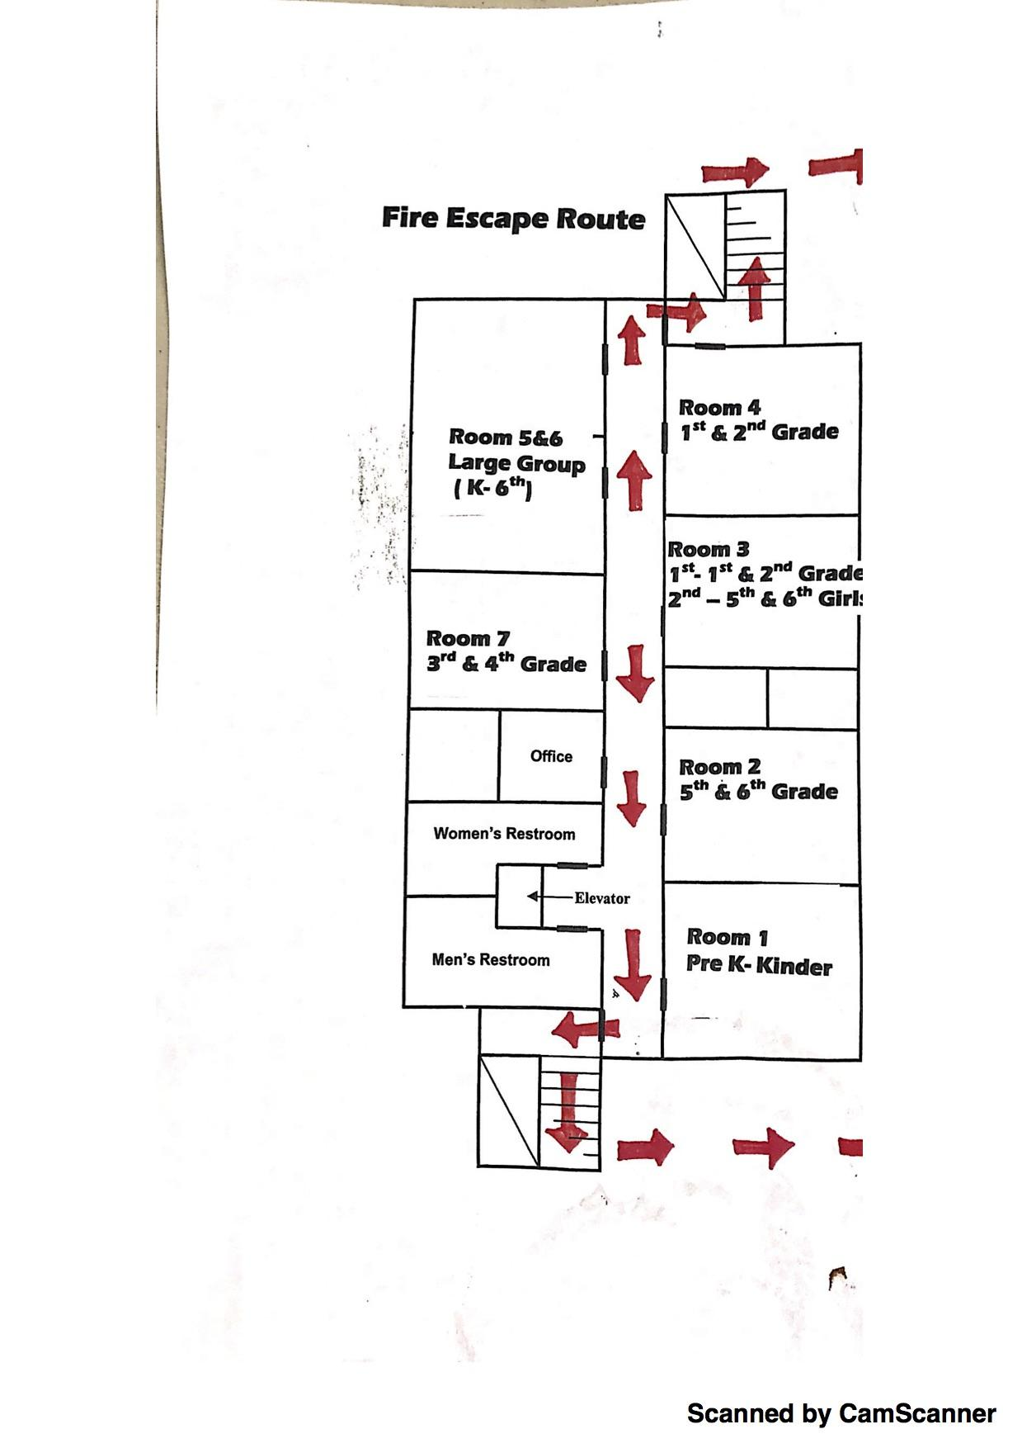
JCS-Innovation Centre La Mesa (ICLM)
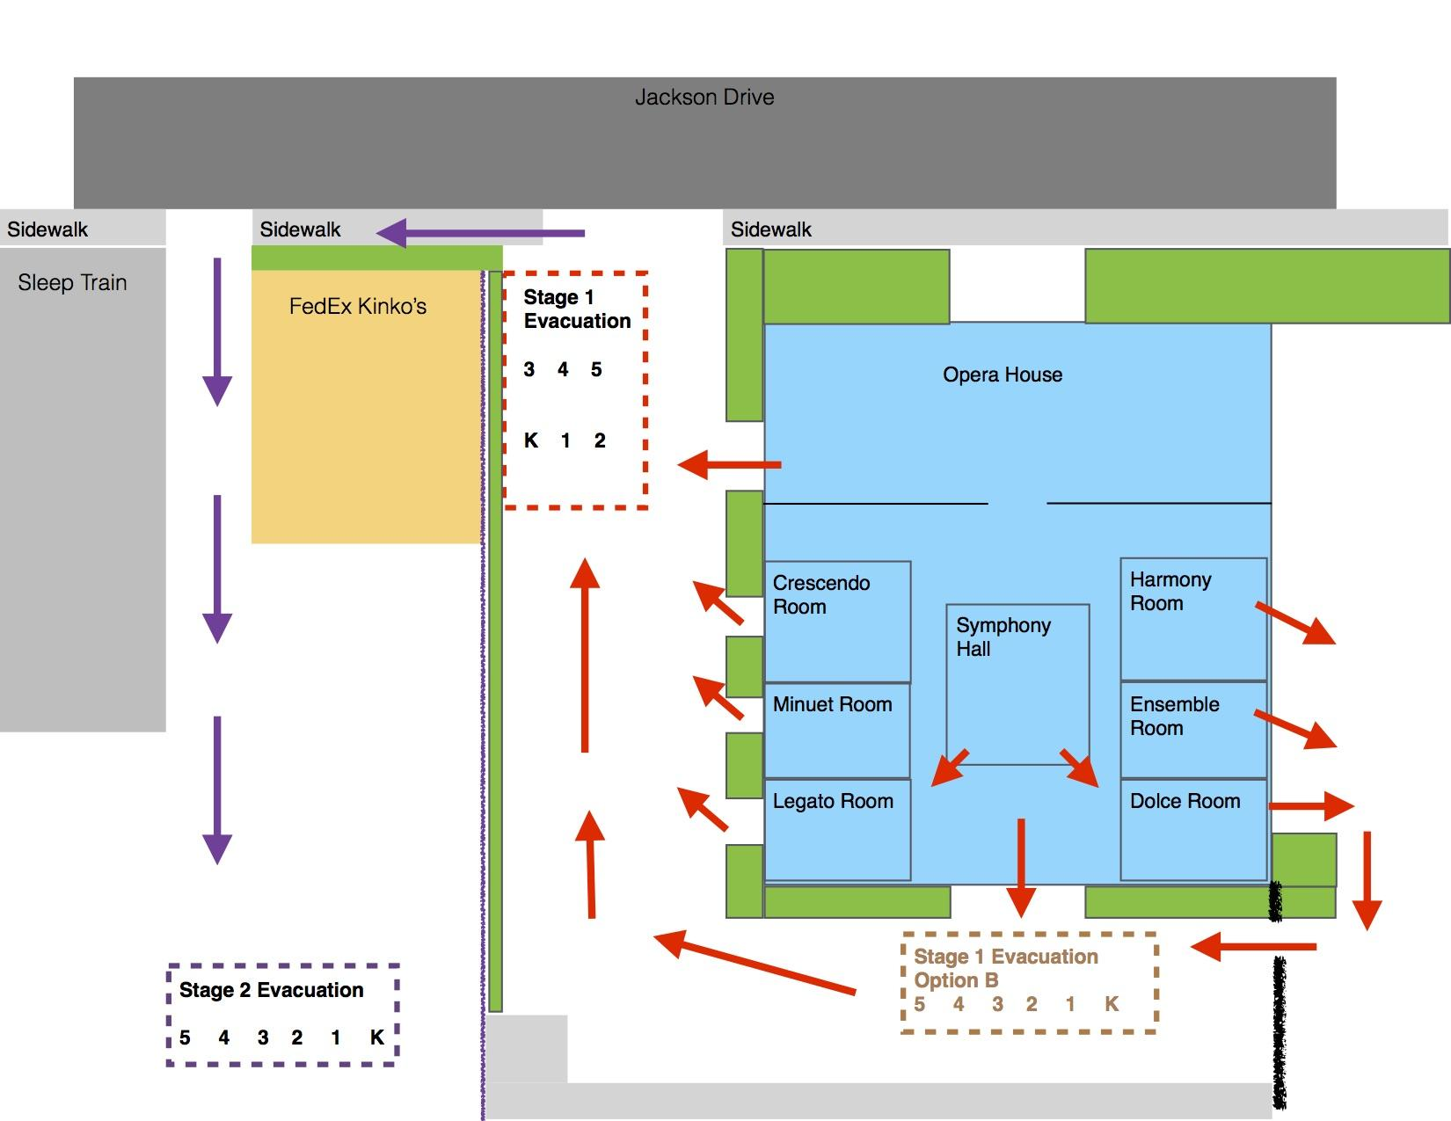

JCS-Phoenix Learning Center
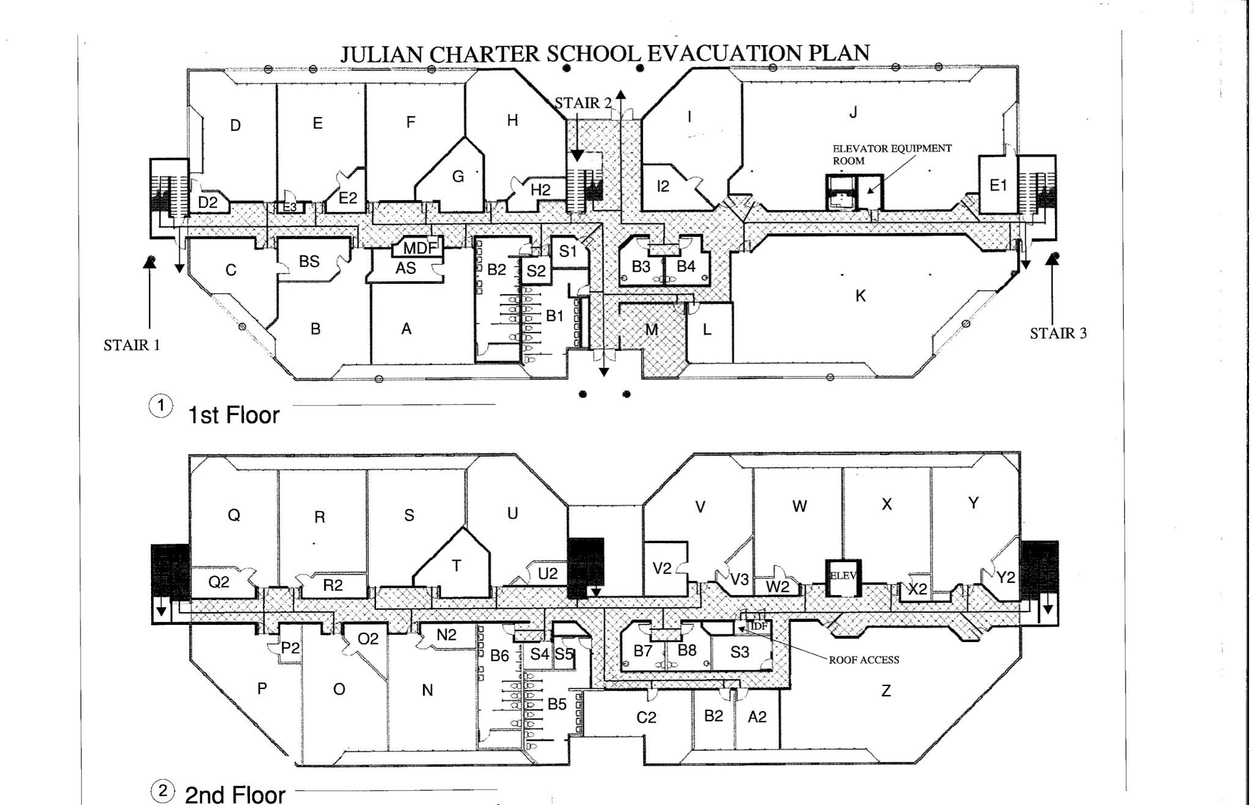

JCS-Vallejo/Temecula Building A
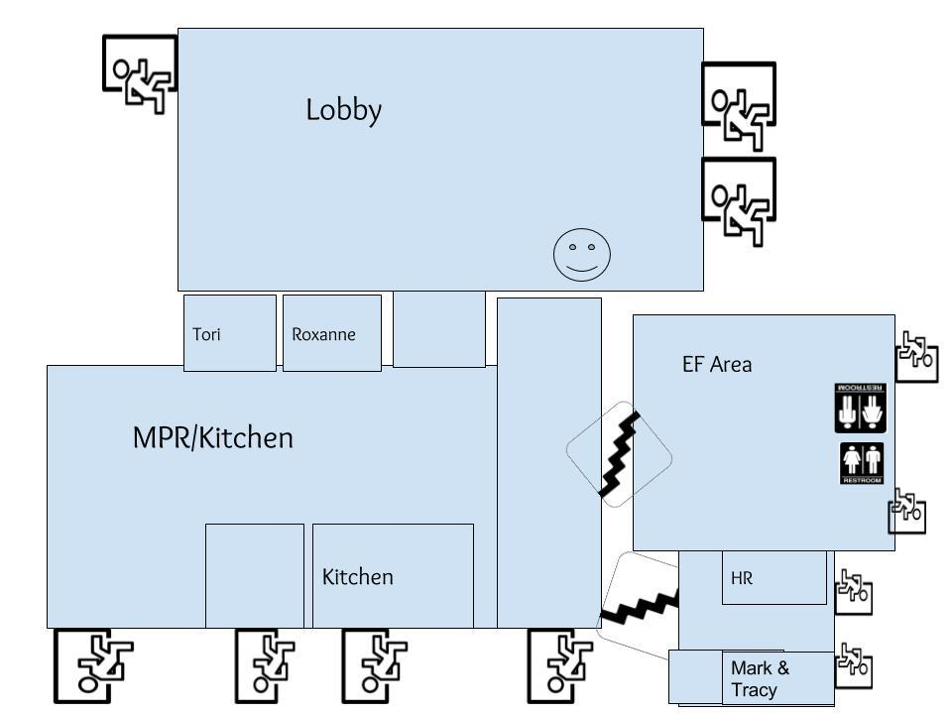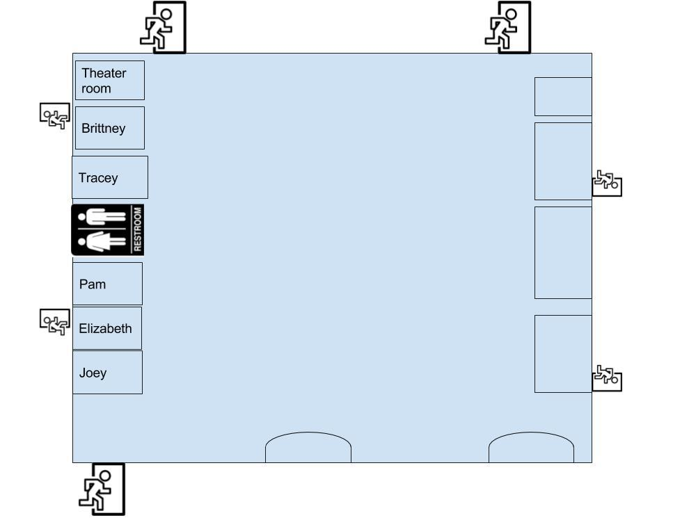

JCS-Vallejo/Temecula, Middle School Academy
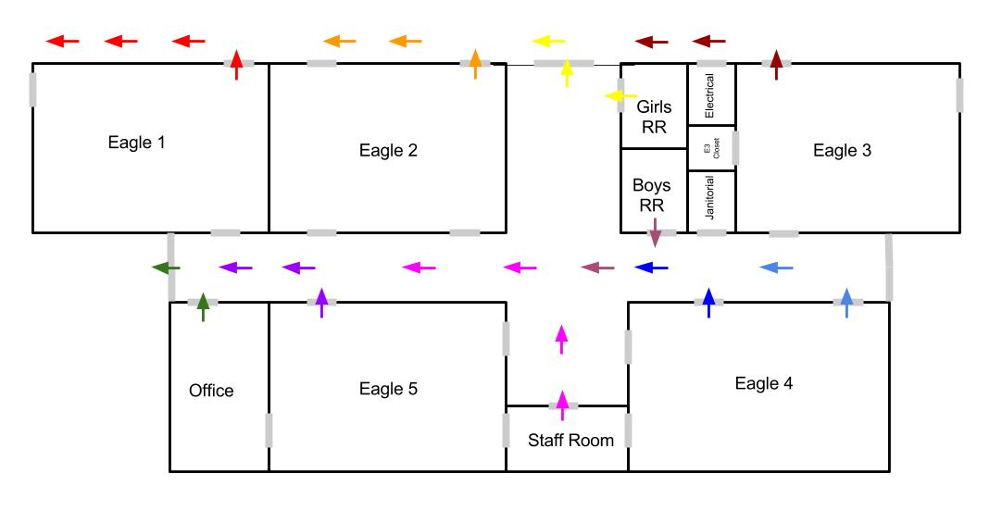

JCS-Vallejo/Temecula, High School Academy
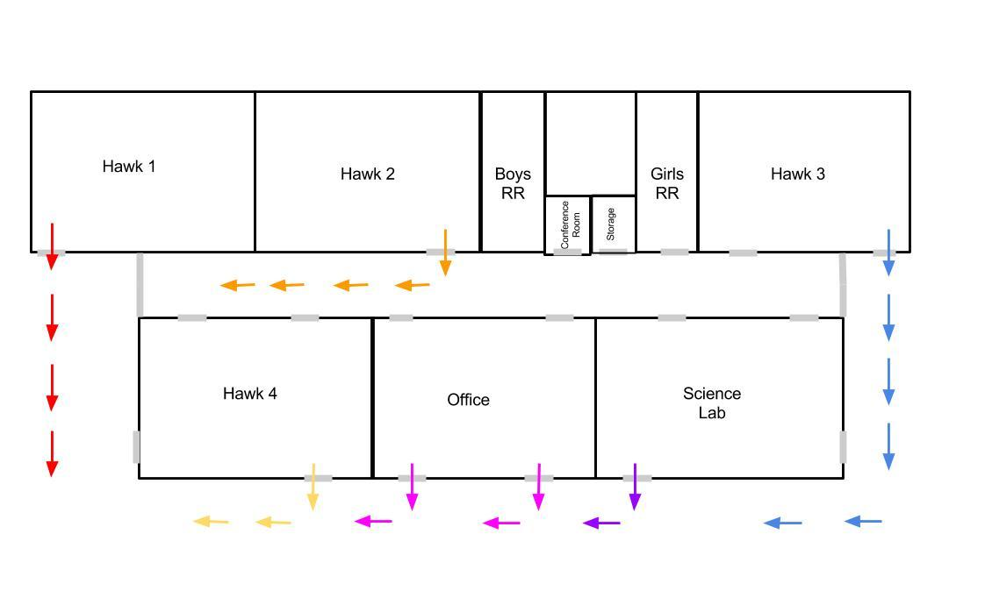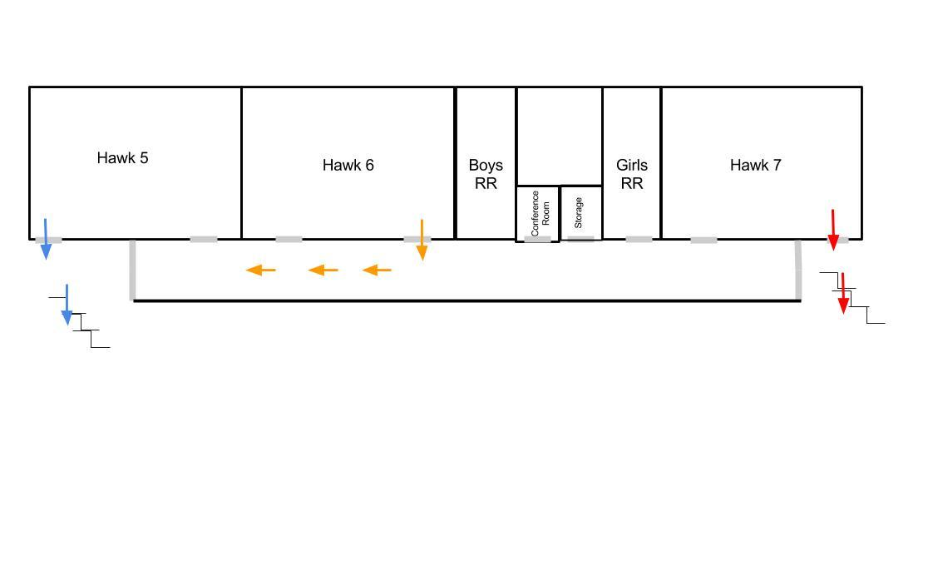

JCS-Innovation Centre Temecula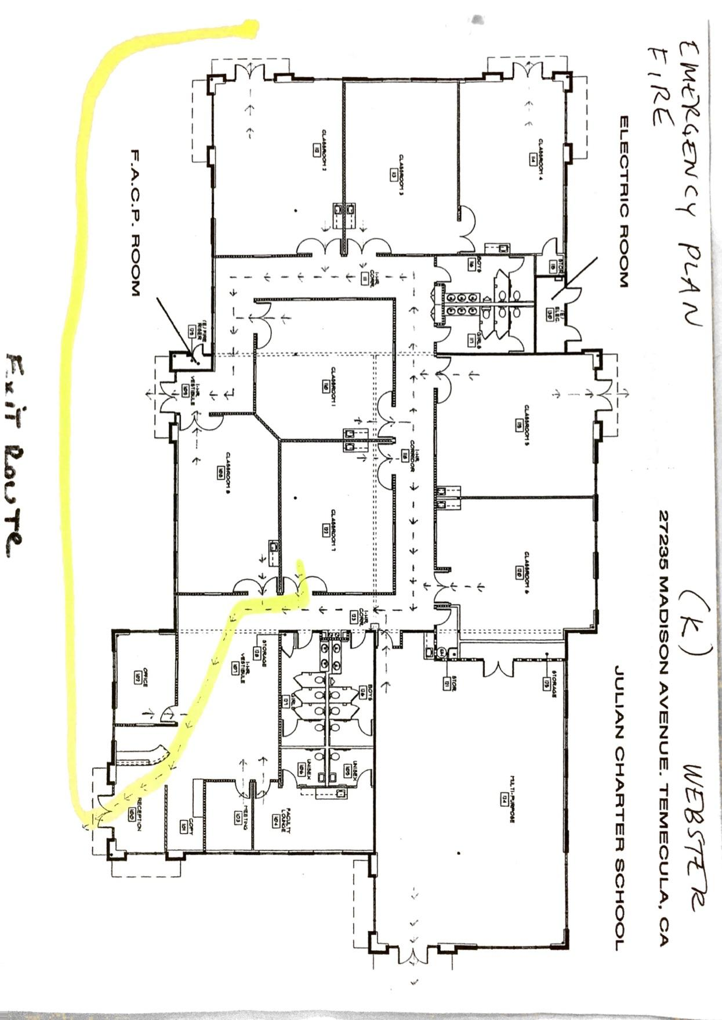
JCS-Murrieta Complex - RC
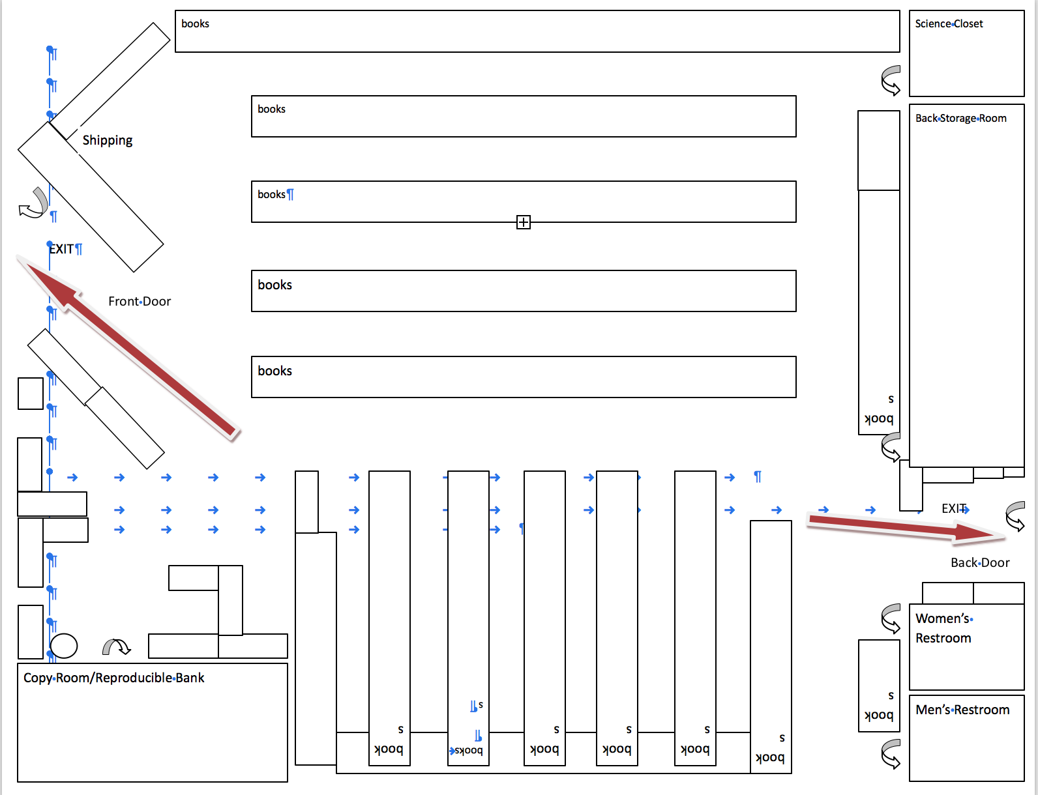

JCS-Murrieta Suite E
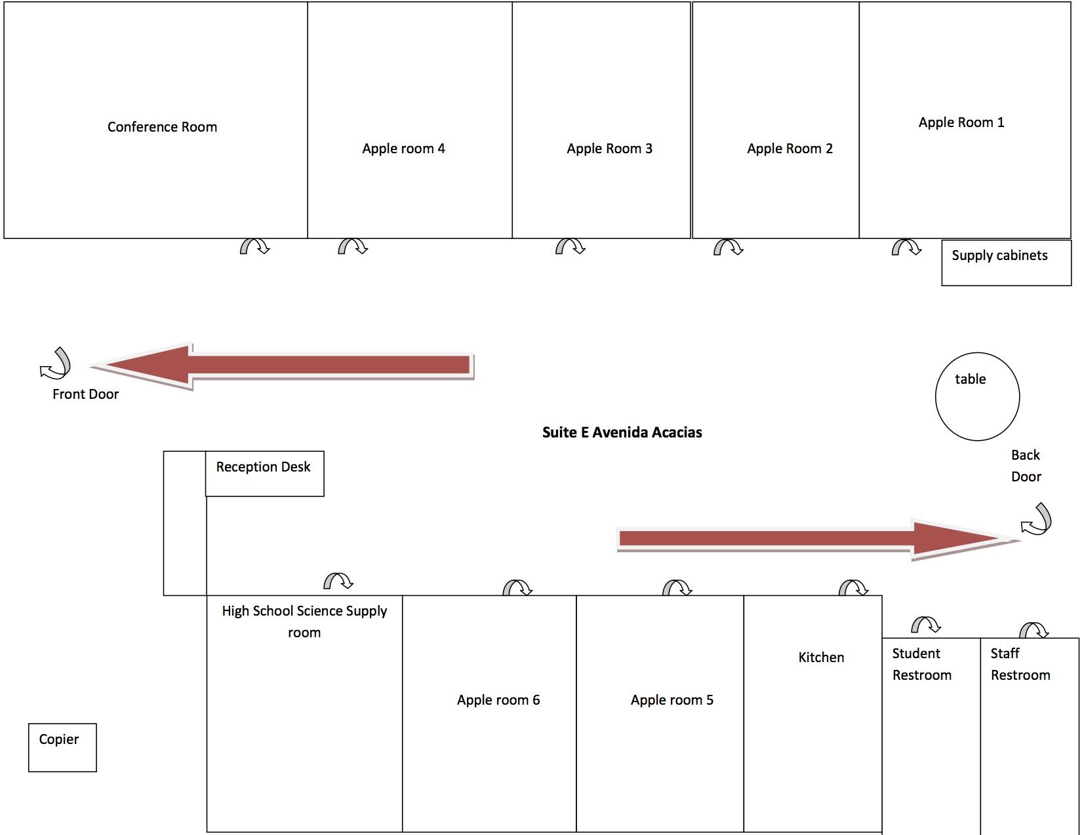

JCS-Murrieta Insite Suite F
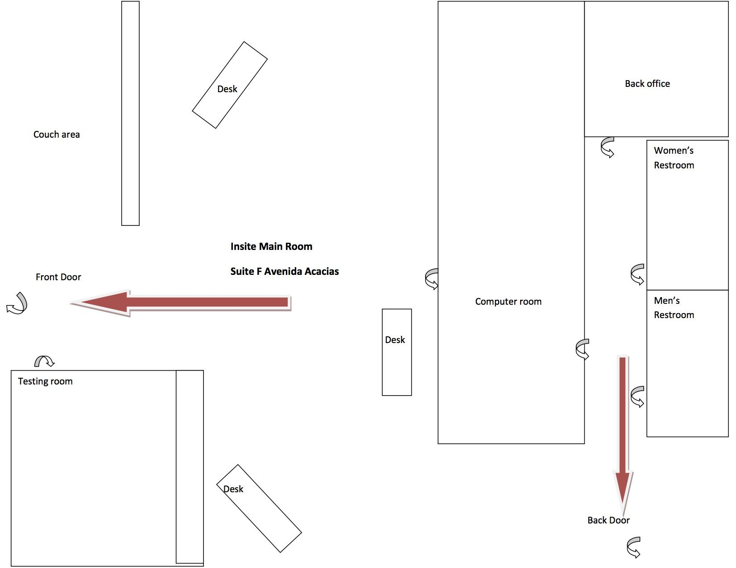

JCS-Main Office

➔ |  | ➔ |  |  | ➔ | ↘ | ↓
 |  |  |  |  | Main Room |  | ➔
➔ |  | ➔ |  |  | ➔ | ↗
↘ |  |  |  |  |  |  | ➔
 | ↓ |  | ↗ |  | ↗
Jennifer’s |  |  |  |  | File Room
Office | ➔ |  | ↗ |  | ↑
↗ |  | ↗
Kitchen | ↗ |  |  | ↑ | ← |  | ←
 |  | ↑
↗ |  |  |  | ↑ | Conference Room
↘ |  | ↑
➔ |  | Back Nook |  |  | ↖
Bathroom

↗ | ↗ | ↖ |  |  |  |  | ↖

JCS-Desert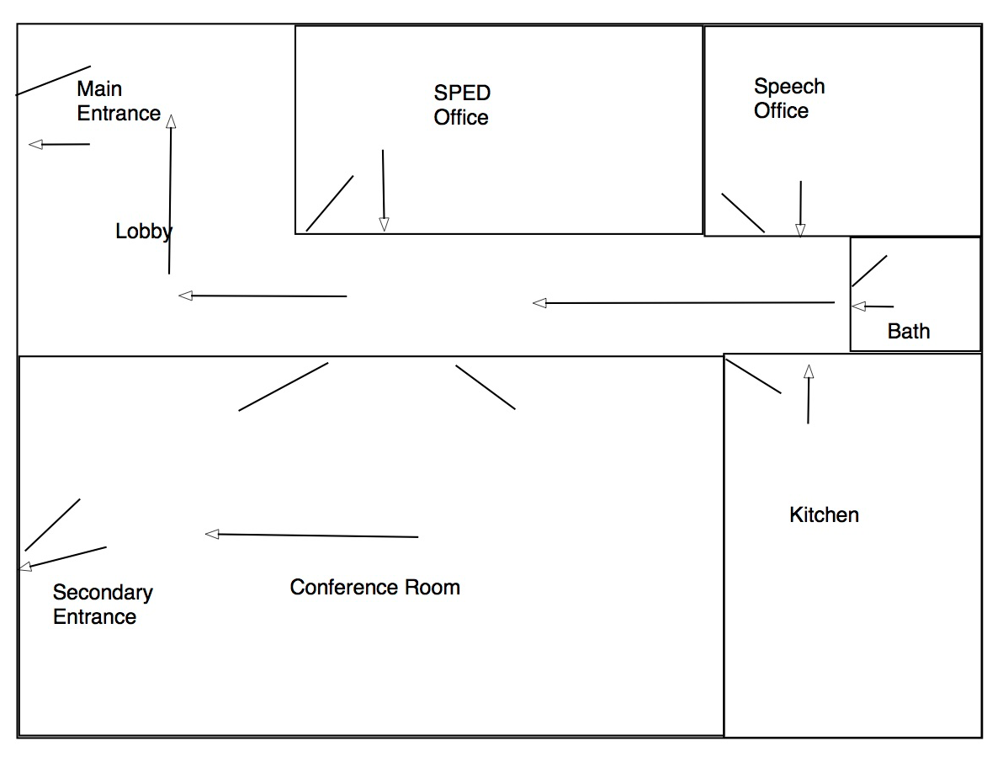

JCS-Innovation Centre Encinitas
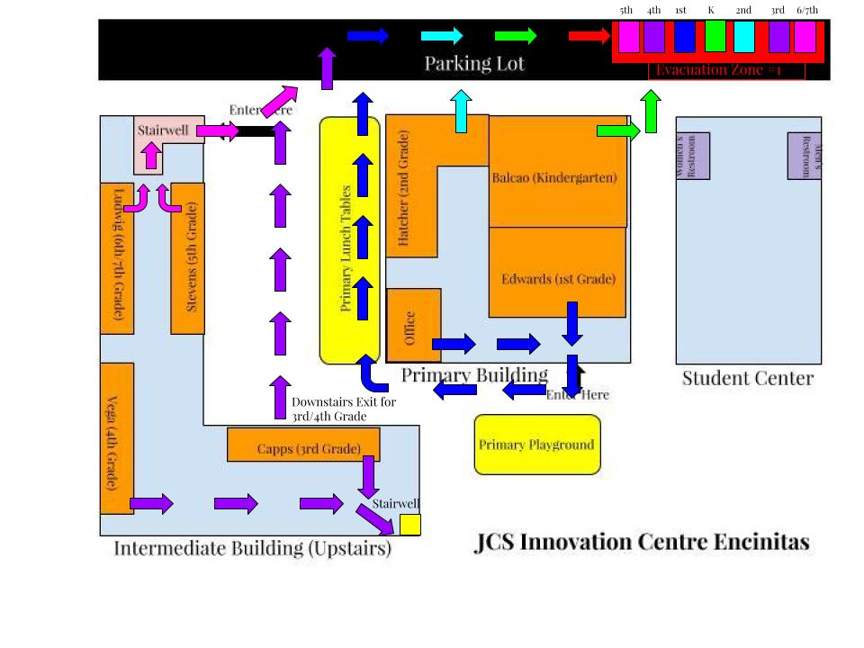
Emergency Evacuation Routes
JCS facility Emergency Evacuation Routes are shown above.
School Discipline
A. Statement of Rules and Procedures On School Discipline
Education Code 44807:
"Every teacher in the public schools shall hold Pupils to a strict account for their conduct on the way to and from school, on the playgrounds, or during recess. A teacher, vice principal, principal, or any other certificated employee of a school district, shall not be subject to criminal prosecution or criminal penalties for the exercise, during the performance of his duties, of the same degree of physical control over a pupil that a parent would be legally privileged to exercise but which in no event shall exceed the amount of physical control reasonably necessary to maintain order, protect property, or protect the health and safety of pupils, or to maintain proper and appropriate conditions conducive to learning."
B. Notification to Students and Parents
Education Code 35291:
- Parents and students shall be notified of JCS and school site rules pertaining to student discipline at the beginning of the first semester, and at the time of enrollment for students who enroll thereafter.
- The discipline policy shall be reviewed annually with input from the Discipline Team, site administrators, campus security, staff, students, and parents.
- Julian Charter School DISCIPLINE CHART AND/OR SELECTED DISCIPLINARY POLICIES AND PROCEDURES.
D. Staff Training
Each JCS Program will discuss the discipline procedures for all new staff in orientation or the first month of employment.
Dress Code
A. Gang Related Apparel
If the school has adopted a dress code prohibiting students from wearing
“gang related apparel,” insert the provisions of that dress code. N/A.
B. Staff Training
Each program will review with newly hired staff on an annual basis the school dress code. New employees are inserviced on dress code during their Human Resource orientation.

Chapter 5
Routine and Emergency Disaster Procedures: Drills
Earthquake Drills
The earthquake emergency procedure system shall, but not be limited to, all of the following:
A school building disaster plan, ready for implementation at any time, for maintaining the safety and care of students and staffs.
Drop procedure. As used in this article, "drop procedure" means an activity whereby each student and staff member takes cover under a table or desk, dropping to his or her knees, with the head protected by the arms, and the back to the windows. A drop procedure practice shall be held at least once each school quarter in elementary schools and at least once a semester in secondary schools.
Protective measures to be taken before, during, and following an earthquake. A program to ensure that the students and that both the certificated and classified staff are aware of, and properly trained in, the earthquake emergency procedure system. (Code of Regulations, Section 35297)
Whenever an earthquake alarm is sounded, all students, teachers and other employees shall immediately begin Duck, Cover and Hold procedures:
- DUCK, or DROP down on the floor.
- Take COVER under a sturdy desk, table or other furniture with backs to the windows. Protect head and neck with arms.
- HOLD onto the furniture and be prepared to move with it.
- Stay in this position for at least one minute or, in a real situation, until shaking stops.
Evacuation. An Evacuation should NEVER be automatic. There may be more danger outside the building than there is inside. If administrative directions are not forthcoming, the teacher will be responsible for assessing the situation and determining if an evacuation is required.
Predetermined evacuation areas should be in open areas, without overhead hazards and removed from potential danger spots (covered walkways, large gas mains, chain linked fences [electric shock potential]).
Make it clear that a post-earthquake route differs from a fire evacuation route, and that appropriate non hazardous alternate routes may be needed.
Practice evacuation using alternate routes to the assembly areas.
Students are to remain with their teacher in the evacuation area. Teachers shall take their roll books, take roll once in the evacuation area and be prepared to identify missing students to administrators and/first responders.
The principal or designee shall keep a copy of each drill conducted on the Emergency Drill Report form and file a copy with the Executive Director/designee.
Standards for a Successful Earthquake Drill:
The Earthquake Alarm can be heard by all staff and students.
Immediately after the earthquake alarm sounds, all students, teachers and other employees shall:
- DUCK, or DROP down on the floor.
- Take COVER under a sturdy desk, table or other furniture with backs to the windows. Protect head and neck with arms.
- HOLD onto the furniture and be prepared to move with it.
Evacuations shall occur when directed over the loudspeaker by the Academy Coordinator/designee. When evacuations are included as part of the drill, appropriate non hazardous alternate routes, avoiding building overhangs, electrical wires, large trees, covered walkways, etc, shall be utilized by staff and students in order to reach the designated evacuation areas.
Teachers have taken roll once in the evacuation area. Any missing students are immediately reported to the Academy Coordinator/designee.
Upon sounding of the all clear students and staff return to their appropriate classroom and the teacher takes roll once more. Missing students are reported to the attendance office.
Fire Drills
Academy Coordinators shall hold fire drills at least once a month in all elementary and middle programs and at least twice each school year at all high school programs.
(Code of Regulations, Title 5, Section 550)
- Whenever the fire alarm is given, all students, teachers and other
- employees shall quickly leave the building in an orderly manner. Teachers shall ascertain that no student remains in the building.
- Designated evacuation routes shall be posted in each room. Teachers shall be prepared to select alternate exits and direct their classes to these exits in the event the designated evacuation route is blocked.
- Evacuation areas will be established away from fire lanes.
- Students are to remain with their teacher in the evacuation area. Teachers shall take their roll books, take roll once in the evacuation area and be prepared to identify missing students to administrators and/or fire marshals/designees.
- The principal or designee shall keep a copy of each drill conducted on the Emergency Drill Report form and file a copy with the Executive Director/designee.
Standards for a Successful Fire Drill:
- The Fire Alarm can be heard by all staff and students.
- Orderly evacuation begins immediately and is completed within 5 minutes of the initial alarm, with minimal congestion at exit gates
- Teachers and students are staged in an orderly fashion away from fire lanes.
- Teachers have taken roll once in the evacuation area. Any missing students are immediately reported to the Academy Coordinator/designee.
- Upon sounding of the all clear students and staff return to their appropriate classroom and the teacher takes roll once more. Missing students are reported to the attendance office.

Lockdown Drills
For sites that have had Training, conducting a Lockdown Drill initially involves more pre-planning and organization than conducting other drills. Middle and high schools should conduct an annual drill, which should take no longer than 40 minutes and impact class time by 20 minutes. Elementary schools should conduct drills every other year (or annually, if the local police department has the resources to support the drills). Drills need to be scheduled with your School Resource or Liaison Officers.
There are several steps that are recommended for Active Shooter Training, including:
- Conduct a staff meeting. Plan on a 20 minute timeframe to review
- expectations and standards in terms of:
  - Locking doors
  - Covering windows
  - Turning off lights
  - Building barricades
  - Reviewing classroom and all clear procedures
  - Reviewing off site evacuation locations.
- Send a follow-up reminder memo to your staff
- Organize your assessment team. This also provides an excellent opportunity for your Critical Response Team to work together with police participants in the drill.
- Conduct the assessment.
- Complete follow-up tasks.
Remember, you are setting the tone for the importance of safety for students and staff on your campus.
Chapter 6
Routine & Emergency Disaster Procedures: Overview
The Basic Plan
The Basic Plan addresses Julian Charter School's responsibilities in emergencies associated with natural disaster, human-caused emergencies and technological incidents. It provides a framework for coordination of response and recovery efforts within JCS in coordination and with local, State, and Federal agencies. The Plan establishes an emergency organization to direct and control operations at all sites during a period of emergency by assigning responsibilities to specific personnel. The Basic Plan:
- Conforms to the Federally mandated National Incident Management System (NIMS), State mandated Standardized Emergency Management System (SEMS) and effectively restructures emergency response at all levels in compliance with the Incident Command System (ICS).
- Establishes response policies and procedures, providing INSERT School Julian Charter School clear guidance for planning purposes.
- Describes and details procedural steps necessary to protect lives and property.
- Outlines coordination requirements.
- Provides a basis for unified training and response exercises to ensure compliance.
Requirements
The Plan meets the requirements of the Standardized Emergency Management System (SEMS) Operational Area Response, and defines the primary and support roles of JCS and individual locations in after-incident damage assessment and reporting requirements.
Objectives
- Protect the safety and welfare of students, employees and staff.
- Provide for a safe and coordinated response to emergencies.
- Protect JCS' facilities and properties.
- Enable JCS to restore normal conditions with minimal confusion in the shortest time possible.
- Provide for interface and coordination between sites and JCS Emergency Operations Center (EOC).
- Provide for interface and coordination between sites and the County or city EOC in which they reside.
- Provide for the orderly conversion of pre-designated Julian Charter School sites to American Red Cross shelters, when necessary.
Schools are required by both federal statute and state regulation to be available for shelters following a disaster. The American Red Cross (ARC) has access to schools in damaged areas to set up their mass care facilities, and local governments have a right to use schools for the same purposes. This requires close cooperation between school officials and ARC or local government representatives, and should be planned and arranged for in advance.
Authorities and References
State of California
California Emergency Services Act (Chapter 7, Division 1, Title 2, California Government Code).
The Act provides the basic authorities for conducting emergency operations following a proclamation of Local Emergency, State of Emergency, or State of War Emergency by the Governor and/or appropriate local authorities, consistent with the provisions of this Act.
California Government Code, Section 3100, Title 1, Division 4, Chapter 4.
States that public employees are disaster service workers, subject to such disaster service activities as may be assigned to them by their superiors or by law. The term "public employees" includes all persons employed by the state or any county, city, city and county, state agency or public district, excluding aliens legally employed.
The law applies to public school employees in the following cases:
- When a local emergency is proclaimed.
- When a state of emergency is proclaimed.
- When a federal disaster declaration is made.
The law has two ramifications for Julian Charter School employees:
- It is likely that public school employees are pressed into service as Disaster Service Workers by their superiors, and may be asked to do jobs other than their usual duties for periods exceeding their normal working hours.
- When pressed into disaster service, employees' Workers' Compensation Coverage becomes the responsibility of state government (OES), but their overtime pay is paid by the school. These circumstances apply only when a local or state emergency is declared.
States that (the Governor's Office of Emergency Services has stated) inadequately trained school staff render school officials potentially liable for acts committed or omitted by school staff acting within the scope of their training during or after a disaster. (Subsections 835-840.6).
It requires that school districts be prepared to respond to emergencies using SEMS. (Section 8607, the Petris Bill).
California Civil Code, Chapter 9, Section 1799.102
It provides for "Good Samaritan Liability" for those providing emergency care at the scene of an emergency. ("No person, who, in good faith and not for compensation, renders emergency care at the scene of an emergency, shall be liable for any civil damages resulting from any act or omission. The scene of an emergency shall not include emergency departments and other places where medical care is usually offered.")
California Education Code, Sections 35295-35297 (The Katz Act), Section 40041, 40042.
Requires that a school site disaster plan outline roles, responsibilities, and procedures for students and staff. It also requires that the school site emergency management organizational structure comply with SEMS, Title 19 Section 2400, and be ready for implementation at all times.
California Emergency Plan
Promulgated by the Governor, and published in accordance with the California Emergency Services Act, it provides overall statewide authorities and responsibilities, and describes the functions and operations of government at all levels during extraordinary emergencies, including wartime. Section 8568 of the Act states, in part, that "...the State Emergency Plan shall be in effect in each political subdivision of the state, and the governing body of each political subdivision shall take such action as may be necessary to carry out the provisions thereof." Therefore, local emergency plans are considered extensions of the California Emergency Plan.
Definitions: Incidents, Emergencies, Disasters
Incident
An incident is an occurrence or event, either human-caused or caused by natural phenomena, that requires action by emergency response personnel to prevent or minimize loss of life or damage to property and/or natural resources.
Incidents may result in extreme peril to the safety of persons and property and may lead to, or create conditions of disaster. Incidents may also be rapidly mitigated without loss or damage. Although they may not meet disaster level definition, larger incidents may call for managers to proclaim a "Local Emergency".
Incidents are usually a single event that may be small or large. They occur in a defined geographical area and require local resources or, sometimes, mutual aid. There is usually one to a few agencies involved in dealing with an ordinary threat to life and property and to a limited population. Usually a local emergency is not declared and the jurisdictional EOC is not activated. Incidents are usually of short duration, measured in hours or, at most, a few days. Primary command decisions are made at the scene along with strategy, tactics, and resource management decisions
Emergency
The term emergency is used in several ways. It is a condition of disaster or of extreme peril to the safety of persons and property. In this context, an emergency and an incident could mean the same thing, although an emergency could have more than one incident associated with it.
Emergency is also used in Standardized Emergency Management System (SEMS) terminology to describe agencies or facilities, e.g., Emergency Response Agency, Emergency Operations Center, etc.
Emergency also defines a conditional state such as a proclamation of "Local Emergency". The California Emergency Services Act, of which SEMS is a part, describes three states of emergency:
- State of War Emergency
- State of Emergency
- State of Local Emergency
SITE COMPREHENSIVE SAFETY PLAN 44
Disaster
A disaster is defined as a sudden calamitous emergency event bringing great damage, loss, or destruction. Disasters may occur with little or no advance warning, e.g., an earthquake or a flash flood, or they may develop from one or more incidents, e.g., a major wildfire or hazardous materials discharge.
Disasters are either single or multiple events that have many separate incidents associated with them. The resource demand goes beyond local capabilities and extensive mutual aid and support are needed. There are many agencies and jurisdictions involved including multiple layers of government. There is usually an extraordinary threat to life and property affecting a generally widespread population and geographical area. A disaster's effects last over a substantial period of time (days to weeks) and local government will proclaim a Local Emergency. Emergency Operations Centers are activated to provide centralized overall coordination of jurisdictional assets, departments and incident support functions. Initial recovery coordination is also a responsibility of the EOCs.
Earthquake Overview
Major Earthquake Threat Summary
Earthquakes are sudden releases of strain energy stored in the earth's bedrock. The great majority of earthquakes are not dangerous to life or property either because they occur in sparsely populated areas or because they are small earthquakes that release relatively small amounts of energy. However, where urban areas are located in regions of high seismicity, damaging earthquakes are expectable, if not predictable, events. Every occupant and developer in Santa Clara County assumes seismic risk because the County is within an area of high seismicity. More than ten severe earthquakes have impacted San Francisco Bay Region during historic times.
The major effects of earthquakes are ground shaking and ground failure. Severe earthquakes are characteristically accompanied by surface faulting. Flooding may be triggered by dam or levee failure resulting from an earthquake, or by seismically induced settlement or subsidence. All of these geologic effects are capable of causing property damage and, more importantly, risks to life and safety of persons.
A fault is a fracture in the earth's crust along which rocks on opposite sides have moved relative to each other. Active faults have high probability of future movement. Fault displacement involves forces so great that the only means of limiting damage to manmade structures is to avoid the traces of active faults. Any movement beneath a structure, even on the order of an inch or two, could have catastrophic effects on the structure and its service lines.
The overall energy release of an earthquake is its most important characteristic. Other important attributes include an earthquake's duration, its related number of significant stress cycles, and its accelerations.
Earthquake Size Descriptions
Descriptive Title Richter Magnitude Intensity Effects
Minor Earthquake 1 to 3.9
Only observed instrumentally or felt only near the epicenter.
Small Earthquake 4 to 5.9
Surface fault movement is small or does not occur. Felt at distances of up to 20 or 30 miles from the epicenter. May cause damage.
Moderate Earthquake 6 to 6.9
Moderate to severe earthquake range; fault rupture probable.
Major Earthquake 7 to 7.9
Landslides, liquefaction and ground failure triggered by shock waves.
Great Earthquake 8 to 8+
Damage extends over a broad area, depending on magnitude and other factors.
Levels of Response
Check with the local police department; these may be in reverse order for your community.
Response Levels are used to describe the type of event:
The area(s) affected, the extent of coordination or assistance needed, and the degree of participation expected from the School Julian Charter School. Response Levels are closely tied to Emergency Proclamations issued by the head of local government.
Response Level 0 - Readiness & Routine Phase
On-going routine response by the School Julian Charter School to daily emergencies or incidents. Stand-by and alert procedures issued in advance of an anticipated or planned event.
Response Level 3 - Local Emergency
A minor to moderate incident in which local resources are adequate and available. This level of emergency response occurs when an emergency incident, e.g., gas leak, sewer back-up, assaults, bomb threat, toxic spill, medical emergency, shooting, etc., occurs. A Level 3 response requires School/Site Coordinators to implement guidelines in the Emergency Standard Operating Procedures and interact with public agencies.
Response Level 2 - Local Disaster
A moderate to severe emergency in which resources are not adequate and mutual aid may be required on a regional, even statewide basis with coordination with local police and fire departments of the affected are working in concert with INSERT School Julian Charter School to respond. The affected Cities and the County of Santa Clara will proclaim a local emergency. Then, the State of California may declare a state of emergency.
Response Level 1 - Major Disaster
Resources in or near the impacted areas are overwhelmed and extensive State and Federal resources are required. The cities and the County of Santa Clara will proclaim a local emergency. Then, the State of California will declare a State of Emergency. A Presidential Declaration of an Emergency or Major Disaster is requested by the State. Examples of major disasters are the Loma Prieta Earthquake of 1989 or the Oakland Hills Firestorm of 1991. When local jurisdictions declare a State of Emergency, JCS board can declare the same.
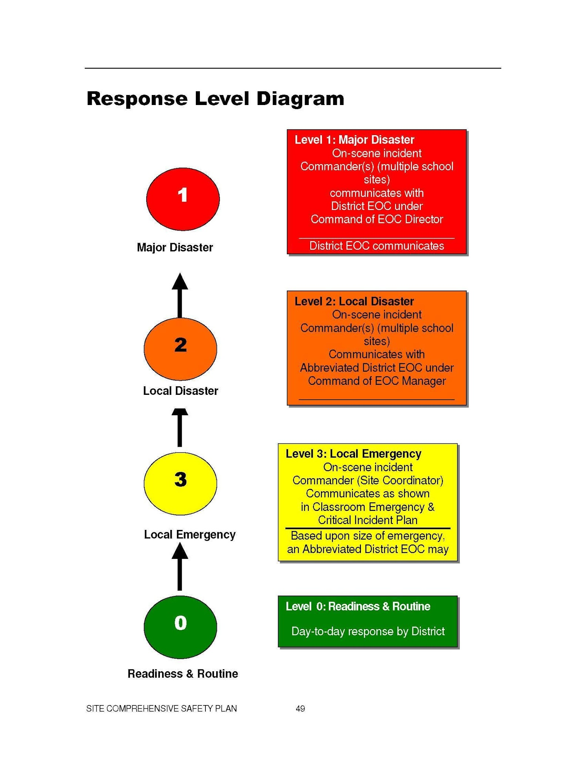

Emergency Phases
Some emergencies will be preceded by a build-up or warning period, providing sufficient time to warn the population and implement mitigation measures designated to reduce loss of life and property damage. Other emergencies occur with little or no advance warning, thus requiring immediate activation of the emergency operations plan and commitment of resources. All employees must be prepared to respond promptly and effectively to any foreseeable emergency, including the provision and use of mutual aid.
Emergency management activities during peacetime and national security emergencies are often associated with the phases indicated below. However, not every disaster necessarily includes all indicated phases.
Prevention/Mitigation Phase
Prevention/Mitigation is perhaps the most important phase of emergency management. However, it is often the least used and generally the most cost effective. Mitigation is often thought of as taking actions to strengthen facilities, abatement of nearby hazards, and reducing the potential damage either to structures or their contents, while prevention is taking steps to avoid potential problems. Both of these elements require education of parents, students and teachers.
While it is not possible to totally eliminate either the destructive force of a potential disaster or its effects, doing what can be done to minimize the effects may create a safer environment that will result in lower response costs, and fewer casualties.
Preparedness Phase
The preparedness phase involves activities taken in advance of an emergency. These activities develop operational capabilities and responses to a disaster. Those identified in this plan as having either a primary or support mission relative to response and recovery review Standard Operating Procedures (SOPs) or checklists detailing personnel assignments, policies, notification procedures, and resource lists. Personnel are acquainted with these SOPs and checklists and periodically are trained in activation and execution.
Response Phase
Pre-Impact: Recognition of the approach of a potential disaster where actions are taken to save lives and protect property. Warning systems may be activated and resources may be mobilized, EOCs may be activated and evacuation may begin.
SITE COMPREHENSIVE SAFETY PLAN 50
Immediate Impact: Emphasis is placed on saving lives, controlling the situation, and minimizing the effects of the disaster. Incident Command Posts and EOCs may be activated, and emergency instructions may be issued.
Sustained: As the emergency continues, assistance is provided to victims of the disaster and efforts are made to reduce secondary damage. Response support facilities may be established. The resource requirements continually change to meet the needs of the incident.
Recovery Phase
Recovery is taking all actions necessary to restore the area to pre-event conditions or better, if possible. Therefore, mitigation for future hazards plays an important part in the recovery phase for many emergencies. There is no clear time separation between response and recovery. In fact, planning for recovery should be a part of the response phase.
First Things First
Preparing your school for emergencies starts with staff preparedness. The backbone of school planning is dependent on the staff's willingness to stay at school during a major community emergency. Personal preparedness makes this much easier.
Each staff member needs:
To prepare their family and home for earthquakes and other emergencies
- 72-hour supply kit for the home
- A Car Kit, including comfortable clothes/shoes and medications
- To develop a plan to reunite with their family
- A neighborhood preparedness program
Preparedness Brochures are available from the local chapter of the American Red Cross, Santa Clara County Office of Emergency Services, school district website, www.redcross.org, www.prepare.org or www,ready.gov.
If the disaster occurs during school time, Emergency Management recommends the child stay at school until the parent or a trusted friend (see Emergency Cards) picks up the child. We have no idea, especially in an earthquake, how impacted our neighborhoods may be.
This means the school staff will need to stay with the children. You can only do this if you are prepared at home! You must feel that your family can activate your Family Plan without you.
Disaster Service Worker Status: California Government Code Section 3100 declares that public employees are disaster services workers, subject to such disaster service activities as may be assigned to them by the superiors or by law. The term public employees include all persons employed by the state or any county, city, city & county, state agency or public district, excluding aliens legally employed. This law applies to public school employees in the following cases:
- When a local emergency has been proclaimed
- When a state of emergency has been proclaimed
- When a federal disaster declaration has been made
Julian Charter School and Parent Responsibilities for Students
JCS RESPONSIBILITY
If the Executive Director declares a school emergency during the school day, the following procedures will be followed:
IN CASE OF A DECLARED EMERGENCY BY THE EXECUTIVE DIRECTOR DURING SCHOOL HOURS, ALL STUDENTS WILL BE REQUIRED TO REMAIN AT SCHOOL OR AT AN ALTERNATE SAFE SITE UNDER THE SUPERVISION OF THE ACADEMY COORDINATOR OR OTHER PERSONNEL ASSIGNED BY THE COORDINATOR.
- Until regular dismissal time and released only then if it is considered safe, - OR -
- Until released to an adult authorized by the parent or legal guardian whose name appears on school records.
  - If students are on their way to school, they should proceed to school if walking.
  - If students are on their way home from school, they are to continue home.
During a Declared Emergency, those students who have not been picked up by their parents or other authorized person may be taken by school personnel to another site where consolidated care facilities can be provided. This information will be given to the media stations and posted at the site to keep parents informed.
PARENT RESPONSIBILITY
Parents and legal guardians of students will be provided with a Student Health/Emergency Form each year. In case of a Declared Emergency, students will be released ONLY to persons designated on this form. Parents are responsible for ensuring that information on the Student Health/Enrollment Form is current at all times.
Parents are asked to share with the school the responsibility for informing students of what they should do in case of a severe earthquake or other major emergency. Parents need to give specific directions to each student to follow the policy outlined above and to follow the directions of school personnel.
School authorities will do everything possible to care for each student while he/she is under JCS supervision.
It is critical that students do not have directions from parents that are contrary to JCS' stated policy on retention at school and authorized release in case of a severe emergency.
Chapter 7
Emergency Response Procedures
Basic Actions
Most emergency responses are covered by the following Basic Actions:
A. Action: STANDBY
Action: STANDBY consists of bringing students into the classroom or holding them in the classroom pending further instruction.
B. Action: LEAVE BUILDING
ACTION: LEAVE BUILDING consists of the orderly movement of students and staff from inside the school building to outside areas of safety or planned evacuation site.
Action: LEAVE BUILDING is appropriate for—but not limited to—the following emergencies:
a. Fire
b. Peacetime Bomb Threat
c. Chemical Accident
d. Explosion or Threat of an Explosion
e. Following an Earthquake
f. Other similar occurrences that might make the building uninhabitable
g. At the onset of an Active shooter/Lockdown Alert, when teacher/supervisor has ascertained that leaving is the best option.
C. Action: TAKE COVER
Action: TAKE COVER consists of bringing/keeping students indoors if possible and sheltering in place as appropriate to the situation.
If outdoors, Action: TAKE COVER consists of hiding behind any solid object (large tree, engine block of car, cement wall), in the event a sniper attack, armed intruder, rabid animal, or moving immediately to a location which is upwind and uphill in the event of a chemical or biological threat
Action TAKE COVER is appropriate for, but not limited to, the following:
a. Severe Windstorm (short warning)
b. Biological or Chemical Threat
c. Sniper Attack
d. Rabid Animal on School Grounds
D. Action: DROP
WARNING: The warning for this type of emergency is the beginning of the disaster itself.
Action: DROP consists of:
a. Inside school buildings
• Immediately TAKE COVER under desks or tables and turn away from all windows
• Remain in a sheltered position for at least 60 seconds silent and listening to/or for instructions
b. Outside of School Buildings
• Earthquake: move away from buildings
• Take a protective position, if possible
c. Explosion/Nuclear Attack:
• Take protective position, OR,
• Get behind any solid object (ditch, curb, tree, etc.); lie prone with head away from light or blast; cover head, face, and as much of the skin surface as possible; close eyes, and cover ears with forearms.
E. ACTION: DIRECTED MAINTENANCE
No school personnel/students are allowed to enter a school facility until inspected by and authorized by appropriate school personnel: Maintenance and School Administrators, and if applicable, Police, Fire, or City Inspectors.
In the event that drinking water is unsafe, water valves will be turned off and the drinking fountains sealed.
Water, gas, and electrical shut-off valves will be shut-off for each applicable building under the join authorization of the administration and head custodian.
F. ACTION: DIRECTED TRANSPORTATION
WARNING: Under certain disaster conditions, authorized officials may attempt to move an entire community, or portion thereof, from an area of danger to another area of safety.
Action: DIRECTED TRANSPORTATION consists of loading students and staff into school buses, cars and other means of transportation, and taking them from a danger area to a designated safety area.
Action: DIRECTED TRANSPORTATION is considered appropriate only when directed by the Executive Director or designee, Site Administrator, Police, Fire, or OES. It may be appropriate for, but not limited to, movement away from:
a. Fire
b. Chemical & Biological Gas Alert
c. Flood
d. Fallout Area
e. Blast Area
f. Chemical & Biological Gas Alert
g. Specific Man-Made Emergency (shooting, fire, etc.)
G. ACTION: GO HOME
Action: GO HOME consists of:
a. Dismissal of all classes
b. Return of students to their homes by the most expeditious
Action: GO HOME is to be considered only if there is time for students to go safely to their homes and if transportation is available for students who live at a distance from the school. Notification of parents by radio broadcast, local television, ALERT website, phone distribution lists, or other means will be requested.
H. ACTION: CONVERT SCHOOL
Action: CONVERT SCHOOL to a Red Cross emergency facility will be initiated by City officials.
Earthquake DROP, COVER, and HOLD
Earthquake procedures in the classroom or office
At the first indication of ground movement, you should DROP to the ground. It will soon be impossible to stand upright during the earthquake. Getting to the ground will prevent being thrown to the ground.
You should seek protective COVER under or near desks, tables, or chairs in a kneeling or sitting position.
You should HOLD onto the table or chair legs. Holding onto the legs will prevent it from moving away from you during the quake. Protect your eyes from flying glass and debris with your arm covering your eyes.
You should remain in the DROP position until ground movement ends. Be prepared to DROP, COVER and HOLD during aftershocks.
After ground movement ends, check for injuries and safely evacuate the building. Move to a safe, open area, away from power lines and other overhead hazards.
Earthquake procedures in other parts of the building
At the first indication of ground movement, you should DROP to the ground.
Take COVER under any available desk, table, or bench. If in a hallway, drop next to an inside wall in a kneeling position and cover the back of the neck with your hands.
After ground movement ends, check for injuries and safely evacuate the building. Move to a safe, open area, away from power lines and other overhead hazards.
Earthquake procedures while outside
At the first indication of ground movement, move away from overhead hazards such as power lines, trees, and buildings. DROP to the ground and COVER the back of the neck with your hands. Be aware of aftershocks. Do not enter buildings until it is determined safe to do so.
If walking to or from school, DO NOT RUN. Stay in the open. If the student is going to school, continue to the school. If going home, the student should continue to home.
While in a vehicle, pull over to the side of the road and stop. If on a bridge, overpass, or under power lines, continue on until the vehicle is away from the overhead dangers. Wait until the ground movement stops and check for injuries. Be aware of after shocks, downed wires, or roads blocked by debris. The driver is legally responsible for the welfare of passengers.

Fire
All classrooms and offices shall have an Emergency Exit sign and Evacuation Chart posted in a prominent location.
Fire Within A School Building:
In the event that a fire is detected within a school building, use the following procedures:
- The Coordinator or Designee will:
  - Order an evacuation if the fire alarm doesn’t work
  - Call 9-1-1
- Notify the Executive Director
- Teachers will supervise the evacuation of the classrooms to the designated areas according to the Emergency Exit Plan posted in every classroom and office.
- Teachers will close doors upon evacuating.
- Teachers will take their roll books to the evacuation site and take roll. Teachers will report any missing student(s) to their Coordinator/ Administrator.
- The Head Custodian or designees shall assist by shutting off gas valves, electricity, etc., or other if necessary for evacuating, putting out the fire, etc.
- The Head Custodian or designee shall open necessary gates for fire truck and other emergency vehicle access when appropriate. The Head Custodian or designee will also keep access entrances open for emergency vehicles.
- Notify students and staff when it is safe to return to the school site under the direction of the Fire Department and in consultation with the Executive Director or designee.
Fire Near School Building:
The Academy Coordinator or designee shall:
- Determine the need to execute an evacuation of nearby fire poses an immediate threat to the students or the building.
- Notify the Fire Department by calling 911.
- Notify the Executive Director's office.
- Notify students and staff when it is safe to return to the school site under the direction of the Fire Department and in consultation with the Executive Director or designee.
Power Outage / Rolling Blackouts
IT IS JCS' INTENT THAT SCHOOLS WILL REMAIN OPEN DURING A POWER OUTAGE.
There are several stages of alerts that are being broadcast over the radio:
- STAGE 1 EMERGENCY indicates that the operating reserves in the real- time market are forecasted to be less than the California Independent System Operator (CAISO) Minimum Operating Reserves criteria.
- STAGE 2 EMERGENCY indicates that the operating reserves in the real- time market are forecasted to be less than five (5) percent.
- STAGE 3 EMERGENCY indicates that the operating reserves in the real- time market are forecasted to be less than 1.5 percent.
If JCS is notified of a STAGE 3 EMERGENCY, possible-affected sites will be contacted as soon as practicable. Once notified, turn off PCs, monitors, printers, copiers, and lights when not in use or not needed. If you cannot turn off the whole computer, turn off the monitor and the printer. Shut off lights in unoccupied rooms. In spite of everyone's best effort to communicate, it is possible that an outage will occur with no notice to JCS. To keep abreast of the daily situation, listen to a local news radio station as you are driving into work for the status of the day.
PREPARING FOR AN OUTAGE
- Update each student's emergency card.
- Determine availability of portable lighting at site, i.e. flashlights & batteries.
- Find out that when power is lost, do emergency lights go on and do the "Exit" signs remain lit?
- Clear away materials and boxes from hallways and pathways.
- Ask your teachers to have alternative teaching methods and plans to be used at STAGE 3 only.
- Conduct a survey of your site for the classrooms and offices with no windows and prepare relocation plans.
- Plan alternative communication methods that suit your site, such as runners, cell phones, or radios.
- Develop a site plan such as a buddy system or chaperone, for restrooms or any other necessary leave during this period.
- Have flashlights & replacement batteries available for the restrooms and other locations with no windows.
- Ask your staff and students to have seasonal warm clothing available.
- Use surge protectors for all computer equipment, major appliances and electronic devices.
- If you have electric smoke detectors, use a battery-powered smoke detector as a back up.
DURING AN OUTAGE
- CONTACT YOUR ASSISTANT DIRECTOR AND THE MAIN OFFICE IMMEDIATELY IF YOUR SITE IS EXPERIENCING A BLACKOUT.
- If an outage lasts more than 30 minutes, have pre-designated people walk through the campus and check on the status of individuals in each building.
- Use a buddy system when going to the restrooms.
- DO NOT USE barbecues, Coleman-type stoves, hibachis and other outdoor-cooking devices indoors.
- DO NOT USE candles or gas lanterns.
- Turn off PCs, monitors, printers, copiers, major appliances and lights when not in use or not needed. If you cannot turn off the whole computer, turn off the monitor and the printer.
- Shut off lights in unoccupied rooms.
The rolling outages should not last more than two hours and, with some preparation, business can be conducted as close to normal as possible.
If a power outage is prolonged, the coordinator should contact the Executive Director for directions (release students/staff, evacuation to another site, etc.).

Shelter-in-Place
Shelter in Place may be directed should there be a danger in the community that could present a danger to the school community or a situation at the school that could harm students or staff if they are outdoors. Incidents could include gas leaks, chemical spills, mountain lions or a predator in the neighborhood. When instructed or when an alerting system triggers a Shelter in Place:
- SHELTER. Go inside the nearest building or classroom and remain there. Lock the door. You are looking for enclosed protection from the outside. Teachers should quickly check halls and get students into classrooms. Teachers will keep all students in the classroom until the emergency is resolved or directed to evacuate by the Academy Coordinator and/or Public Safety Responders.
- SHUT. Close all doors and windows. The tighter and more complete the seal the better. Close as many windows and doors between the outside and your shelter-in-place room as possible.
- LISTEN. Remain quiet to hear critical instructions from school officials.
  - If there is no direction, continue instructional/work activities until the situation resolves or you directed to do otherwise.
ADDITIONAL STEPS FOR TEACHERS AND STAFF IF APPROPRIATE:
- Advise students to cover mouth and nose with a damp cloth or handkerchief to protect from any airborne hazards.
- A school official (or student if no official present) should close all vents and turn off ventilation systems. The goal is to keep inside air in and outside air out. Air conditioners and heating systems bring outside air in.
- Turn off all motors and fans. Still, non-moving air is best. Turn off anything that creates wind, generates extra heat, or could generate sparks.
- Advise students to remain sheltered until the “all-clear” signal is given by a school or local official.

Bomb Threat
Most likely, threats of a bomb or other explosive device will be received by telephone.
THE PERSON RECEIVING THE BOMB THREAT WILL:
- Attempt to gain as much information as possible when the threat is received. Do not hang up on the caller.
- Use the "bomb threat checklist" form (attached) as a guide to collect the information needed. Don't be bashful about asking direct, specific questions about the threat. Keep the caller on the phone as long as possible. If the threat is received by phone, attempt to gain more information.
The most important information is:
- When will the bomb explode and where is the bomb located?
- Immediately after receiving the bomb threat, the person receiving the call will verbally notify the coordinator of the threat received. Complete the "bomb threat checklist" form (attached).
- Turn off cellular phones and/or walkie-talkie radios (transmits radio waves--could trigger a bomb).
COORDINATOR WILL (IF NECESSARY):
- Call 9-1-1. Give the following information:
  - Your name
  - Your call-back phone number
  - Exact street location with the nearest cross street
  - Nature of incident
  - Number and location of people involved and/or injured
- Notify Executive Director.
- Evacuate involved buildings using fire drill procedures. Academy Coordinator must have Executive Director's permission to evacuate the entire site.
- Implement a systematic inspection of the facilities to determine if everyone is out.
- Fire Department or Police Officers shall organize a search team to check for suspicious objects; a bomb can be disguised to look like any common object. Site employees should be ready to assist as needed.
- Maintain an open telephone line for communications.
- Secure all exits to prevent re-entry to buildings during the search period.
- Be certain people stay clear of all buildings; a bomb(s) may be planted against an outside wall. The blast will be directed in large part away from the building.
- Re-occupy buildings only when proper authorities give clearance
Intruder on Campus
The campus intruder is defined as a non-student or a student on suspension who loiters or creates disturbances on school property. Intruders are committing the crime of Criminal Trespass. Dangerous and/or concealed weapons are forbidden on school premises unless carried by law enforcement officers.
Low Level:
- Have the person(s) under suspicion kept under constant covert surveillance.
- Approach and greet the intruder in a polite and non-threatening manner.
- Identify yourself as a school official.
- Ask the intruder for identification.
- Ask them what their purpose is for being on campus.
- Advise intruder of the trespass laws.
- Ask the intruder to quietly leave the campus or invite him/her to accompany you to the office.
- If the intruder refuses to respond to your requests, inform him/her of your intention to summon law enforcement officers.
- If the intruder gives no indication of voluntarily leaving the premises, notify Police and Administration.
- If Intruders are on playground or grounds at brunch or lunch time:
  - Outdoor Supervisors should notify the office by radio and move all students into cafeteria/gym/classrooms unless otherwise directed.
  - Lock exit doors to cafeteria/gym.
  - Spread SHELTER IN PLACE or LOCKDOWN/Active shooter alarm throughout rest of school as appropriate.

Hostage Situation
Staff and students should sit quietly if the situation is in their presence. TRY to remain calm. Staff should set the example if the armed intruder is in their presence by doing anything possible for the staff member and students to survive. If gun fire starts, staff and students should seek cover or begin rapid movement procedures.
- Do not engage in a conversation or try to persuade the intruder to leave your classroom or school. Remember, you are In an illogical situation so any logical argument may go unheard. The intruder is probably aware of the potential danger that he/she would be facing if he/she left the classroom. The intruder may perceive himself/ herself as being sane.
- If the intruder speaks to you or to your students, then answer him or her. Do not provoke him or her. Don't try to take matters into your own hands. Students should be told not to whisper to one-another, laugh, or to make fun of the intruder. Remember, the intruder is disturbed and probably mentally ill, and more than likely paranoid. Any whispering or laughter may be perceived by the intruder as directed at him or her.
- Students should be taught to respond on their own when threatened. Incidents can occur which leave no time for signals. If students are outside unable to find access a room, they should, depending on the situation, initiate Action "TAKE COVER" position or run in a zigzag fashion to the staging areas and STAY CALM.
- If and when possible, call Administration and/or 9-1-1.

Lockdown: Active shooter
For sites that have an Active shooter Training, conducting an Active shooter Lockdown Drill initially involves more pre-planning and organizations than conducting other drills. Middle and high schools should conduct an annual drill, which should take no longer than 40 minutes and impact class time by 20 minutes. Elementary schools should conduct drills every other year (or annually, if the local police department has the resources to support the drills). Drills need to be scheduled with your School Resource or Liaison Officer.

There are a number of steps that are recommended in Active shooter Training in order to successfully conduct your drill. They involve:

- Conduct a staff meeting. Plan a 20 minute timeframe to review expectations and standards in terms of:
  - Locking doors
  - Covering windows
  - Turning off lights
  - Building barricades
  - Reviewing classroom procedures
  - Reviewing off-site evacuation locations
- Send a follow-up reminder memo to your staff
- Organize your assessment team. This also provides an excellent opportunity for your Critical Response Team to work together with police participants in the drill.
- Conduct the assessment.
- Complete follow-up tasks.

Remember you are setting the tone for the importance of safety for students and staff on your campus.

Lockdown: Active Shooter (Con’t)
An Active shooter/Lockdown Alert is sounded if there is a sniper, armed intruder or active shooter on campus. Staff members have a very limited amount of time in which to commit to a course of action. Immediately assess both the situation and the surrounding environment and responds to the situation based upon the Active shooter Training and drills. This is also true for your students who may need to become resources for substitutes or who are alone when an event occurs.
Remember, the Active shooter response is a partnership with local law enforcement.
Immediate actions should include:
- Students and staff go into classrooms/buildings or run to off-site evacuation areas.
- LOCKDOWN includes building door barricades, internal barricades, covering windows and turning off/dimming lights.
- Notify administration
- Call 9-1-1 if you know the location of the shooter, the description or identity of the shooter or if you need medical direction for a victim.
- Administration notifies the Executive Director
Intermediate activities:
- Place a red card under the door/in a window if you have a serious injury in the classroom.
- Take roll
- Conduct anxiety-reducing activities
Evacuation:
- Prepare students and yourself for a quick evacuation
- Follow directions of law enforcement when they arrive

Poisoning, Chemical Spills, Hazardous Materials
POISONING:
If a student ingests a poisonous substance:
- Call Poison Control Center Link Line 1-800-222-1222. Take appropriate first aid measures.
- Call parents.
- Notify the Health Services Office.
Following any emergency, notify JCS Executive Director
CHEMICAL SPILL ON SITE:
The following are guidelines for Chemical Spills:
- Evacuate the immediate area of personnel
- Determine whether to initiate Shelter In Place Protocol
- Secure the area (block points of entry)
- Identify the chemical and follow the procedures for that particular chemical.
- Notify JCS Office.
CHEMICAL SPILL OFF SITE INVOLVING JCS EQUIPMENT/PROPERTY
- Notify [INSERT] with the following information:
- Date, time, and exact location of the release or threatened release
- Name and telephone number of person reporting
- Type of chemical involved and the estimated quantity
- Description of potential hazards presented by the spill
- Document time and date notification made
- Other emergency personnel responding (Highway Patrol, CALTRANS, etc.)
- Locate a fire extinguisher and have present, should the need arise
- Place reflective triangles or traffic cones if in street or highway. DO NOT LIGHT FLARES!
- If spill response equipment is available use it to take the necessary measures to prevent the spill from spreading.
Reporting Chemical Spills
Once an emergency spill response has been completed, the person reporting the initial spill must complete a SPILL RESPONSE EVALUATION. The incident must be reported to the Executive Director WITHIN 24 HOURS OF THE SPILL.
Spill Clean Up
Chemical Spills may not be cleaned up by school personnel. The cleanup will be coordinated through a designated contractor. For emergencies contact:
- Call 911 for emergency assistance. This usually results in the fire department’s response
- California Office of Emergency Services Cal OES 800-852-7550
HAZARDOUS SUBSTANCES
- Hazardous Substances include the following, but is not limited to the following:
- Gasoline Lacquer Thinner
- Solvents Paint
- Motor Oil Agricultural Spray
- Diesel Fuel Paint Thinner
- Anti-Freeze
- Airborne Gases/Fumes
- Brake Fluid
Always call for assistance and:
- Extinguish all ignition sources
- Shut off main emergency switch to fuel pump, if appropriate
- Move appropriate fire extinguishing equipment to area
- If possible, contain the spill to prevent further contamination
- Move people/personnel away or evacuate from contamination area
- If the spill is too great to handle, contact:
  - Call 911 for emergency assistance. This usually results in the fire department’s response
  - California Office of Emergency Services Cal OES 800-852-7550
WIND
Staff and students will evacuate the area immediately, if appropriate. Move uphill, upwind, upstream if possible.
VEHICLE FUEL SPILL
When a spill has occurred, the first thing to do is to keep the situation from worsening. Follow these steps:
- Shut off emergency switch
- Avoid skin contact
- Isolate the spill from people and vehicles by blocking all points of entry
- Stop and evaluate any hazards
- Prevent discharge into storm drains. Divert the flow by sealing off areas with absorbents. Prevent runoff. Use absorbent "socks" or "booms" to contain the spill
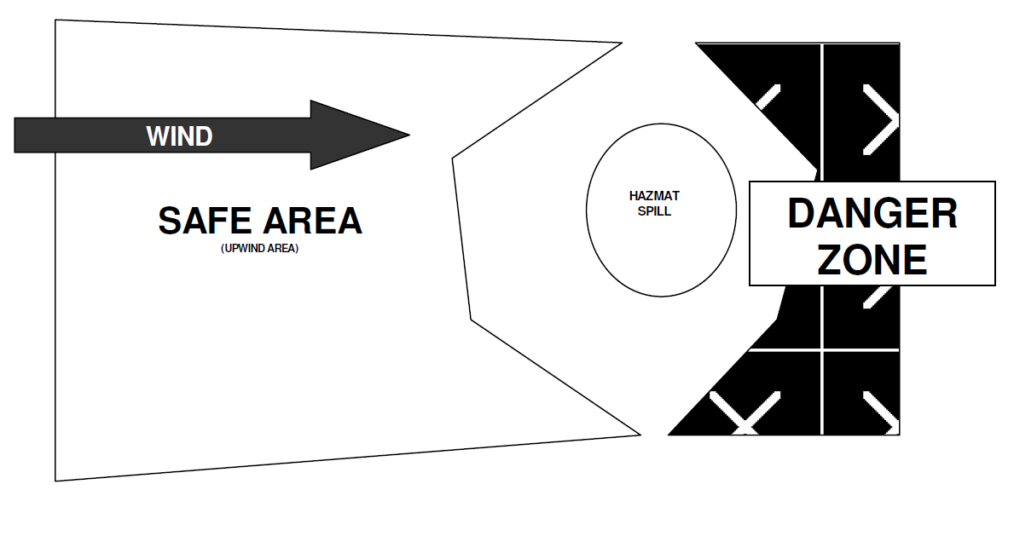
- Identify the source, estimated quantity spilled and stop further release(s) - IF IT CAN BE DONE SAFELY
- Take care of any injured
- Notify JCS Office.
- If the spill is unmanageable, contact the Fire Department by calling 9-1-1 If, after attempted containment, the release still poses either a present or a potential threat, notify the California Office of Emergency Services and local emergency assistance organizations (fire, police, etc.). Give the following information:
- Date, time, and exact location of the release
- Name and telephone number of persons reporting the release
- The type of fuel spilled and the estimated quantity
- Description of potential hazards presented by the fuel spill
- Document the time and date notification was made and the information provided
- A written report to the appropriate office of the California Department of Health Services is required within 15 days after the incident.

Emergency Evacuation Routes and Procedures
See Daily Ingress/Egress Routes located above in this document.

In an Emergency Building Evacuation all employees will:
- Upon emergency alert, secure work area and depart/report to assigned area.
- Perform duties as pre-assigned by the Academy Coordinator in cooperation with emergency services personnel.
- DO NOT re-enter the building without permission or request of emergency service authorities.
- Remain in the general assembly areas and calm students if not assigned another duty.
- When signaled to re-enter safe areas of the school, quickly do so.
- Upon safe re-entry, report anything amiss to the Operations Chief.
In an Emergency Building Evacuation teachers will also:
- Upon alert, assemble students for evacuation using designated routes and account for all students.
- Secure room.
- If possible, leave a note on the door advising where the class evacuated to if other than the standard assembly area.
- Upon arrival at the assembly area, account for all students.
- Secure medical treatment for injured students.
- Report any students missing or left behind because of serious injuries.
- Stay with and calm students.
- If signaled to re-enter school, ensure students do so quickly and calmly. Account for all students.
- Check room and report anything amiss to the Coordinator.
- Debrief students to calm fears about the evacuation.
Emergency Campus Evacuation
If it is necessary to evacuate the entire campus to another school or relief center, the Academy Coordinator will:
- Notify the Executive Director of the Campus Evacuation.
- Cooperate with emergency authorities in enlisting students/staff with cars to help transport evacuees.
- Direct the evacuation, assure all students/staff are accounted for as they depart and arrive.

Medical Emergencies
Calmly and carefully, assess the medical emergency you are faced with. Take only those measures you are qualified to perform.
You should always wear latex or rubber gloves to prevent contact with bodily fluids.
Rescue Breathing
- Gently tilt the head back and lift the chin to open the airway.
- Pinch the nose closed.
- Give two slow breaths into the mouth.
- Breathe into an adult once every five seconds, and for children or infants breathe gently once every three seconds.
- If you are doing the procedure correctly, you should see the chest rise and fall.
To Stop Bleeding
- Apply direct pressure to the wound.
- Maintain the pressure until the bleeding stops.
- If bleeding is from an arm or leg, and if the limb is not broken, elevate it above the level of the heart.
- If limb appears to be broken, minimize any movement, but take what measures are necessary to stop the bleeding.
Treatment for Shock
- Do whatever is necessary to keep the person's body temperature as close to normal as possible.
- Attempt to rule out a broken neck or back.
- If no back or neck injury is present, slightly elevate the person's legs.
Choking
- Stand behind the person.
- Place the thumb side of one of your fists against the person's abdomen, just above the navel and well below the end of the breastbone.
- Grasp your fist with your other hand, give an abdominal thrust.
- Repeat until the object comes out.
- If required, begin rescue breathing.
Triage Guidelines
Triage is defined as the sorting of patients into categories of priority for care based on injuries and medical emergencies. This process is used at the scene of multiple-victim disasters and emergencies when there are more victims than there are rescuers trained in emergency care.
Incidents that involve large numbers of casualties, and have a delay in the response time of emergency medical services, require a special form of triage. The modified triage system that is in most common use is the S.T.A.R.T. (Simple Triage And Rapid Treatment) Plan. In this plan, patients are triaged into very broad categories that are based on the need for treatment and the chances of survival under the circumstances of the disaster. These categories are listed below:
TRIAGE Priorities Highest Priority - RED TAG
- Airway and breathing difficulties
- Cardiac arrest
- Uncontrolled or suspected severe bleeding
- Severe head injuries
- Severe medical problems
- Open chest or abdominal wounds
- Severe shock
Second Priority - YELLOW TAG
- Burns
- Major multiple fractures
- Back injuries with or without spinal cord damage
Third Priority - GREEN TAG
- Fractures or other injuries of a minor nature
Lowest Priority - BLACK
- Obviously mortal wounds where death appears reasonably certain
- Obviously deceased
S.T.A.R.T. Plan Triage Checklist
This method allows rapid identification of those patients who are at greatest risk for early death and the provision for basic life-saving stabilization techniques.
Initial contact
- Identify self, and direct all patients who can walk to gather and remain in a safe place. Tag these people GREEN
- Begin evaluating the non-ambulatory patients where they are lying.
Assess respiration (normal, rapid, absent)
- If absent, open airway to see if breathing begins
- If not breathing, tag BLACK (dead) DO NOT PERFORM C P R
- If patient needs assistance to maintain open airway, or respiratory rate is greater than 30 per minute, tag RED (attempt to use a bystander to hold airway open)
- If respiration is normal, go to next step
Assess perfusion (pulse, bleeding)
- Use the capillary refill test to check radial (wrist) pulse
- If capillary refill test is greater than 2 seconds, or radial pulse is absent, tag RED
- If capillary refill is less than 2 seconds, or radial pulse is present, go to next step.
- Any life threatening bleeding should be controlled at this time, and if possible, raise patient's legs to treat for shock (attempt to use a bystander to hold pressure/bleeding control)
Assess Mental Status (commands, movement)
- Use simple commands/tasks to assess
- If patient cannot follow simple commands, tag RED
- If patient can follow simple commands, they will be tagged YELLOW or GREEN
- This will depend on other conditions, where their injuries will determine the priority of YELLOW or GREEN (i.e. multiple fractures would require a higher level of treatment than superficial lacerations)

Suicide
The publications of many organizations and governmental agencies contain advice for people who are faced with suicidal people. That advice is summarized below.
Do’s
- Listen to what the person is saying and take her/his suicidal threat seriously.
- Many times a person may be looking for just that assurance.
- Observe the person’s nonverbal behavior. In children and adolescents, facial expressions, body language, and other concrete signs often are more telling than what the person says.
- Ask whether the person is really thinking about suicide. If the answer is “YES,” ask how she/he plans to do it and what steps have already been taken. This will convince the person of your attention and let you know how serious the threat is.
- GET HELP by contacting an appropriate Crisis Response Team member. Never attempt to handle a potential suicide by yourself.
- STAY with the person. Take the person to a CRT member and stay with that person for awhile. The person has placed trust in you, so you must help transfer that trust to the other person.
Dont’s
- Don’t leave the person alone for even a minute.
- Don’t act shocked or be sworn to secrecy.
- Don’t underestimate or brush aside a suicide threat (“You won’t really do it; you’re not the type”), or to shock or challenge the person (“Go ahead. Do it”). The person may already feel rejected and unnoticed, and you should not add to the burden.
- Don’t let the person convince you that the crisis is over. The most dangerous time is precisely when the person seems to be feeling better. Sometimes, after a suicide method has been selected, the person may appear happy and relaxed. You should, therefore, stay involved until you get help.
- Don’t take too much upon yourself. Your responsibility to the person in a crisis is limited to listening, being supportive, and getting her/him to a trained professional. Under no circumstances should you attempt to counsel the person.
Mass Casualty
In the event of a Mass Casualty Incident (MCI):
- Determine what the problem is and call 9-1-1 for local emergency services. Note: A casualty is a victim of an accident or disaster.
- Identify the problem and give the school address.
- Site administrators decide whether or not to activate the School Site Disaster First Aid Team protocols (See School Site Disaster Plan).
- Determine if problem will continue or if it is over.
- Notify Executive Director's Office.
- School representative will meet Incident Command Officer (Fire Department or Police Official) who will determine exact nature of incident.
- Site administrators/First Responders will implement Mass Casualty Tracking Protocols as appropriate to the situation.
- Keep calm, reassure students.
- Fire Department will notify appropriate agencies for additional help.
- Crisis Team will convene.
- Contact Executive Director to determine need to send students ho

Bioterrorism
Anthrax Threat
How to identify suspicious letters or packages
Some characteristics of suspicious letters or packages include the following:
✓ Excessive postage ✓ Handwritten or poorly typed addresses ✓ Incorrect titles ✓ Title, but no name ✓ Misspellings of common words ✓ Oily stains, discolorations or odors ✓ No return address ✓ Excessive weight ✓ Lopsided or uneven envelope ✓ Protruding wires or aluminum foil ✓ Excessive security material such as masking tape, string, etc. ✓ Visual distractions ✓ Ticking sound ✓ Marked with restrictive endorsements, such as “Personal” or “Confidential.” ✓ Shows a city or state in the postmark that does not match the return address.
Suspicious unopened letter or package marked with threatening message such as “Anthrax”
- Do not shake or empty the contents of any suspicious envelope or package.
- Place the envelope or package in a plastic bag or some other type of container to prevent leakage of contents.
- If you do not have any container, then cover the envelope or package with anything (e.g., clothing, paper, trash can, etc.) and do not remove this cover.
- Then leave the room and close the door, or section off the area to prevent others from entering.
- Wash your hands with soap and water to prevent spreading any powder to your face.
- If you are at home, report the incident to the local police. If you are at work, report the incident to the local police and your site administrator.
- List all people who were in the room or area when this suspicious letter or package was recognized. Give the list to both the local public health authorities and law enforcement officials for follow-up investigations and advice.
Envelope with powder, or powder spills out onto a surface
- Do not try to clean up the powder. Cover the spilled contents immediately with anything and do not remove this cover.
- Leave the room and close the door or section off the area to prevent others from entering.
- Wash your hands with soap and water to prevent spreading any powder to your face.
- If you are at home, CALL 9-1-1 to report the incident. If you are at work, CALL 9-1-1 and your site administrator to report the incident.
- Remove heavily contaminated clothing as soon as possible and place in a plastic bag, or some other container that can be sealed. The clothing bag should be given to the emergency responders for proper disposal.
- Shower with soap and water as soon as possible. Do not use bleach or other disinfectant on your skin.
- If possible, list all people who were in the room or area, especially those who had actual contact with the powder. Give the list to both the local police and public health authorities so that proper instructions can be given for medical follow-up and further investigation.
Possible room contamination by aerosol (Examples: small devices triggered warning that air handling systems is contaminated, or warning that a biological agent is released in a public space.)
- Turn off local fans or ventilation units in the area.
- Leave the area immediately.
- Close the door or section off the area to prevent others from entering.
- Move upwind, uphill, upstream.
- If you are at home, report the incident to the local police. If you are at work, report the incident to the local police and your site administrator.
- Shut down air handling systems in the building if possible.
- If possible, list all people who were in the room or area, especially those who had actual contact with the powder. Give the list to both the local police and public health authorities so that proper instructions can be given for medical follow-up and further investigation.
DO NOT PANIC
Anthrax organisms can cause infection in the skin, gastrointestinal system, or the lungs. In order for this to happen, the organism must be rubbed into abraded skin, swallowed, or inhaled as a fine, aerosolized mist. Disease can be prevented after exposure to the anthrax spores by early treatment with the appropriate antibiotics. Anthrax is not spread from one person to another person.
For anthrax to be effective as a covert agent, it must be aerosolized into very small particles. This is difficult to do, and requires a great deal of technical skill and special equipment. If these small particles are inhaled, life- threatening lung infection can occur, but prompt recognition and treatment are effective.
Botulism
Botulism infection is extremely rare, with fewer than 200 cases report in the U.S. each year. There are two forms of botulism which are associated with a terrorist act:
Foodborne Botulism
The bacterium is ingested with the contaminated food source.
Symptoms begin within 6 hours to 2 weeks, but most commonly between 12 to 36 hours after eating contaminated foods.
Double or blurred vision, drooping eyelids, slurred speech, difficulty swallowing, dry mouth, and a descending muscle weakness that affects the shoulders first, then upper arms, lower arms, thighs, calves, etc.
These symptoms may be preceded by gastrointestinal disorder such as abdominal cramps, nausea, vomiting, and diarrhea. Paralysis of the respiratory muscles will cause death unless the person is assisted by mechanical ventilation. Botulinum toxin can occur naturally in undercooked food, but the frequency of this is extremely rare.
Inhalational Botulism
Inhalation botulism results from the inhalation of the aerosolized toxin. A small amount of aerosolized toxin released into the wind can have a devastating effect on the surrounding population. Notwithstanding, inhalational botulism could be inflicted upon a more limited number of victims by introducing a contaminated object into an enclosed area such as inside of a building. The symptoms are indistinguishable from those of foodborne botulism, except that the gastrointestinal signs sometimes associated with foodborne botulism may not occur.
Botulism cannot be transmitted from one person to another. There is no vaccine for botulism treatment at this time. However, treatment consists of passive immunization with equine antitoxins and supportive patient care.
Smallpox
Smallpox infection results from the variola virus. The disease was once worldwide in scope. Before people were vaccinated, almost everyone contracted the disease. The virus was effectively eradicated from the world in the late 1970’s, and the World Health Organization recommended governments cease routine vaccinations in 1980.
Vaccination has proven effective in preventing the disease in exposed persons if administered within 4 days of exposure.
Smallpox is a highly contagious infectious disease that has a mortality rate of about 30%. Since the discontinuation of vaccination in the early 1980’s, virtually no one is protected against the disease today. The U.S. government is currently working to address the need for vaccinations. There is no proven treatment should infection occur

Incident Command System

Responsibilities for a School Disaster
Everyone at a school will have some responsibilities in an emergency based on their job, and some people will have additional responsibilities. Below is a short discussion of how the Standard Emergency Management System (SEMS) and the Incident Command System (ICS) can be adapted to your school.
Major Concepts and Components
Every emergency, no matter how large or small, requires that certain tasks be performed. In ICS, these tasks are called Management, Planning, Operations, Logistics, and Finance/Administration.
Under SEMS, the ICS team can be expanded or reduced, depending on the situation and the immediate needs. One person can do more than one function.
Every incident needs a person in charge. In SEMS and ICS, this person is called the Incident Commander or School Commander.
No one person should be supervised more than seven people (the optimum number is five). This does not apply to the Student Supervision Team under Operations, however.
Common terminology:
All teachers and staff in the school should use the same words to refer to the same actions. The terminology should be known before a disaster. SEMS is a system that, when used properly, affords common terminology.
If the fire department or other responding agencies come on campus, they will coordinate better with the site's command structure if similar situations and actions are described with similar wording
How ICS Functions
This system provides for an effective and coordinated response to multi-agency and multi- jurisdictional emergencies, to include multi-disciplines and
- Facilitates the flow of information within and between all levels of the system.
- Facilitates interaction and coordination among all responding agencies.
- Improves the processes of mobilization, deployment, tracking, and demobilization of needed mutual aid resources.
- Reduces the incidence of ineffective coordination and communications, and avoid duplication of resource ordering in multi-agency and multi-jurisdiction response actions.
Primary Incident Command System Functions:
Incident/School Commander (The “leader”)
The Management Section is responsible for overall policy, direction, and coordination of the emergency response effort in the Emergency Operations Center (EOC) throughout Julian Charter School. The Management Section Staff is also responsible for interacting with each other and others within the EOC to ensure the effective function of the EOC organization.
Operations Section (The "doers")
The Operations Section is responsible for coordinating all operations in support of the emergency response and for implementing action plans. This section includes response teams that work toward reduction of the immediate hazard, mitigating damage, and establishing control and restoration of normal operations.
Planning/Intelligence Section (The 'thinkers")
The Planning and Intelligence Section is responsible for collecting, evaluating, and disseminating information; maintaining documentation; and evaluating incoming information to determine the potential situation in the not-too-distant future. This section also develops Julian Charter School EOC/Field action plans for implementation by the Operations Section.
Logistics Section (The "getters")
The Logistics Section is responsible for providing all types of support for the emergency response operation. This section orders all resources from off-site locations and provides facilities, services, personnel, equipment, transportation, and materials.
Finance and Administration Section (The "collectors")
The Finance and Administration Section is responsible for accounting and financial activities such establishing contracts with vendors, keeping pay records, and accounting for expenditures. This section is also responsible for all other administrative requirements and acts as the clearinghouse for documentation during the recovery phase.
Routine use of ICS facilitates seamless integration of ICS into larger emergencies operations as they evolve. The key to ICS is remembering to focus on the functions and where possible, delegate authority to staff essential functions to distribute the workload.
Unified Command Structure
Unified Command is a procedure used at incidents which allows all agencies with geographical, legal or functional responsibility to establish a common set of incident objectives and strategies, and a single Incident Action Plan. The use of Unified Command is a valuable tool to help ensure a coordinated multi-agency response. Unified Command procedures assure agencies that they do not lose their individual responsibility, authority, or accountability.
Unified Command is highly flexible. As the incident changes over time with different disciplines moving into primary roles, the Unified Command structure and personnel assignments can change to meet the need.
Advantages of using Unified Command
- One set of objectives is developed for the entire incident
- All agencies with responsibility for the incident have an understanding and are fully aware of joint priorities and restrictions.
- Duplicative efforts are reduced or eliminated, thus reducing cost and chances for frustration and conflict.
Pre-Designated Incident Facilities
- Staging Areas
- Command Posts
- Mass Care Centers
- Evacuation Centers

Emergency Response Teams
COMPLETE THE FOLLOWING CHART:

Julian Charter School ICS TEAM
Incident School (Site) Commander
- Overall Operations and Staff Supervision
Operations
- Team Lead
- Search & Rescue
- Medical
- Student Release
- Student Staging Area Teams
  - Staging Area 1
  - Staging Area 2
Planning/Intelligence
- Team Lead
  - Site Check/Security
  - Documentation
  - Communication
  - Supplies/Facilities
Logistics
- Team Lead
  - Situational Analysis
  - Supplies/Facilities
  - Medical
  - Transportation
Finance
- Team Lead
  - Financial
  - Purchasing

Staging Areas
Information available with the JCS Main Office.

Julian Charter School Emergency Directory
Jennifer Cauzza -760-522-5038 (cell, doesn’t work after hours due to where she lives)
Melanie Marks - 619-961-6375
Ray Barton - 760-604-5754
Lori Cummings - 760-420-3690
Sheryl McKay - 619-335-8632
Jillian Tonkin - 619-346-3560
Miranda Shields -760-421-9239

Emergency Communications
When emergencies occur, communication is key to ensure appropriate parties are notified regarding the extent of the incident and what needs to be done. Below is a checklist as to how emergency communications may be conducted at your school.
Emergencies within a school:
Internal communications will be via:
- Public address systems.
- Emails.
- Message runner.
- Julian Charter School telephone/emergency radio to administration offices.
External communications will be via:
- The main communications network.
- News bulletins, as needed, by appointed personnel only.
Emergencies affecting two or more schools:
In-district communications will be via:
- Telephone, if operable.
- Julian Charter School internal communications.
- Executive Director or designated Public Information Officer will release
information to news media and prepare necessary bulletins.
A Crisis Communications Center will be established to collect and release information if the emergency is of a continuing nature.

When using JCS radio system:
This section may be modified to suit your communications system operations.
- Set radio to ____________________________________________________
- Firmly push down button to transmit, wait several seconds, then speak calmly and clearly into the mouthpiece. State numbers singly, such as "five-one," not "fifty-one."
- Unit to Base
- Identify yourself: “ This is ___NAME__. ___POSITION___, from __SITE__.
- Base will respond.
- Give message, after transmission is complete. Base will end with (base number)clear
- Unit to Unit
- Use unit number to begin and end transmissions.
- School Bus to unit
- Use Unit number to begin and end transmissions.
- DO NOT interrupt when someone is transmitting exception for emergency information.
- Portable units should remain in charger when not in use.
- Portable units keep a usable charge for ___ to ___ hours.
Briefings/bulletins will be necessary in a continuing emergency, especially when school remains open.
- Use established communication channels to keep employees, students, parents, essential communicators and community informed.
- Keep secretaries briefed on situation changes and what to tell people who phone the School Julian Charter School.
- Hold briefings with employees, labor association leaders, Board President student leaders and other key communicators.
- Enact telephone tree in order to communicate updates.
- Prepare bulletins to distribute to employees, students, parents and essential
- communicators, as needed.
- Supply Executive Director's office and public information offices with a copy of each bulletin.

SITE COMPREHENSIVE SAFETY PLAN 110
Working with the news media:
Only pre-assigned personnel will meet with the media in a designated area so as not to disrupt the educational process. News media personnel are not to be on school grounds, except in designated areas. Staff are to report any news media personnel that appear elsewhere on campus.
Recovery
It is critical to provide a mental health response for students, staff and parents after a crisis that has impacted a school. Often, this can be provided by school or local community resources.
Victims of a crisis experience a real need to return to normal, but normal as they once knew it is forever gone and changed. Counselors and crisis survivors find the concept of a “new normal” to be very reassuring and accurate.
One of the most important actions is simply to listen and allow victims to express his/her own needs and feelings. Encouragement and support, while avoiding judgmental remarks, is the goal.
When the needs of the victims exceed the immediate resources available to the school, San Diego or Riverside County Mental Health and the agencies working under its umbrella is available to support schools.
Numerous agencies under the County Mental Health Department umbrella currently provide ongoing mental health services to students and families both at schools and within the neighborhood communities. These services are provided by licensed therapists, social workers or supervised interns. The services typically involve a one-on-one or family-oriented approach requiring a different skill set than an emergency mental health response to a community or school crisis.

LOCAL MENTAL/SOCIAL SUPPORT RESOURCE CONTACT INFORMATION:
San Diego Access and Crisis Hotline (888) 724-7240
Riverside University Health System Behavioral Health Help-Line (951) 686-4357

Chapter 8
Appendices
Annual Emergency Awareness/ Preparedness

Checklists & Forms
The following checklists highlight areas of school operations, maintenance, security, and personnel that may pose opportunities for risk reduction. Use this checklist as a proactive tool to generate awareness over the potential for terrorist acts, at a time when it is needed most.
The recommendations contained in this checklist are not intended to represent or to replace a comprehensive school security program. Such a program would include much more. Many of the procedures included in the checklist are routine in districts with full- time security operations. Whether your school district has full-time security coverage, or has minimal security resources, these recommendations may be used as a focal point around which to build an appropriately renewed sense of awareness.
The following forms are designed to use on an annual basis to meet emergency preparedness requirements.
Julian Charter School
Safety Plan Annual Emergency Plan Checklist

Submit To: JCS Main Office Operations Department
This is a checklist to help Academy Coordinators organize and meet the site requirements mandated by the Emergency Preparedness Plan. It is recommended that each Academy Coordinator ask for volunteer staff, parents, and students to help carry out the tasks of this checklist.
Check Requirement
- Read JCS Disaster Plan, and know the responsibilities of the site manager
- Designate a second-in-command and a backup
- Orient staff to Julian Charter School Disaster Plan, review site procedures (staff meeting)
- Update academy plans, assign staff responsibilities (complete staff roster sheet)
- Schedule necessary training (First Aid, CPR)
- Schedule drills: Fire, Earthquake, Active shooter, Communications
- Complete site map, post as required, and forward a copy to INSERT
- Complete Site Hazard Survey
- Complete Classroom Hazard Survey Summary
- Submit Classroom Hazard Survey Summary to INSERT
- Participate in test of Julian Charter School Radios
- Check battery-operated radios
- Complete supplies and equipment inventory to include classroom emergency kits
- Order supplies and equipment as necessary
- Evacuation areas/alternative identified for all classes
- Communications to parents and students about disaster procedures
  - Julian Charter School Student Release Policy
  - Emergency Information Cards
- Complete Emergency I.D. Tags collected and put into Classroom Emergency Kits if appropriate.
- Assess food supplies as applicable.

Julian Charter School
Annual Site Hazard Survey (I)
General Guidelines
Academy Coordinators are required to conduct an annual Site Hazard Survey. The survey should be completed early each fall, signed, and submitted to the INSERT by October 30. (Please put N/A by any items that are not applicable.)
The purpose of the Site Hazard Survey is to check for safety hazards outside of the classroom. The survey shall include evaluation of interior and exterior portions of buildings as well as school grounds.
The Site Hazard Survey shall include assessment of the following areas.
- Proximity of toxic, flammable, corrosive, chemically, or reactive materials
- Proximity of high voltage power lines has been considered in establishing the site evacuation plan
- Likelihood and possible effects of flooding or landslides
- Probably safety of evacuation areas after an earthquake; proximity of gas, water, and sewer lines, or sprinklers
- Water heaters are strapped
- Objects that restrict people from moving to a safe place (tables an desks in hallways) etc.
- Janitorial areas: storage of tools and cleaning chemicals (keep a 3 foot clearance in front of all electrical panels)
- Storerooms: heavy items stored on high shelves, shelving secured ( keep 3 foot clearance in front of all electrical panels)
- All computers and peripherals should be situated so as not to create a tipping hazard
- Large and heavy office machines: restrained and located where they will not slide, fall off computers, or block exits
- Sound system speakers and spotlights: secure
- Laboratory chemicals on shelves: restrained

Julian Charter School
Annual Site Hazard Survey (II)
GENERAL GUIDELINES
CAMPUS Signs Posted, Controlled Access Traffic review, parking, fire lanes, adequate surfacing, lighting, Safety Plan required postings
ASSEMBLY ROOMS Exits clear, exit & emergency lights, floors, seating maintained stage: clean, clear exits, wiring, kitchen: clean, safe food storage
ATHLETIC FACILITIES Bleachers, fences, backstops, stairs, ramps, walkways, gates, surfacing in common areas, equipment
INDUSTRIAL ARTS All guards, shields, covers in place, aisles clear, material storage, first aid kits; eyewash operable Dust collection/housekeeping Compressed gas cylinders secure Protective equipment, safety training, safety signs posted, enforced
SCIENCE ROOMS Hazardous material storage, adequate ventilation, fume hoods, eyewash, gas shut-off, safety training, safety signs posted, enforced
EMERGENCY PREPAREDNESS Fire extinguishers checked monthly, Fire and Earthquake drills conducted, First Aid Equipment in place, Evacuation routes posted, Staff Training on Emergency Procedures
Julian Charter School
Annual Classroom Hazard Survey
Nonstructural hazards are caused by the furnishings and nonstructural elements of a building. Anything that does not actually hold the building up is non-structural, including floors, ceilings, windows, and all furnishings. In California schools, non-structural hazards represent the greatest threat to the safety of students and staff. Eliminating these hazards can reduce injuries significantly.
Teachers shall assess his/her room for hazards and correct any he/she can; items he/she cannot correct will be submitted to the coordinator. The coordinator shall submit a completed copy of the school needs with the coordinator’s checklist.
ROOM NUMBER
Deficiencies examples to be corrected by maintenance staff:
- Free standing shelves over 4 feet tall secured to floor or wall
- File cabinets bolted to wall
- File cabinet drawers have latches
- Paints and chemicals restrained on shelves
- Wall-mounted objects are secured
- Sound system speakers are secured to building
- TV securely fastened to platform or cart
Deficiencies examples to be corrected by school personnel:
- Heavy objects removed from high shelves
- Aquariums located on low counter or restrained
- Computers fastened to workstation
- Desks and tables cannot block exits
- Cabinets or equipment on wheels cannot block doorway
Julian Charter School Safety Plan
Annual Drill Report - Example
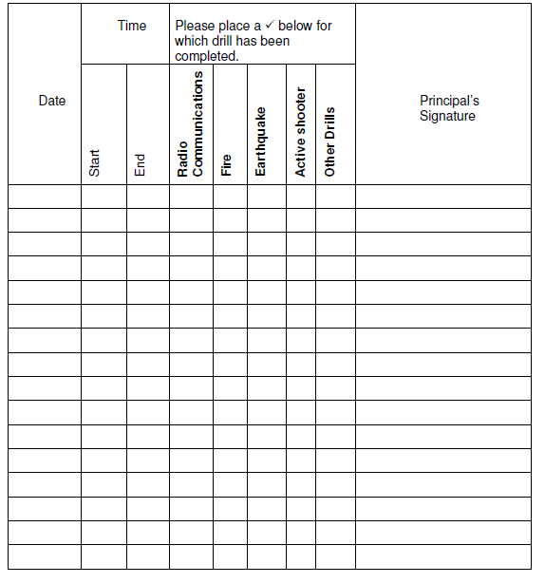
AMERICAN RED CROSS
RECOMMENDED EMERGENCY SUPPLIES FOR SCHOOLS
Drawn from lists created by the California Senate Select Committee on the Northridge Earthquake, Task Force on Education, August 1994
Introduction
What to Store
Begin with an analysis of the hazards of the area. Is your school threatened by tornadoes? Earthquakes? Is emergency assistance close at hand or would you have to wait for help if the entire community has been impacted? Do you think you will need tools for clearing debris? Remember that any school in the country could be locked down due to an intruder or gunfire in the area, so all schools should be prepared to have their students stuck inside the building for many hours. Similarly, all schools face the potential of a hazardous materials spill nearby, requiring the school to shelter-in-place with doors and windows closed and heating systems off. Adjust the supplies for extreme heat or cold temperatures. If your plan includes Search & Rescue teams for light search and rescue following an earthquake, tornado or other damaging event, stock supplies for the number of teams assigned.
Budget
Adjust the list, prioritizing for limited budget and storage space, if necessary. Develop a plan to phase in the supplies. Contact local service clubs and vendors for assistance.
How Much to Store
Make some planning assumptions. Do most of your students' families live nearby or do some of them commute long distances? Some schools could be cut off for days if a bridge or the main highway is blocked. If you determine that most of your students could be picked up in most emergencies within a day, then begin by stocking supplies for one day. Some schools plan that half their student body will be picked up by parents within one day, half the remainder within a day, and the remainder within another day; these schools stock supplies for 100% for day one, 50% for day two, plus 25% for day three. Other schools stock supplies for 3 days, the recommendation of many emergency management agencies. Remember to factor in the number of staff and other adults who may be on campus.
Storage
Determine where to store emergency supplies. Every classroom should have some supplies and there should be a cache of supplies for the whole school. Many schools in California and other states threatened by earthquakes use outdoor storage, anticipating the possibility of having to care for students outside the buildings. They use an existing building or a cargo container, also called a land-sea container, purchased used and installed near the emergency assembly area. Schools with limited budgets and/or temperature extremes may opt to store their supplies in various caches throughout the school facility, primarily in locked closets or classrooms. Many schools stock supplies in (new) trash barrels on wheels. Do not store water in the barrels because it may leak and destroy everything else. Make sure that there are keys to ensure access to the supplies during an emergency, including access by programs such as daycare and after-school events. Plan an annual inventory, replacing water and other items with limited shelf life as necessary.
Recommended Supplies - The following lists address classroom kits, supplies for the whole school and Search & Rescue gear:
Classroom Kit
- Leather Work gloves
- Latex gloves: 6 pairs
- Safety goggles: 1 pair
- Small First Aid kit
- Pressure dressings: 3
- Crow bar
- Space blankets: 3
- Tarp or ground cover
- Student accounting forms (blank)
- Student emergency cards
- Buddy classroom list
- Pens, paper
- Whistle
- Student activities
- Duct Tape: 2 rolls (for sealing doors and windows)
- Scissors
- Suitable container for supplies (5-gallon bucket or backpack)
- Drinking water and cups (stored separately)
- Toilet supplies (large bucket, used as container for supplies and toilet when needed, with 100 plastic bags, toilet paper, and hand washing supplies)
- Portable radio, batteries or other communication system
- Flashlight, batteries
- Push broom (if classroom includes wheelchairs)

Supplies for the Whole School: Water, First Aid, Sanitation, Tools, Food

Water
- 1⁄2 gallon per person per day times three days, with small paper cups

First Aid
- Compress, 4 x 4": 1000 per 500 students
- Compress, 8 x 10": 150 per 500 students
- Elastic bandage: 2-inch: 12 per campus; 4-inch: 12 per campus
- Triangular bandage: 24 per campus
- Cardboard splints: 24 each, small, medium, large o Butterfly bandages: 50 per campus of Water in small sealed containers: 100 (for flushing wounds, etc.)
- Hydrogen peroxide: 10 pints per campus o Bleach, 1 small bottle
- Plastic basket or wire basket stretchers or backboards: 1.5/100 students
- Scissors (paramedic): 4 per campus
- Tweezers: 3 assorted per campus
- Triage tags: 50 per 500 students
- Latex gloves: 100 per 500 students
- Oval eye patch: 50 per campus
- Tapes: 1" cloth: 50 rolls per campus; 2" cloth: 24 per campus
- Dust masks: 25 per 100 students
- Disposable blanket: 10 per 100 students
- First Aid books: 2 standard and 2 advanced per campus
- Space blankets: 1 per student and staff
- Heavy duty rubber gloves: 4 pairs
- Sanitation Supplies (if not supplied in the classroom kits)
- 1 toilet kit per 100 students/staff, to include:
- 1 portable toilet, privacy shelter, 20 rolls toilet paper, 300 wet wipes, 300 plastic bags with ties, 10 large plastic trash bags
- Soap and water, in addition to the wet wipes, is strongly advised.
Tools per Campus
- Barrier tape, 3" x 1000": 3 rolls
- Pry bar
- Pick ax
- Sledge hammer
- Shovel
- Pliers
- Bolt cutters
- Hammer
- Screwdrivers
- Utility knife
- Broom
- Utility shut off wrench: 1 per utility
Other Supplies
- Folding tables, 3' x 6': 3-4 o Chairs: 12-16
- Identification vests for staff, preferably color-coded per school plan
- Clipboards with emergency job descriptions
- Office supplies: pens, paper, etc.
- Signs for student request and release
- Alphabetical dividers for request gate
- Copies of all necessary forms
- Cable to connect car battery for emergency power

Food
The bulk of stored food should be easy to serve, non-perishable and not need refrigeration or heating after opening. Food is generally considered a low priority item, except for those with diabetes and certain other specific medical conditions. One method used by schools is to purchase food at the beginning of the school year and donate it to charity at the end of the year. A supply of granola bars, power bars, or similar food which is easy to distribute, may be helpful. Some schools store hard candy, primarily for its comfort value.

Search & Rescue Equipment
Training on how to do light Search & Rescue is required—contact your local fire department for information on whether such training is offered in your community.

Protective Gear per S&R Team Member
- Hard hat, OSHA approved
- Identification vest
- Leather work gloves
- Safety Goggles
- Dust mask
- Flashlight & extra batteries
- Duffel or tote bag to carry equipment

Gear per S&R Team
- Backpack with First Aid supplies
- Master Keys
Homeland Security Advisory System
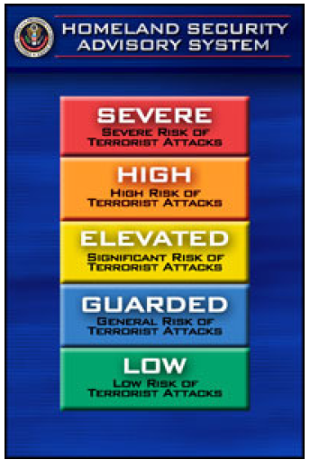
Homeland Security Advisory System
The Homeland Security Advisory System provides a comprehensive and effective means to disseminate information regarding the risk of terrorist acts to Federal, State, and local authorities and to the American people. This system provides warnings in the form of a set of graduated "Threat Conditions" that increase as the risk of the threat increases. At each Threat Condition, Federal departments and agencies would implement a corresponding set of "Protective Measures" to further reduce vulnerability or increase response capability during a period of heightened alert.
The following protective measures are general guidelines for schools. In the event that the threat level increases to RED, schools may or may not need to take specific protective action. The nature of the emergency will dictate the response.
Threat Conditions and Recommended Protective Measures
The following Threat Conditions each represent an increasing risk of terrorist attacks. Beneath each Threat Condition are some suggested protective measures. Each school is responsible for developing and implementing appropriate specific emergency plans.
GREEN: LOW RISK OF TERRORIST ATTACK
This condition is declared when there is a low risk of terrorist attacks. The following general measures should be considered in addition to any specific plans that are developed and implemented:
General Measures
- Assign the responsibility for action to the School Emergency Manager to ensure all checklist items are completed.
- Refine and exercise as appropriate, school and district emergency plans.
- Train teachers and staff on the Homeland Security Advisory System and specific emergency plans.
- Assess school sites for proximity and vulnerability to potential terrorist targets (i.e. Commercial occupancies with potential hazards, utility companies, etc) updating plans as needed.
- Develop and implement security procedures, (Assign a member of the school staff to ensure that this checklist item is completed).
- Conduct routine inventories of emergency supplies and medical kits.
- Include a weekly check of the generator when applicable.
- Know how to turn off water, power, and gas to your facilities.
- Budget for security measures.
- Advise all personnel to report the presence of unknown suspicious persons, vehicles, mail, and other suspicious activities.
- Develop visitor identification and sign in procedures.
- Arrange for staff members to take a First Aid/CPR course.
- All school keys should include the provision for “Do Not Duplicate”
- Review and update the Emergency Call-in List.
BLUE: GENERAL RISK OF TERRORIST ATTACK
This condition is declared when there is a general risk of terrorist attacks. All general measures listed in green alert conditions should be taken, and the following general measures should be considered, in addition to any specific plans that are developed and implemented:
General Measures
- Communicate the change in threat level to all staff members.
- Check and test emergency communications, coordinate with all school sites and staff.
- Review and update emergency response procedures.
- Provide parents or guardians with any information that would strengthen a school’s ability to respond to a terrorist threat.
- Mark keys with “Do Not Duplicate”. (See Condition Green)
- Conduct routine perimeter checks of site, checking integrity of fencing, locks, and ensuring appropriate security signage is in place.
- Review and update emergency call-in list.
- Review current emergency communication plan to notify parents in times of emergency; disseminate information to families of students, staff, and faculty.
- Test your generator once per week.
YELLOW: SIGNIFICANT RISK OF TERRORIST ATTACK
An Elevated Condition is declared when there is a significant risk of terrorist attacks. All general measures listed in green and blue alert conditions should be taken, and the following measures should be considered, in addition to any specific plans that are developed and implemented:
General Measures
- Communicate the change in threat level to all staff members.
- Review whether the precise characteristics of the threat require the further refinement of any current emergency plans.
- Implement, as appropriate, contingency emergency response plans.
- Identify and monitor government sources for warnings.
- Review mail handling, and delivery of packages procedure with staff.
- Consider escorts for building visitors.
- Check site for potential hazards such as unattended packages, unauthorized vehicles, or perimeter violations.
- Increase perimeter checks of site, check buildings for unattended packages, and report any suspicious activity or circumstances to law enforcement immediately.
- Test your generator once per week.
ORANGE HIGH RISK OF TERRORIST ATTACK
A High Condition is declared when there is a high risk of terrorist attacks. All general measures listed in green, blue, and yellow alert conditions should be taken, and the following measures should be considered, in addition to any specific plans that are developed and implemented:
General Measures
- Communicate the change in threat level to all staff members.
- Identify the need for any additional security and coordinating efforts, if necessary, with your local Emergency Manager.
- Be alert to parent, staff, student concerns to determine when/how to communicate. a. Communication should focus on reassurance that school is a safe place
  - Reminder – schools have existing safety plans
  - Reminder – schools practice their safety procedures
  - Reminder – schools have an outstanding ongoing working relationship with law enforcement and excellent communication networks.
- Evaluate school events and take additional precautions, if necessary.
- Consider assigning mental health counselors for students, staff and faculty, if needed.
- Discuss student’s fears concerning possible terrorist attacks and offer available resources.
- Consider reducing site ingress and egress points to an absolute minimum.
- Refuse access to people who do not have identification or a legitimate need to enter the site.
- Inspect all deliveries; restrict parking near buildings, and report suspicious vehicles to local law enforcement.
- Consider parking controls or special restrictions at all sites
- Test your generator once per week.
RED: SEVERE RISK OF TERRORIST ATTACKS
A Severe Condition reflects a severe risk of terrorist attacks. Under most circumstances, the protective measures for a Severe Condition are not intended to be sustained for substantial periods of time.
All general measures listed in green, blue, yellow, and orange alert conditions should be taken, and the following measures should be considered, in addition to any specific plans that are developed and implemented:
General Measures
- Make contact with your day-to-day local Emergency Manager or assigned contact to ensure a reliable line of communication during the red level.
- Test communication lines - including e-mail link to ACOE, telephone lines, or amateur radio.
- Make sure cellular phone is charged and ready along with adequate batteries for AM/FM radios, pagers, etc.
- Communicate the change in threat level to all staff members.
- Monitor e-mails and telephone calls from the ALCO EOC for updates during crisis.
- Gather and provide related information to students, staff and parents.
A. review communication guidelines under Orange Threat Level B. reminder – In the event of a RED threat level, school districts have a direct communication link via amateur radio to the Santa Clara County Emergency Operations Center. They receive timely, accurate information, from which to make decisions affecting the safety and welfare of students.
- Assess the threat condition on a regular basis and evaluate whether any further protective measures are needed.
- Consider canceling special events.
- Consider closing campuses, if necessary.
- Maintain close contact with your local Emergency Manager.
- Monitor all deliveries and mail to your buildings.
- Provide security for parking lots; deploy personnel to observe and report to Law Enforcement to protect facility.
- Be prepared to Evacuate, Lockdown, or Shelter in Place if ordered.
- Ensure mental health counselors are available for students, staff and faculty.
Listed below are websites that provide additional information.
http://www.ready.gov Disaster Preparedness Information
http://:www.whitehouse.gov White House
http://:www.dhs.gov Federal Department of Homeland Security
http://:www.nasponline.org National Association of School Psychologists
http://www.fema.gov/ Federal Emergency Management Agency
http://www.oes.ca.gov/ California Office of Emergency Services
http://www.bt.cdc.gov/ Centers for Disease Control and Prevention
http://www.fbi.gov/ Federal Bureau of Investigation

