Section I.
DECISION MAKING / JUDGMENT
Outstanding Exceeds Meets Expectations Fails to Meet Unsatisfactory
Expectations Requirements
Decisions are consistently ☐ ☐ ☐ ☐ ☐
well researched and appropriate.
Comments in support of rating:

Outstanding Exceeds Satisfactory Fails to Meet Unsatisfactory
Requirements Requirements
Decisions are made in a ☐ ☐ ☐ ☐ ☐
timely basis.
Comments in support of rating:

Outstanding Exceeds Satisfactory Fails to Meet Unsatisfactory
Requirements Requirements
Board input is sought when ☐ ☐ ☐ ☐ ☐
appropriate.
Comments in support of rating:

Outstanding Exceeds Satisfactory Fails to Meet Unsatisfactory
Requirements Requirements

Overall Rating: ☐ ☐ ☐ ☐ ☐

PLANNING/ORGANIZATION SKILLS
Outstanding Exceeds Satisfactory Fails to Meet Unsatisfactory
Requirements Requirements
Consistently exercises effective ☐ ☐ ☐ ☐ ☐
planning techniques for the
attainment of Board/District goals.
Comments in support of rating:

Outstanding Exceeds Satisfactory Fails to Meet Unsatisfactory
Requirements Requirements
Sets challenging goals that are ☐ ☐ ☐ ☐ ☐
in line with Board direction.
Comments in support of rating:

Outstanding Exceeds Satisfactory Fails to Meet Unsatisfactory
Requirements Requirements
Exhibits a structured and organized ☐ ☐ ☐ ☐ ☐
approach, both short and long term,
in planning and implementation.
Comments in support of rating:

Outstanding Exceeds Satisfactory Fails to Meet Unsatisfactory
Requirements Requirements
Demonstrates good forward thinking/ ☐ ☐ ☐ ☐ ☐
planning skills.
Comments in support of rating:

Outstanding Exceeds Satisfactory Fails to Meet Unsatisfactory
Requirements Requirements
Overall Rating: ☐ ☐ ☐ ☐ ☐

COMMUNICATION SKILLS
Outstanding Exceeds Satisfactory Fails to Meet Unsatisfactory
Requirements Requirements
Demonstrates effective written ☐ ☐ ☐ ☐ ☐
communication skills.

Comments in support of rating:

Outstanding Exceeds Satisfactory Fails to Meet Unsatisfactory
Requirements Requirements
Demonstrates effective oral ☐ ☐ ☐ ☐ ☐
communication skills.

Comments in support of rating:

Outstanding Exceeds Satisfactory Fails to Meet Unsatisfactory
Requirements Requirements
Provides effective Board ☐ ☐ ☐ ☐ ☐
communication.

Comments in support of rating:

Outstanding Exceeds Satisfactory Fails to Meet Unsatisfactory
Requirements Requirements
Overall Rating: ☐ ☐ ☐ ☐ ☐

LEADERSHIP_______________________________________________________________________________
Outstanding Exceeds Satisfactory Fails to Meet Unsatisfactory
Requirements Requirements
Instills confidence, trust, and ☐ ☐ ☐ ☐ ☐
exhibits capable and responsive
management.
Comments in support of rating:

Outstanding Exceeds Satisfactory Fails to Meet Unsatisfactory
Requirements Requirements
Promotes teamwork and a ☐ ☐ ☐ ☐ ☐
collaborative work environment.
Comments in support of rating:

Outstanding Exceeds Satisfactory Fails to Meet Unsatisfactory
Requirements Requirements
Builds an effective and cohesive staff. ☐ ☐ ☐ ☐ ☐

Comments in support of rating:

Outstanding Exceeds Satisfactory Fails to Meet Unsatisfactory
Requirements Requirements
Creates an environment which supports ☐ ☐ ☐ ☐ ☐
risk-taking, when appropriate.
Comments in support of rating:

Outstanding Exceeds Satisfactory Fails to Meet Unsatisfactory
Requirements Requirements
Overall Rating: ☐ ☐ ☐ ☐ ☐

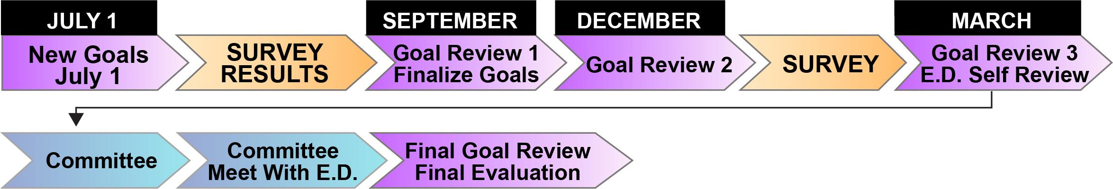
Section II.

Assessment of annual performance against goals and objectives:

GOAL AREA | Not Enough Rater Information | Outstanding | Proficient | Needs Improvement
GOAL 1

GOAL 2

GOAL 3

GOAL 4

GOAL 5

Section III.

Overall Performance: (Overall summary of individual and/or organizational performance, unique events/challenges. Include comments as appropriate, on developmental areas.)

Board Member: _______________________________________________ Date: ____________________________

