**Section I.**

**DECISION MAKING / JUDGMENT**

Outstanding Exceeds Meets Expectations Fails to Meet Unsatisfactory

Expectations Requirements

Decisions are consistently ☐ ☐ ☐ ☐ ☐

well researched and appropriate.

*Comments in support of rating*:

Outstanding Exceeds Satisfactory Fails to Meet Unsatisfactory

Requirements Requirements

Decisions are made in a ☐ ☐ ☐ ☐ ☐

timely basis.

*Comments in support of rating*:

Outstanding Exceeds Satisfactory Fails to Meet Unsatisfactory

Requirements Requirements

Board input is sought when ☐ ☐ ☐ ☐ ☐

appropriate.

*Comments in support of rating*:

Outstanding Exceeds Satisfactory Fails to Meet Unsatisfactory

Requirements Requirements

**Overall Rating:** **☐** **☐** **☐** **☐** **☐**

**PLANNING/ORGANIZATION SKILLS**

Outstanding Exceeds Satisfactory Fails to Meet Unsatisfactory

Requirements Requirements

Consistently exercises effective ☐ ☐ ☐ ☐ ☐

planning techniques for the

attainment of Board/District goals.

*Comments in support of rating*:

Outstanding Exceeds Satisfactory Fails to Meet Unsatisfactory

Requirements Requirements

Sets challenging goals that are ☐ ☐ ☐ ☐ ☐

in line with Board direction.

*Comments in support of rating*:

Outstanding Exceeds Satisfactory Fails to Meet Unsatisfactory

Requirements Requirements

Exhibits a structured and organized ☐ ☐ ☐ ☐ ☐

approach, both short and long term,

in planning and implementation.

*Comments in support of rating*:

Outstanding Exceeds Satisfactory Fails to Meet Unsatisfactory

Requirements Requirements

Demonstrates good forward thinking/ ☐ ☐ ☐ ☐ ☐

planning skills.

*Comments in support of rating*:

Outstanding Exceeds Satisfactory Fails to Meet Unsatisfactory

Requirements Requirements

**Overall Rating:** **☐** **☐** **☐** **☐** **☐**

**COMMUNICATION SKILLS**

Outstanding Exceeds Satisfactory Fails to Meet Unsatisfactory

Requirements Requirements

Demonstrates effective written ☐ ☐ ☐ ☐ ☐

communication skills.

*Comments in support of rating*:

Outstanding Exceeds Satisfactory Fails to Meet Unsatisfactory

Requirements Requirements

Demonstrates effective oral ☐ ☐ ☐ ☐ ☐

communication skills.

*Comments in support of rating*:

Outstanding Exceeds Satisfactory Fails to Meet Unsatisfactory

Requirements Requirements

Provides effective Board ☐ ☐ ☐ ☐ ☐

communication.

*Comments in support of rating*:

Outstanding Exceeds Satisfactory Fails to Meet Unsatisfactory

Requirements Requirements

**Overall Rating:** **☐** **☐** **☐** **☐** **☐**

**LEADERSHIP_______________________________________________________________________________**

Outstanding Exceeds Satisfactory Fails to Meet Unsatisfactory

Requirements Requirements

Instills confidence, trust, and ☐ ☐ ☐ ☐ ☐

exhibits capable and responsive

management.

*Comments in support of rating*:

Outstanding Exceeds Satisfactory Fails to Meet Unsatisfactory

Requirements Requirements

Promotes teamwork and a ☐ ☐ ☐ ☐ ☐

collaborative work environment.

*Comments in support of rating*:

Outstanding Exceeds Satisfactory Fails to Meet Unsatisfactory

Requirements Requirements

Builds an effective and cohesive staff. ☐ ☐ ☐ ☐ ☐

*Comments in support of rating*:

Outstanding Exceeds Satisfactory Fails to Meet Unsatisfactory

Requirements Requirements

Creates an environment which supports ☐ ☐ ☐ ☐ ☐

risk-taking, when appropriate.

*Comments in support of rating*:

Outstanding Exceeds Satisfactory Fails to Meet Unsatisfactory

Requirements Requirements

**Overall Rating:** **☐** **☐** **☐** **☐** **☐**

**Section II.** 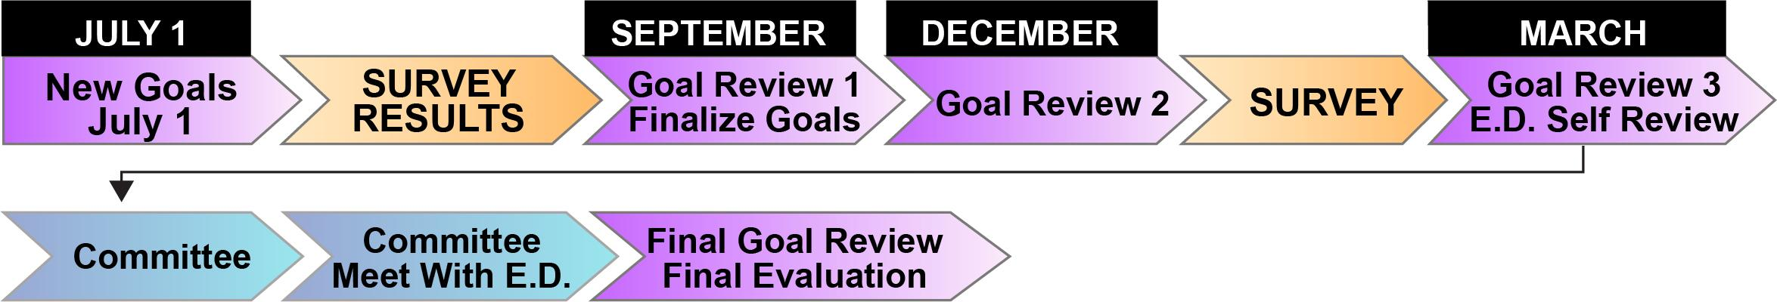

**Assessment of annual performance against goals and objectives:**

| **GOAL AREA** | **Not Enough Rater Information** | **Outstanding** | **Proficient** | **Needs Improvement** |
| --- | --- | --- | --- | --- |
| **GOAL 1** |  |  |  |  |
| **GOAL 2** |  |  |  |  |
| **GOAL 3** |  |  |  |  |
| **GOAL 4** |  |  |  |  |
| **GOAL 5** |  |  |  |  |

**Section III.**

**Overall Performance:** (Overall summary of individual and/or organizational performance, unique events/challenges. Include comments as appropriate, on developmental areas.)

**Board Member: _______________________________________________ Date: ____________________________**